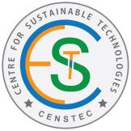
CENTRE FOR SUSTAINABLE TECHNOLOGIES

Name of the Coordinator: Dr.V.Preethi
Objectives
• To promote interdisciplinary activities and initiatives that lead to sustainability associated with Built Environment.
• To develop and showcase cost effective solutions in the areas of green building materials, health monitoring of structural systems, water, air, solid waste management, renewable energy and other issues related to environmental resources using the state of art technologies.
• To develop technologies for cleaner production and help the industries for adoption.

RESEARCH ACTIVITIES
Green building materials
• Synthesize of artificial aggregates from ceramic waste, lathe waste, plastic waste, fly ash and GGBS
Health Monitoring of Structural Systems
• Health Monitoring of Signature Tower located at Chennai, using electrical strain gauges over a period of 550 days.
Renewable Energy
• Recovery of Hydrogen from Sulphide containing wastewater
• Biogas production from solid Waste
• CO₂ Sequestration
• Techniques adopted for energy efficiency buildings

ACHIVEMENTS (2014-23)
- Young Scientist Awards – 3
- Innovative Awards – 2
- Patent – 7
- Published 30 research papers in Elsevier Journals with high impact
- Visited La Trobe University, Melbourne University, Deakin University in Australia, University Federal de Juiz de Fora, University de Rio de Janerio, Brazil, Universiti Malaysia Pahang, Universiti Technology Malaysia, Malaysia, King Mongkut’s University of Technology Thonburi, University of South Bangkok, Asian Institute of Technology, Thaniland for research collaboration
- Paper presented in several International Conferences viz., ICFCHT2015, Malaysia, ‘Pollution Control Congress 2017, Melbourne; WHEC2018, Brazil; ICESM2019, Malaysia; Climate and Clean year 2023, Thailand.
- Delivered a Guest lecture in University of Melbourne, Universiti Malaysia Pahang etc.,
- Visiting faculty in UMP, Malaysia and KMUTT, Thailand

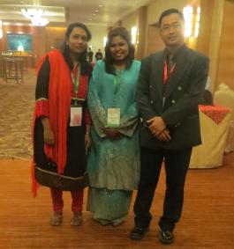 | 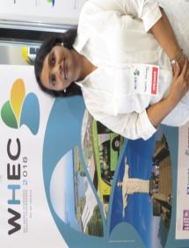
ICFCHT 2015 conference, UTM,  Malaysia | Paper presented in WHEC2018, Brazil
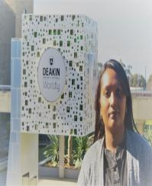 | 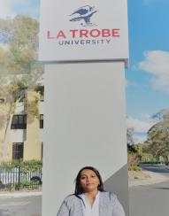
Waurn Ponds Campus, In La Trobe University Campus,
Deakin University, Australia 2017 Australia, 2017

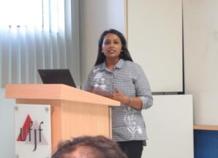 | 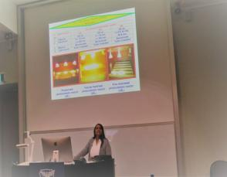
Guest Lecture delivered on ‘Effect of  Sulphide Wastewater and Treatments at UFJF, Brazil, 2018 | Guest lecture at Melbourne University, 2017

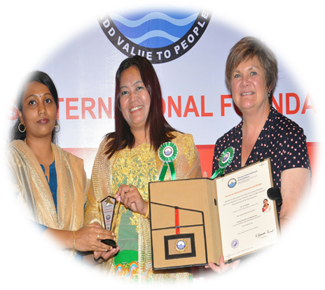  Recognition as session, EPSE 2017 chair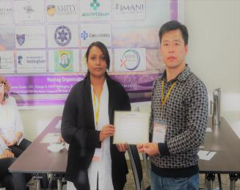airsion | Paper presentation at EPSE 2017  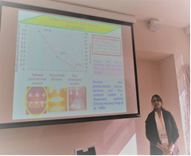
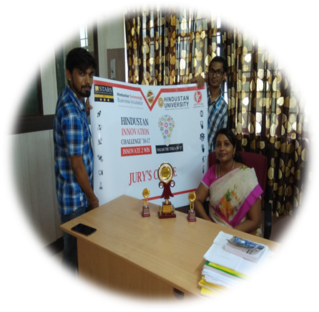
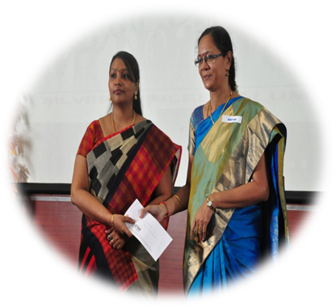

Venus International Award 2017
Young Faculty in Engineering
Hindustan Innovative Awards 2017 – CO2 Sequestration
Young Scientist Award 2017 from HITAA 1988- 1992 Batch

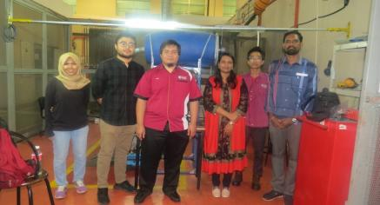 | 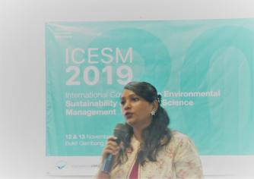
Visiting Faculty at Universiti Malaysia Pahang (UMP), Malaysia, 2019 | Delivered a Keynote speech during the conference ICESM2019, Malaysia
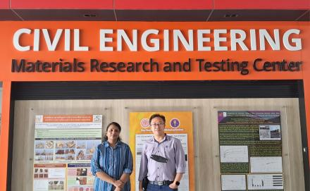 | 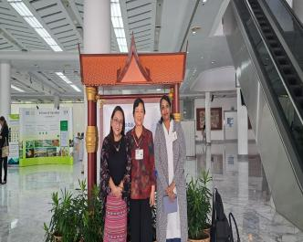
Visiting Faculty at King Mongkut’s University of Technology, Thonburi, 2023 | During the climate and clean air conference (CCAC2023)

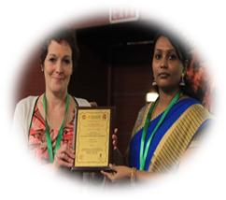
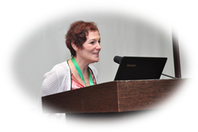
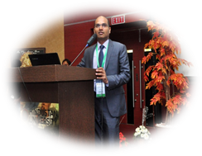

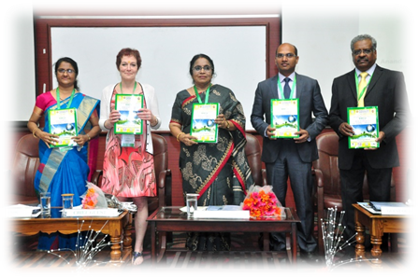
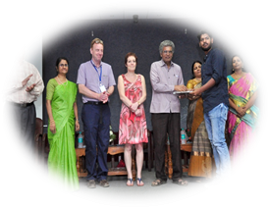

International Conference ICSEE2017
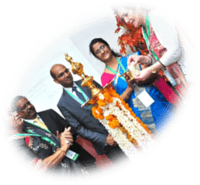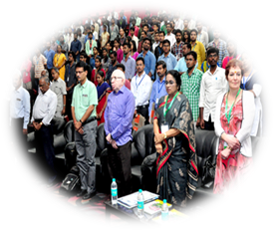

 | 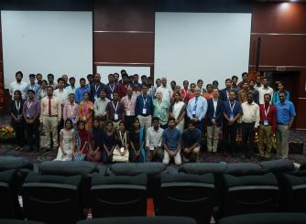 | 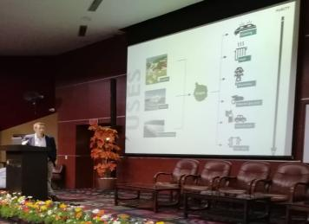
 |  | 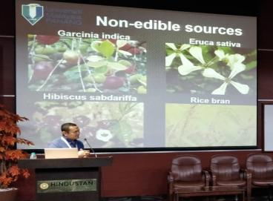

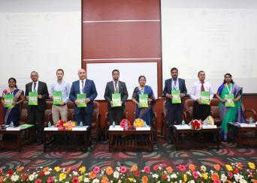
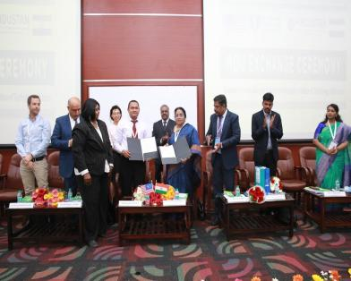
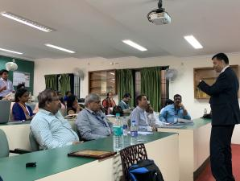

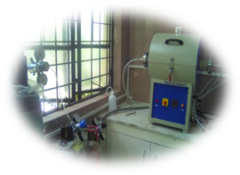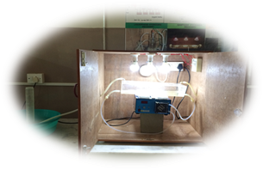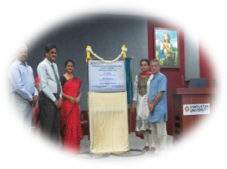
Tubular furnace
Photocatalytic Reactor for Hydrogen Recovery
Inauguration of
Renewable Energy Lab

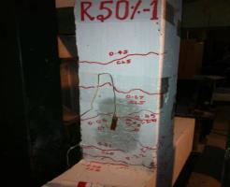
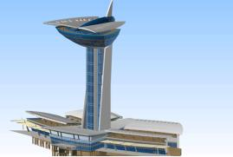
Health Monitoring of Signature Tower
Seismic Performance of Columns with GGBS

