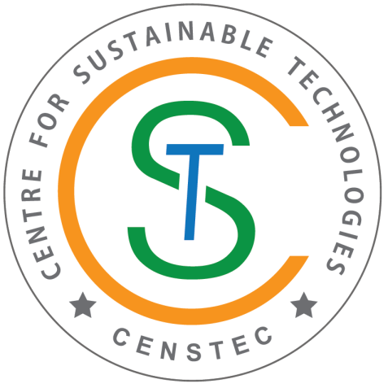 | CENTRE FOR SUSTAINABLE TECHNOLOGIES

Introduction

Centre for Sustainable Technologies was established in the year 2012. The centre is taking a leading role in pursuing research in important areas like materials replacement in concrete (High Volume fly ash concrete, High Volume Ground Granulated Blast furnace Slag concrete, Silica fume concrete, Geo Polymer Concrete, Crumb Rubber concrete, Artificial aggregates from ceramic waste, lathe waste, plastic waste, fly ash and GGBS), Health monitoring of structural systems, Recovery of energy from sulphide wastewater, Biogas production from organic waste materials, CO₂ sequestration, Techniques adopted for energy efficient buildings. The centre has laboratory facilities to carry out research in these areas.

The objectives of the centre is to promote interdisciplinary activities and initiatives that lead to sustainability associated with Built Environment, to develop and showcase cost effective solutions in the areas of green building materials, health monitoring of structural systems, water, air, solid waste management, renewable energy and other issues related to environmental resources using the state of art technologies and to develop technologies for cleaner production and help the industries for adoption.

Facilities available for research

- Photocatalytic Reactor – Renewable energy, Hydrogen recovery from sulphide wastewater
- Tubular Furnace – for synthesis of carbon nano tubes (CNTs)
- Deep Freezer – to store and preserve the samples below (-60ºC).
- Amine Reactor - CO₂ sequestration
- Bio-Reactor – Labscale Biogas production from food waste and water weeds etc.,
- Reverse lateral loading frame, Vertical loading frame, Column testing frame, Data acquisition system, Computerized UTM – To study the behavior of the structural components with sustainable materials.

Brief Description About the Centre:
The Centre for Sustainable Technologies is taking a leading role in pursuing research in the following areas
- Student Projects using Green Building Materials
- Study on High Volume Fly Ash Concrete, High Volume GGBS Concrete, Silica Fumes Concrete, Polymer Concrete, Crumb Rubber Concrete
- Synthesis of artificial aggregates from ceramic waste, lathe waste, plastic waste, fly ash and GGBS
- Health Monitoring of Structural Systems
- Flexural Behaviour of Composite Beams in Tall Buildings
- Renewable Energy
- Recovery of Hydrogen from wastewater containing Sulphide
- Carbon Sequestration
Vision of Centre: To find solutions for problems related to Built Environment towards sustainability.
Mission of Centre:
• To promote interdisciplinary activities and initiatives that lead to sustainability associated with Built Environment.
• To develop and showcase cost effective solutions in the areas of green building materials, health monitoring of structural systems, water, air, solid waste management, renewable energy and other issues related to environmental resources using the state of art technologies.
• To develop technologies for cleaner production and help the industries for adoption.

Research activities:
- Hydrogen Production
- CO₂ Sequestration
- Bio-oil production from algae
- Bio-gas production from food waste and utilization
- Development and characterization of high volume fly ash concrete for structural applications.
- Research on Real Time Health Monitoring is being done in Signature Tower

Facilities:
- Vertical loading frame
- Column testing frame
- Data acquisition system
- Reversed lateral loading frame
- Computerized UTM
- UV-Vis Spectrophotometer
- Photocatalytic reactor for Hydrogen Recovery
- Tubular Furnace
- Deep freezer
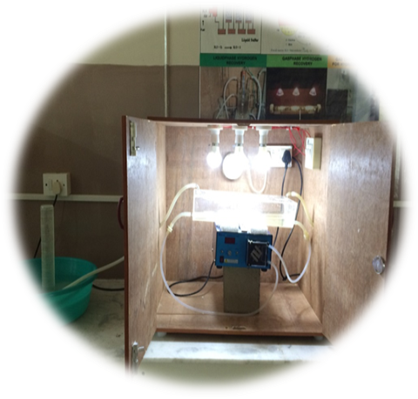  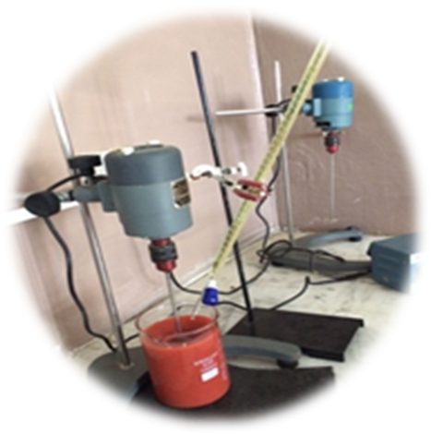  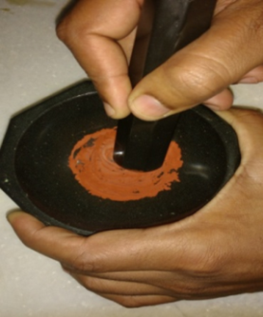  Synthesis of novel CNT  doped CdZnS/ Fe₂O₃  Indoor Photocatalytic  Hydrogen Recovery | 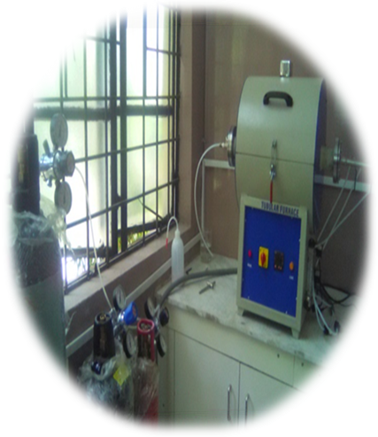  Tubular Furnace

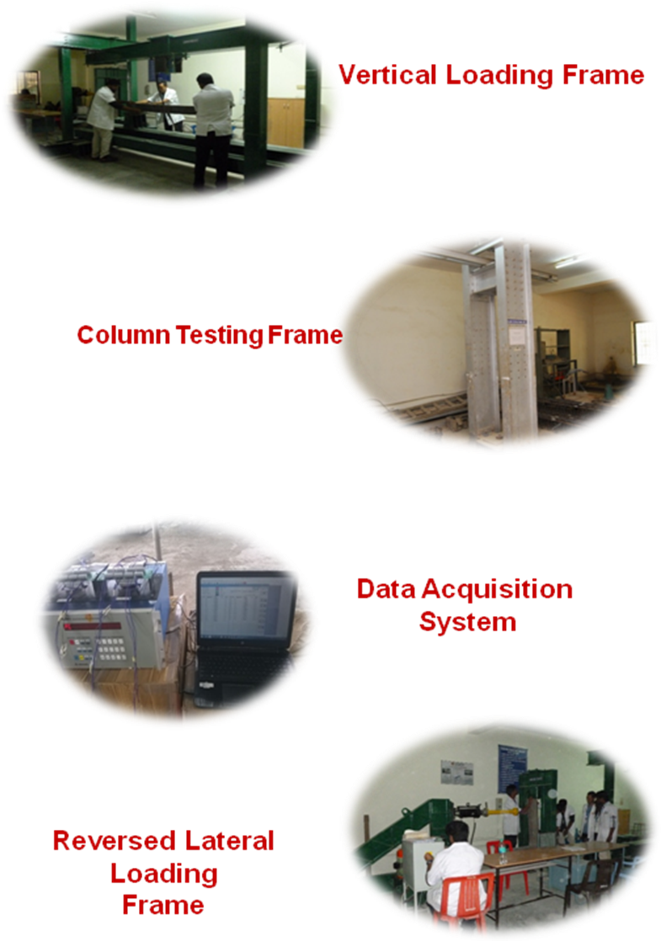

Collaboration Details:
- Indra Gandhi Centre for Atomic Research (IGCAR) – Kalpakkam
- Development and characterization of high volume fly ash concrete for structural applications.
- Structural Engineering Research Centre (SERC) – Chennai
- A project proposal on “Seismic Performance of High Volume Fly Ash Concrete” has been submitted to IGCAR, Kalpakkam. Testing is to be done at SERC.
- Eversendai Construction Private Limited
- Research on Real Time Health Monitoring is being done done in Signature Tower.
- Universidad de La Laguna, Spain
- Biogas production from food waste
- Yogi Vemana University, Kadapa
- Out-door solar studies for hydrogen production
- University of Melbourne, Australia
- Hydrogen fuel recovery from sulphide wastewater
- NCL Pune
- Thin-film photocatalyst for large-scale hydrogen production

Milestones Achieved so far:
- Young Scientist Awards – 3
- Innovative Awards – 2
- Patent – 9
- Published 9 research papers in Elsevier Journals with high impact
- Presented a paper in the 15th World Conference on Earthquake Engineering at Portugal, 2012
- Presented a paper in International Conference at University of Technology Malasyia
- Visited La Trobe University, Melbourne University and Deakin University for research collaboration
- Session Chair and Presented a Research Paper in an International Conference ‘Pollution Control Congress 2017, Melbourne
- Delivered a Guest lecture in University of Melbourne
- Honda Fujishima Renewable Energy Lab – Inaugurated
- Organized two International Conference ‘ICSEE 2017 & 19’ at HITS

Publication Details from the starting of Centre:
May 2020- till date

1. Geetanjali Chandam, Yanchen Oinamm Rochitra Keisham, Nungdren N, Pratheeba Paul, “Development of Road Congestion Index based on Comprehensive Parameters” International Journal of Innovative Technology and Exploring Engineering (IJITEE) 9(9):220-225.
2. Karthick, R.Samuel Devadoss, S.Sharmila, and S.Karthikeyan,(2020), “Assessment Of Meteorological Parameters For Flat Terrain Condition By Using AERMET a Pre-Processor Dispersion Model”, Research Journal of Chemistry and Environment, 24(8), 96-107.
3. Sankar Sekar, Sejoon Lee, Preethi Vijayarengan, Kalirajan KM, Santhakumar T, Saravanan Sekar, Sudha S, “Upcycling of Wastewater via Effective Photocatalytic Hydrogen Production Using MnO2 Nanoparticles-Decorated Activated Carbon Nanoflakes”, Nanomaterials 10, 2020, 1610.
4. Sankar Sekar, Sejoon Lee, Preethi Vijayarengan, “Biomass Activated Carbon-Decorated Spherical β-Ni(OH)2 Nanoparticles for Enhanced Hydrogen Production”, Journal of Water Process Engineering (accepted for publication), Sep 2020.
5. V. T. Neelmudiyon, Preethi Vijayarengan*, S.Govindarajan, “A Study on Conjunctive use of Green and Blue Water in Deevanur Tank Irrigated Area”, International journal of advanced research in engineering & technology 11(9):272-281, 2020.
6. Hariram Venkatesan, Godwin John John Rose, Preethi Vijayarengan, Seralathan Sivamani, Jagannathan Krishnan, Micha Premkumar T, “Predicting the combustion behaviour of compression ignition engine fuelled with biodiesel from Stoechospermum marginatum, a macro algae”, Environmental Science and Pollution Research,DOI:10.1007/s11356-020-10048-z,
7. Dhinakaran, Branesh Robert J. and Angeline Prabhavathy R., ‘Behaviour of Reinforced Concrete Beams with Opening in the Flexural Zone Strengthened using Steel Plates’, Journal of critical reviews,2020;7(11): 3304-3310.
8. Christopher Danielraj. R, Merin Mary Alex, ‘Analyse the element and minimise cost overrun and delays in construction projects’, International journal of Science and Technology IJST, 29, 8S(2020),4604-4608.
9. Sushmitha, Christopher Danielraj. R, ‘A computer aided inventory management and scheduling’, Journal of critical review , Vol 7, Issue 17, 2020
10. Raja, M.A., Preethi, V., Pal, Y., Nalajala, N., Gopinath, C.S., “Photocatalytic Hydrogen Production from H2S using Nanostructured CNT blended CdZnS/Fe2O3 Thin Film on Glass Substrate”, Journal of Physics: Conference Series 2020

June 2019-May 2020

1. Shalini R Nair, Dr. Jessy Rooby, Dr.T.S.Parvati and Dr.P.S.Joanna, “Response of Tall Structures Subjected to Constant and Varying Wind Velocity”, International Journal of Civil Engineering and Technology (IJCIET), Volume 10, Issue 12,December 2019, pp. 459-465, Article ID: IJCIET_10_12_046
2. Sabarish, K.V., Paul, “An Experimental Analysis on Beam Structural with Taguchi Orthogonal Array”, International Journal of Innovative Technology and Exploring Engineering (IJITEE), October 2019,ISSN: 2278-3075, Volume-8 Issue-12S.
3. J. Karthick, R. Samuel Devadoss, S.Sharmila and R.Natesan. (2020) “Investigational assessment on gaseous stack emissions from liquid form of fuels under various loading conditions”, Pollution Research, 39 (2), S106 – S112.
4. J. Karthick, R. Samuel Devadoss (2019). “Comparative study on air contaminants discharged from several industrial stacks operated from various forms of fuels”. Disaster Advances, 12(11): 7-14.
5. Karthick.J, Samuel Devadoss.R, Sharmila.S and Karthikeyan.S “Assessment of meteorological parameters for flat terrain condition by using AERMET, a pre-processor,” Research Journal of chemistry and Environment (2020), 24(8) 96-10 ISSN: 22784527
6. M. Anthony Raja and V. Preethi, “ Photocatalytic Hydrogen Production using Bench-scale Trapezoidal Photocatalytic Reactor under Visible and Solar Irradiation”, International Journal of Hydrogen Energy, 45 (2020) 7574-7583.
7. Preethi V, Anthony Raja, “Performance of Square and Trapezoidal Photoreactors for Solar Hydrogen Recovery from Various Industrial Sulphide Wastewater using CNT & Ce3+ doped TiO2,” International Journal of Hydrogen Energy, 45 (2020) 7616-7626.
8. S.N.Mohamed, Preethi V and Matheswaran M, ‘Enhancing biohydrogen production from sugar industry wastewater using metal oxide/graphene nanocomposite catalysts in microbial electrolysis cell’, International Journal of Hydrogen Energy, 45 (2020) 7647-7655.
9. M. Siva, Joel Vianneys, “Development of Modified Recycled Aggregate for the Production of Sustainable Concrete”, International Journal of Recent Technology and Engineering (IJRTE) ISSN: 2277-3878, Volume-8 Issue-3, September 2019.
10. Banerjee, Jessy Rooby, “ Strength properties of tyre rubber concrete”, International Journal of Recent Technology and Engineering 8(4), pp. 8217-8222, 2019
11. Sulagno Banerjee, Jessy Rooby, “ Strength and ductility of tyre rubber concrete columns” , International Journal of Recent Technology and Engineering , 8(4), 2019, pp. 4927-4934.
12. S. Anandaraj, J. Rooby, G. Ravindran, A. K. Beerala, V. Mulukalla and S. Koduri, "Strength prediction using ANN for concrete with Marble and Quarry dust," 2018 International Conference - I2C2SW, Erode, India, 2018, pp. 357-363. (IEEE Explorer ,February 2020)
13. Ravi Kumar P, Abhinav Bhandari, Tika Devi Rai, Jessy Rooby, Sundararajan T “Strength of Geopolymer paste using ternary blend of flyash, GGBS and silica fume under ambient conditions”, International J Innovative Tech and Exploring Engg ISSN: 2278-3075, 8 (11), September 2019
14. V. Navakoteswara Rao, N. Lakshmana Reddy, M. Mamatha Kumari, P. Ravi, M. Sathish, K.M. Kuruvilla, V. Preethi*, K. Raghava Reddy, T.M. Aminabhavi*, M.V. Shankar*., “Photocatalytic H2 production coupled with pollutant removal from sulphide wastewater: Surface and interface control of photo-excitons in Cu2S@TiO2 core-shell nanostructures”, App Cata B Environ 254, (2019) 174-185.
15. Joanna. P.S, Christopher Daniel raj. R, Namitha Jacob, Sajil Johnson, Parvati. T.S, ‘Performance of sustainable Nano concrete’ International J Engg and Adv Tech, Vol 9, Issue 2, December 2019
16 J. Samuel, P.S. Joanna , “Experimental study and numerical modelling on the behaviour of built-up cold-formed steel beams with diagonal web bars”, International Journal Of Scientific & Technology Research, Volume 9, Issue 02, February 2020 , pp. 2272-2276
17. Yoganantham C and Joanna P.S. "Effect Of High Volume Fly Ash Concrete In Self-curing Engineered Cementitious Composite (ECC)" International Journal of Advanced Research in Engineering and Technology (IJARET) Volume 11, Issue 4, April 2020, pp. 306-314, Article ID: IJARET_11_04_029
18. Aravind Raj P S, Divahar R, Sangeetha S P , Joanna P S, “Quasi-Static cyclic load performance of encased concrete filled steel tubular with steel loops joint using sustainable concrete”, Asian Journal of Civil Engineering, 21, (2020), pp: 1259–1267, https://doi.org/10.1007/s42107-020-00274-8.
19. Divahar Ravi, Aravind Raj P.S, Sangeetha S.P, Joanna Philip Saratha, "Experimental, Analytical and Numerical studies on Concrete Encased Trapezoidally Web Profiled Cold Formed Steel Beams by Varying Depth-Thickness (dw/tw) Ratio , Frontiers of Structural and Civil Engg, 2020, 14(4), pp. 930-946.
20. Ravikumar P, Abhinav Bhandari, Joshua Paul Verghese, Abhilesh N Jain, Tika Devi Rai, Jessy Rooby, Sundararajan T “Mechanical Properties of High Calcium Flyash- GGBFS Geopolymer Paste, Mortar and the Effect of Glass Fibre Mesh on the Strength of Geopolymer Mortar Tile”, International Journal of Innovative Technology and Exploring Engineering (IJITEE’, ISSN: 2278–3075 (Online), Volume-9 Issue-6, April 2020, Page No. 722-729.

June 2018-May 2019

1. Sabarish K.V, J.Baskar, Pratheeba Paul, “Overview on L9 Taguchi optimizational method” International Journal of Mechanical Engineering and Technology (IJMET), S Volume 10, Issue 03, March 2019, pp. 683-689. DOI: 10.34218/IJARET.10.2.2019.062.
2. Joe Paulson A., Angeline Prabhavathy R., Shobha Rekh and Evelyn Brindha “Application of Neural Network for Prediction of Compressive Strength of Silica Fume Concrete”, International Journal of Civil Engineering & Technology (IJCIET), 10 (2), February 2019, pp. 1859–1867.
3. V. Prabhu , Jessy Rooby and A. Rajaraman (2019) ‘Investigational Study on Eco and Energy Friendly Infrastructural Material’. Journal of Green Engineering, 9(1), pp.112-135.
4. R. Angeline Prabhavathy, Ms. B. Selvarani, “Experimental Study on Eco friendly Polypropylene Fiber reinforced concrete using foundry sand”, ARPN Journal of Engineering & Applied Sciences . ISSN 1819-6608, Volume 13, No. 23, December 2018, pp. 9229-9236.
5. Sabarish, K.V., Paul, P,Utilization Of M-Sand As A Partial replacement For Fine Aggregate In Concrete Elements, “Int J Civil Engg & Tech (IJCIET), 9(10), October 2018, Pp. 422–426.
6. Sabarish, K.V., Akish, R.M., Paul, P. “Utilization Of Sisal Fiber In Portland Cement Concrete Elements”, Int J Civil Engg & Tech (IJCIET), Volume 9, Issue 9, September 2018, pp. 1682–1686.
7. Ganesan, C and Joanna, P.S. (2018). ‘Modeling the Residual Strength and Fatigue Life of Carbon Fiber composites under Constant Amplitude Loading’. Mechanics of Advanced Materials and Structures. (Article under press)http://dx.doi.org/ 10.1080/15376494.2018.1526353 (IF-2.645).
8. M.Jothilingam and Dr. Pratheeba Paul (2018) ‘A Study on Strength and Xrd Analysis of Carbonated Concrete’ International Journal of Engineering and Technology 7(4.2) pp35-39.
9. S.Anand Raj,Jessy Rooby,P.O.Awoyera,R.Gobinath (2018) Structural distress in glass fibre-reinforced concrete under loading and exposure to aggressive environments, Construction and Building Materials..
10. S.Anand Raj, Jessy Rooby, R.Gobinath (2018) Strength Properties of Glass Fiber Reinforced concrete containing Quarry dust as sand replacement, Int J Civil Engg & Tech :9(13),pp.1185-1193
11. C.Ganesan and Joanna P.S, (2018) ‘Fatigue Life and Residual Strength prediction of GFRP Composites: An Experimental and Theoretical approach”, Latin American Journal of Solids and Structures’, 15(7), e72, 1-16.
12. E.Vinodhini, (2018) Experimental investigations of copper waste as a partial replacement of sand in concrete, Journal of Advanced research in Dynamical and Control systems, vol 10,pp:1150-1153.
13. J.Karthick, R.Natesan, R.Samuel Devadoss and Shanaz Fathima A. (2019). Limited environmental impact (Air Pollution) evaluation for a Tamilnadu Port, India, Eco. Env. & Cons. 25 (1) : 347-351.
14. Karthick J , Dr Samuel Devadoss, (2018) “Behaviour and the influence of meteorological parameters towards air pollutant dispersion modelling studies Manali Industrial area, Chennai,” Ecology Environment and Conservation , 24 (4) : 2018; pp. 1830-1836
15. Sabarish K V, Pratheeba Paul,(2018) Utilization of M-Sand as a Partial Replacement for Fine Aggregate in Concrete Elements, International Journal of Civil Engineering and Technology (IJCIET) Vol 9, Issue 10, pp 422-426.
16. V. Preethi and Kanmani S, (2018) Performance of Nano Photo catalysts for the Recovery of Hydrogen and Sulphur from Sulphide Containing Wastewater, International Journal of Hydrogen Energy, 43,pp 3920-3934. https://doi.org/10.1016/j.ijhydene.2017.11.006
17. Bharatvaj J, Preethi V and Kanmani S, (2018) “Hydrogen Production from Sulphide Wastewater using Ce3+–TiO2 Photocatalysis”, International Journal of Hydrogen Energy, 43,pp 3935-3945. https://doi.org/10.1016/j.ijhydene.2017.12.069
18. A.Madhumitha, V.Preethi and S.Kanmani,(2018) “Photocatalytic Hydrogen Production using TiO2 Coated Iron-Oxide Core Shell Particles”, International Journal of Hydrogen Energy, 43 ,pp 3946-3956.
19. Parvati.T.S., Namitha Jacob, Samuel.J.,and P.S. Joanna (2018) ‘Mechanical Properties of High volume fly ash concrete beams’. International Journal of Civil Engineering and Technology Vol 9 (9), pp. 1320–1326
20. Sulagno Banerjee, Jessy Rooby,(2019) “Behaviour of columns made from concrete content waste rubber as aggregate replacement”, Journal of Engineering and Applied Science,Volume 14, Issue 10, pp: 3430-3433.
21. Aritra Mandal, Jessy Rooby,(2019) “Behaviour of Beams with waste rubber as aggregate replacement”, International Journal of Civil Engineering and Technology, Vol 10, Issue 2,pp.446-453.
22. Ms. M. Bhagyawati, “Study on Behavior of Concrete with Partial Replacement of Fine Aggregate with Waste Plastics”, Materials Today: Proceedings , 8(Part 1), 2019,182-187.
23. E.Prabakaran, Jessy Rooby (2019) “Analysis of Magnetic Treatment Water Usage in concrete”, Journal of Advanced Research in Dynamical & Control Systems, Vol. 11, 01-Special Issue,pp.304-312. (scopus)
24. E.Prabakaran, Jessy Rooby “Experimental Investigation on Concrete Using Flyash As a Partial Replacement for Cement with Grey Water in Magnetic Field” International Journal of Recent Technology and Engineering (IJRTE) ISSN: 2277-3878, Volume-7, Issue-5S3, February 2019
25. P.Ravikumar, Vinodhini Ellappan (2018) “The Mix Proportion and Strength of Polyester Resin Concrete with Various Microfillers” International Journal of Civil Engineering and Technology (IJCIET) , Volume 9, Issue 5, May 2018, pp. 1042–1050
26. S. Sharmila, Dr. R. Samuel Devadoss “Experimental study on properties of strength and durability of concrete by partial replacement of cement with egg shell powder “International Journal of Civil Engineering and Technology (IJCIET) Volume 9, Issue 11, November 2018, ISSN Print: 0976-6308
27. S. Sharmila Dr. R. Samuel Devadoss, Felix Mathew “ IMPACT OF MECHANISATION IN CONSTRUCTION PROJECTS IN INDIA” International Journal of Civil Engineering and Technology (IJCIET) Volume 09, Issue 13, December 2018,ISSN Print: 0976-6308
28. Prashob T.S, Shashikala.A.P, T.P.Somasundaran (2018) Effect Of FRP Parameters In Strengthening The Tubular Joint For Offshore Structures. Ocean Systems Engineering, Vol. 8(4) pp:409-426.DOI: https:// doi.org/10.12989/ose.2018.8.4.409
29. Shalini R Nair , Shayam R Nair, Jessy Rooby (2018) Application Of Autonomous Robots For Health Monitoring Of Structures: A Review, International Journal of Mechanical and Production Engineering Research and Development, Vol:8(6) pp 69-74
30. Christopher Daniel Raj, Narne Maruthi Chand, V. Amudhan and P.S. Joanna (2018) Mechanical Properties of High volume GGBS Concrete With Micro And Nano Silica. International Journal of Civil Engineering and Technology (IJCIET) Vol 9 (9), pp. 1320–1326.

Completed Projects:
S. No. | Title of project | Funding Agency | Grant (Rs) | Principal Investigator
1 | Development and Characterization of High Volume Fly Ash Concrete for structural applications | Department of Atomic Energy (BRNS scheme )  2013 | 25 lakhs | Dr.P.S.Joanna
2 | Modernized Nodal Centre for e-learning, testing & research in Structural Engineering with Computer Aided Laboratory | AICTE (MODROBS)  2008 | 10 lakhs | Dr.R.Angeline Prabhavathy
3 | Recovery of Hydrogen from Sulphide Waste Streams | SERB, DST  2015-19 | 10.55 lakhs | Dr.V.Preethi

Consultancy projects:
S.No. | Year | Revenue Earned (Rs.) | Details
1. | 2018-19 | 3,00,000 | Testing of break water structure models in wave flume
2. | 2017-18 | 2,70,000 | Stability check on buildings
3. | 2017-19 | 50,000 | Performance of Precast coupled shear walls and Sandwich Panels
4. | 2016-17 | 1,00,000 | Design and detailing of multistoried building

Awards and Recognitions:
1. Dr.V.Preethi, received the NCHEAM SCIENTIST OF THE YEAR AWARD 2015.
2. Dr.V.Preethi, received a SPECIAL AWARD from Hindutan Institute of Technology and Science 2016
3. Dr.V.Preethi, received a Research Award from Hindustan Institute of Technology and Science 2016.
4. Dr.V.Preethi, received Hindustan Innovation Award 2017
5. Dr.V.Preethi, received Venus International Young Faculty Award 2017
6. Dr.Pratheeba Paul, received best researcher award 2018 by international journal of reseaech under literal access.
7. Dr.P.S.Joanna, received best non circuit faculty award by ASDF 2018
8. Dr.V.Preethi, received SERB funding for conducting international conferences
9. Dr.V.Preethi, received SERB travel grant for presenting paper in international conference, Melbourne, Australia.
10. Dr.V.Preethi, received IAHE, USA – travel grant to present paper at WHEC 2018, Brazil.

Contact Details:
Dr.V.Preethi
Co-ordinator
Centre for Sustainable Technologies
Civil Engineering
Hindustan Institute of Technology and Science,
Padur,
Chennai.

