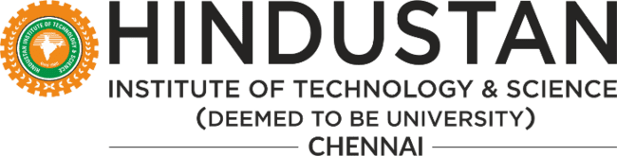

# Consolidated Extra Curricular Activities Report 2022-23

|  |  |  |
| --- | --- | --- |
| SL.NO. | DESCRIPTION | PAGE NO. |
| 1 | **ABOUT CULTURAL CLUB** | 2 |
| 2 | **EVENTS CONDUCTED FOR THE ACADEMIC YEAR (2022)** | 3 |

**CULTURAL CLUB**

**ABOUT**

## Cultural club of Hindustan Institute of Technology & Science organized various intra and inter college competitions for the active members of the clubs like Dance, Music, Theatre, Fashion, etc. The event not only provided a platform for the students to foster their creativity and decision-making skills but also helped them explore their hidden talents and discover new areas of interest.Students who are part of the club will be given a stage or a platform to perform in various intra events to showcase their talents. Later on the best talented students will be shortlisted and selected to perform in international, national , inter and intra institutions/colleges events also.

**AIM**

As the name suggests, one of the primary aims of the Cultural Club is to help students keep in touch with the rich cultural values, customs and traditions of our country. The Cultural Club aims at moulding the personality of students and exposes them to a wide range of cultural events throughout the year. Apart from participating in a multitude of events, the students also get a first-hand experience of organizing and managing the events, and of course, it caters to the creative needs of the students. Along with giving a platform to creativity, the Club aims at developing the intellectual, organizational and social skills of the students. Various skills like leadership, working in a team, sharing success and failure, accepting responsibility are implicit in the working of the club.

#### Winners of Literosody Fest | Event Date: Thursday, 6th, January 2022

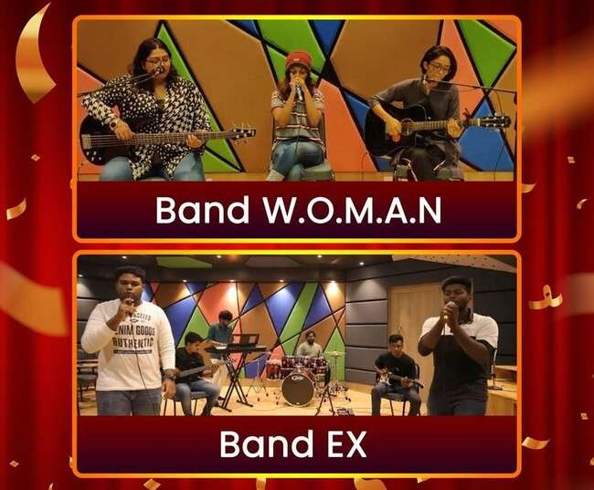

HITS Music Club participated in "Literosody Fest 2022", a virtual Music band competition organized by DG Vaishnav College, Chennai on 6 January 2022. Band W.O.M.A.N. won FIRST place by performingamashupof“Girl on Fire” by Alicia Keys ft. Nicki Minajand“Fight Song” by Rachel Platten. Band Ex won SECOND place by performing “Vengamavan” from the movie Natpe Thunai. The competition was judged by singer Apoorva Ramaseshan.

Band W.O.M.A.N.

1. Meenakshi R., III Year B. Tech. ECE.
2. Varsha Nair, II Year B.A. English
3. Nila Ellya Lama, I Year B.A. English. Band Ex
4. Srikeath, II Year B. Tech. Aerospace.
5. Shakthivel Balamurugan, II Year B. Tech. Aerospace.
6. Simeon Rohith Adams, II Year B. Tech. IT.
7. Prathik Alex Matthai, II Year B. Tech. IT.
8. Sailesh S., I Year BBA Aviation.
9. Santhosh Britto Kennedy, I Year MBA.

#### STORYGRAM | Event Date: Thursday, 20th, January 2022

The valedictory programme of 'STORYGRAM' event was organised by Athena-The Literary Club of the Department of Languages on 20 January 2022 via MS Teams. The event was intended mostly for people who wished to demonstrate the strength of their imagination by sharing stories. On 11 January 2022, members of the literary club unveiled the official poster for the event. Participants had until 17 January 2022, to register and submit their entries. Many students enthusiastically participated in the event by exhibiting their skills in giving the beststories.

Ms. Nusaibah Anas, First Year, B.A. English hosted the event congruously. Ms. Varsha Nair, Second Year, B.A. English, and Presidentofthe Athena Literary Clubopened the ceremony with an invocation hymn. Dr. Akkara Sherine, Head, Languages and Rankings, welcomed the Chief Guest Dr. P. Duvaraganathan, Principal, Vivekananda Vidyalaya CBSE School, Ramanathapuram. In her address, she emphasised the importance of developing storytelling skills which is always the way one expresses his or her story that matters the most. She also highlighted how one should only tell his/her story rather than selling himself/herself for thesame.

In his keynote address, Dr. P. Duvaraganathan reminded the audience that they are the authors of their own stories, and that it is not just innovation that matters, but also how we communicate our ideas to others. He also advocated daydreaming, as it is a creative medium; and emphasised the need to read stories to improve vocabulary. The winners were declared by Dr. Sonu Joseph, Assistant Professor, Department of Languages and the Faculty Coordinator of Athena Literary Club.

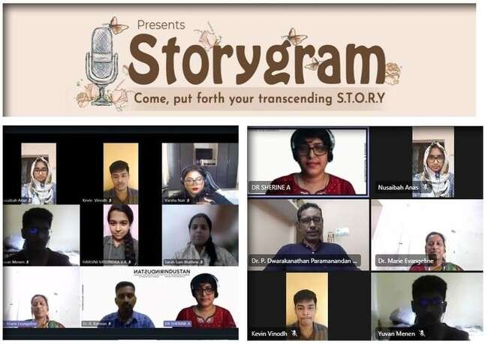

#### PONGAL'22 | Event Date: Thursday, 13th, January 2022

The Hindustan Institute of Technology and Science (HITS) welcomed the bountiful year with a profound thanksgiving to Mother Nature through the festival of harvests, Pongal ‘22. The Office of Student Affairs organised the Pongal '22 festivities colourfully in the Open-Air Theatre on 13 January 2022, with eye-catching, creative kolams, festoons, coconut leaf-stalk hut, fresh flowers, festivity, fun activities, and devotion. HITS hosted a memorable harvest festival with students and faculties from all nations and cultures. Since, almost half of India celebrates the harvest festival on the same day, it takes on greater significance for HITS which has students from almostevery part of India as well as from othercountries.

The festive ceremonyincluded Directors, Mr. Ashok Vergheseand Dr. Aby Sam; Vice Chancellor, Dr. S. N. Sridhara; Pro Vice Chancellor, Dr. R.W. Alexander Jesudasan; Registrar, Dr. Pon. Ramalingam; Deans, HODs, and our Student Chaplain. Faculty and students enthusiastically engaged in the numerous events conducted. Regardless of age, everyone was looking forward to the Pongal games. The celebrations were coloured with a feeling of camaraderie and brotherhood amongst each other, owing to the youthful colours of everyone. Tug of War, Uri Adi, Music Chair, and other fun games were organised to bring out the child in everyone, young and old.

The day was made even more remarkable by a hot, steaming, delicious Pongal prepared in mud pots and served in eco-friendly Thoongai with spoons.“Events like Pongal integrates students and builds a peaceful global order,” stated Dr.

* 1. Prabaharan, Head of Student Affairs. Bullock cart and tractor ride were also arranged throughout the campus for faculty andstaff members to enjoy the Pongal customs in thegreatestwaypossible at HITS, capping offthewonderful day filled with happiness. Ms. Lidya Zewdu, an Ethiopian student, proposed the vote of thanks emphasising the importance of customs and cultures in the best of ways.

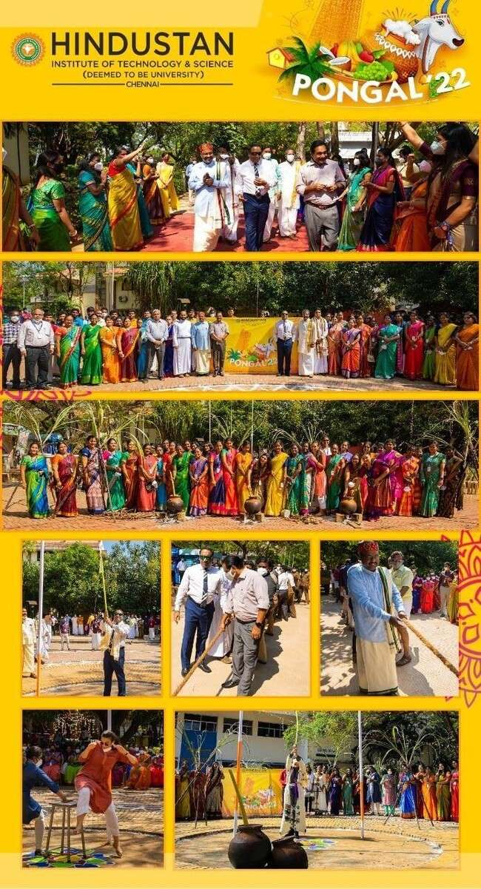

#### KAVIARANGAM | Event Date: Saturday, 8th, January 2022

The Office of Student Affairs organised “Kaviarangam”, a poetry session to celebrate the harvest festivals of the season on 8 January 2022 Mrudhulani P., Secretary, Hindustan Student's Council welcomed the participants and audience of the Kaviarangam. Head - Student Affairs delivered the Presidential Address. He said, "Poetry is an inseparable part of Tamil culture. For ages, the world was in awe with the poetry that grew from Tamil and Tamilliterature. From Tholkappiarto Thiruvalluvarand Bhartiyar, poetry is avitalaspectof the culture.” Head - Student Affairs beseeched the students to continue this rich tradition and rare gift of the Tamils.

Poets enthusiastically read out their poems eulogizing farmers, farming, sun, cattle, culture and traditions. Gowtham P.S., I Year B.A., Political Science; Sharumathi, I Year B.A PPE, Harshini Vasundra, I Year B.A., Political Science; Sam Praveen, III Year, B.Tech., Cyber Security; Vivian Richards, II Year B.Tech., Aeronautical Engineering; Esaya, I Year B.Des. Voiced their poetries bringing out its elements in a coherent way. Priyadarshini S.K, Cultural Secretary, Hindustan Student's Council proposed the vote of thanks.

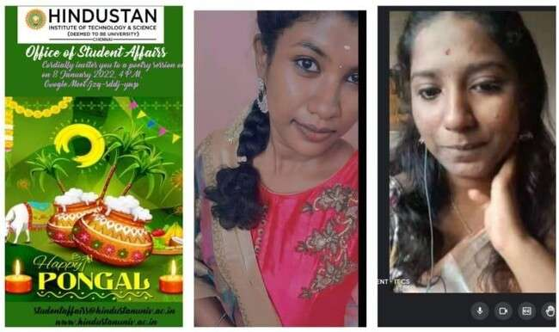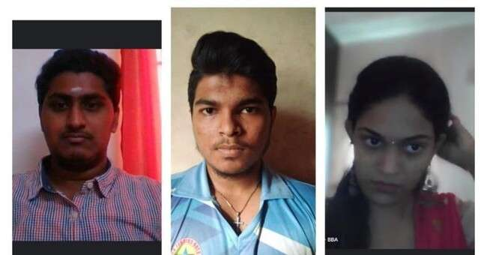

#### Folklore 2022 - Symphony of the World! | Event Date: Monday, 21st, February 2022

International Mother Language Day is observed every year to promote linguistic and cultural diversity, and multilingualism. As a part of this year’s International Mother Language Daycelebration, the Music Clubstudentsof HITS participatedin“Folklore 2022 - Symphony of the World” Season 2 organised by American International University, Bangladesh (AIUB). The event was conducted on a virtual platform (Zoom) on 21 February 2022. Over 100 incredible students’ performances from 19 esteemed institutions across 9 different countriesexhibitedagranddisplayoftraditionandtalentthroughsongs, dances, recitals, and folklores. Students who had performed virtually felt a testament to the idea that diversity doesn't divide, but only unites. A total of 14 students represented Hindustan Institute of Technology and Science in the Folklore 2022. The Vice Chancellor of AIUB, Dr. Carmen Z. Lamagna, and the Organizing Committee thanked HITS for being a part of "Folklore 2021 - Symphony of the World".

###### Musical Performances:

**Performance 1** – “Chaudhary – Amit Trivedi Feat Mame Khan, Rajasthani Folk” depicts the

return of a man to his hometown and the nostalgic connections he makes. **Performance 2** – “Balam Pichkari - Yeh Jawaani Hai”, a popular song sung during Holi festival celebrating the festival colours of colours and friendship.

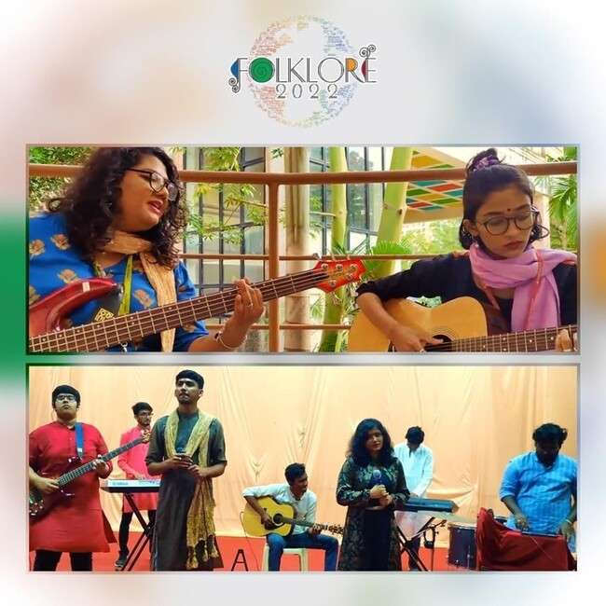

#### HOLI | Event Date: Friday, 18th, March 2022

The Office of Student Affairs organised Holi'22 grandlyatthe Open Air Theatre on 18 March 2022. Head - Student Affairs, welcomed the gathering. Students performed different dances, belted out Holi numbers, and showcased the Holi costumes on stage. Dr. K.Mohammed Ibrahim Khaleel, Regional Director, Indian Council for Cultural Relations (ICCR), Chennai delivered the Chief Guest address and expressed, “Holi symbolizes the unity, diversity, magnanimity & versatility of India. It removes enmity and brings joy in everyone. Different colours spread gives us happiness. Color and variety are synonymous with Indian culture, beliefs, and way of life.

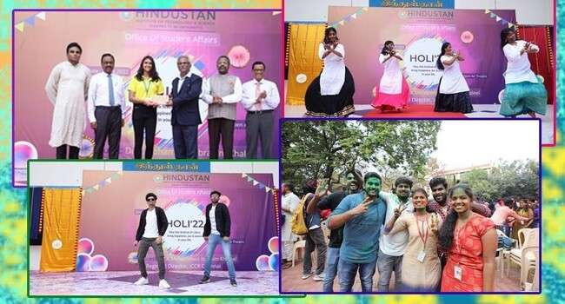

A country steeped in traditions, India charms and bedazzles all her visitors with a kaleidoscopic rendezvous.

Every street, every city, and every corner has a story to tell—all you have to do is listen. But it is tradition,culture,andcelebrationsthattrulybringthiscountrytogether.

One of the most symbolic in the country is called Holi festival of colors.

A festival that celebrates the victory of good over evil, Holi is a celebration of the arrival of spring and harvests to come.

It’s the Holi festival of colors, emotions, and happiness. And what better way to express yourself than with the vibrant colors of the rainbow? I wish you all a happy Holi!”

The Vice Chancellor, Dr. S. N. Sridhara gave away prizes to the winners of various events. The Pro Vice Chancellor, Dr. R. W. Alexander Jesudasanfelicitatedthewinners. The Head– SLAAS, Dr. David Easow expressed his greetings and congratulated the participants.

#### STAGING “THE DINNER DILEMMA” | Event Date: Tuesday, 29th, March 2022

“The Dinner Dilemma”, a mega musical drama was staged by Hindustan Masquerade Theater Club, a subsidiary of Athena - the Literary Club of the Department of Languages on 29 March 2022 at Andromeda Lecture Theater, Jubilee Block. Observed as a part of World Theatre Day celebrations, this musical extravaganza, “The Dinner Dilemma” was filled with a lot of twists, songs, and of course dance.

The event commenced with a word of prayer by Rev. Justin Jose, Student Chaplain, followed byaprayersong by Stuti Goyal, Second Year, B. Tech. Aerospace Engg. Dr. Akkara Sherine, Head, Languages and Rankings delivered the welcome address and introduced the Chief Guest, Mr. Michael Muthu, Indian Director, Actor and the Founder of Broadwalkers Theaters. Dr. S. N Sridhara, Vice Chancellor stressed on being expressive and exclaimed that an expressive person is always successful. He touched upon how theater becomes the escape route to come out of stress; and highlighted the Navras of Theatre-the 9 emotions that are displayed through drama; inclusive of facial and body expressions. Mr. Michael’s simple and humble address revealed how theater and acting had always been hispassion. Thestagewasthenallset for thecommencementoftheplaywhichran for about an hour. The actors were brimming withtheir fullest energy throughout the play. The elements ofsarcasm, wit and humor were at peak. The surprise pieces of music and dance definitely did spice up the performance. The encomium for the performance was given by Sarah Sam Mathew, Second Year, B. Sc. Food Technology and the Vice President of the Athena Literary Club. The event concluded with the Vote of Thanks by Dr. Sonu Joseph, Assistant Professor, Department of Languages and the Faculty Coordinator of Athena Literary Club. Jane Carolyn, Final Year, B. Tech. IT Cybersecurity and Sri Ratan, Second Year,

* 1. Tech. Aeronautical Engineering compered the event.

###### CAST & CREW:

1. **Brooklyn Diaz Ronald - Varsha Nair,** Second Year, B.A. English.
2. **Donald Ronald - Ragesh Shyam,** First Year, B.Tech. Aerospace Engg.
3. **Caren Wilson - Jumana Shekhi,** First Year, B.B.A. Aviation.
4. **Linda - Anjali Singh,** First Year, B. Tech. Aerospace Engg.
5. **Will Roberto - Rhythm Gupta,** Second Year B. Tech. Aerospace Engg.
6. **Louise Roberto - Oshin Alam,** First Year, B. Tech. Aerospace Engg.
7. **Julia Diaz - Nila Ellya Lama,** First Year, B.A. English.
8. **Max Powers - Ayush Bhardwaj,** Second Year, B. Tech. CSE.
9. **Han Yu - Hetal Nimje,** Second Year, B. Tech. Aerospace Engg.
10. **Mr. Yu - Dhairya Mehta,** Second Year. B. Sc. Visual Communication.

###### Dance Troop:

1. Yahvi Patira, First Year, B.A. Psychology
2. Scibi, First Year, B.Tech. Aerospace Engg.
3. Ann Mariya Jacob, First Year, B. Des. Fashion and Apparel Designing.
4. Sathiga J., First Year, B. Des. Fashion and Apparel Designing.
5. J. Cijo Stany, First Year, B.Tech. CSE.
6. R. Raja Kumar Paswan, First Year, B.Tech. CSE.

###### About “The Dinner Dilemma”

An anxious Brooke is expecting her boss home to ask for a promotion. But her toxic husband, Donny, refuses to do so because ofboth Brooke's failure in the past, and the boss' attitude. The play runs along a journey of managing the family to get a dinner ready by the time the boss arrives. Of course, until they all realise it would be their biggest mistake of their lives!

To Watch: <https://www.youtube.com/watch?v=I5-pnLH6QA8&t=4508s>

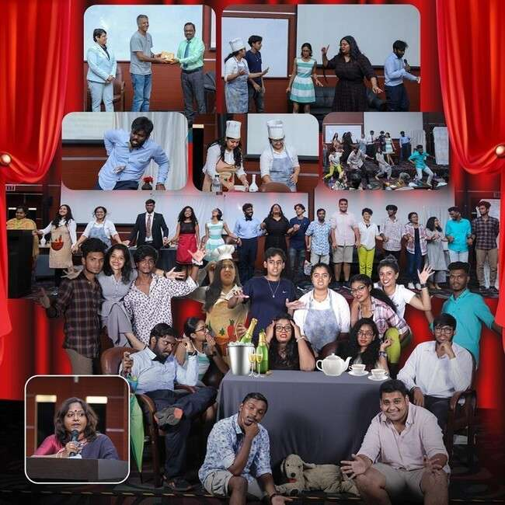

#### BAND POORVANG SWEEPS TO VICTORY | Event Date: Friday, 8th, April 2022

A state level cultural festival "PRAYAAS 2022" was conducted by the Department of Commerce and Research of DB Jain College Chennai on 8 April 2022. Band POORVANG representing Hindustan Institute of Technology and Science bagged prizes in the Solo Singing and Group Singing category. The band gave a stellar performance on stage with a classical mashup of “Singaravelane velane” and “Kannodu kanbadhellam” for the solo, and a trendy mashup of famed Tamil numbers “Vassegara”, “Maiya maiya”, “Kadhalaraondru” for the group and gained instantaneous popularity. Hindustan wishes the team the best in all endeavours!

RESULTS:

Solo Singing - SECONDPlace

Ms. Shreya, III Year, B.Tech. CSE.

GroupSinging– FIRST Place

|  |  |  |  |  |  |  |  |  |
| --- | --- | --- | --- | --- | --- | --- | --- | --- |
| Lead | Vocalist - | Ms. | Shratha, | III | Year, | B.Tech. | Aeronautical | Engg. |
| Lead | Vocalist - | Ms. | | Shreya, | III | Year, | B.Tech. | CSE. |
| Lead | Vocalist - | Ms. | | Sadhana, | III | Year, | B.Tech. | CSE. |
| Keys | - Mr. | Jerin | | Paul,III |  | Year, | B.Tech. | CSE. |

Keys - Mr. Alwin, III Year, BBA Aviation

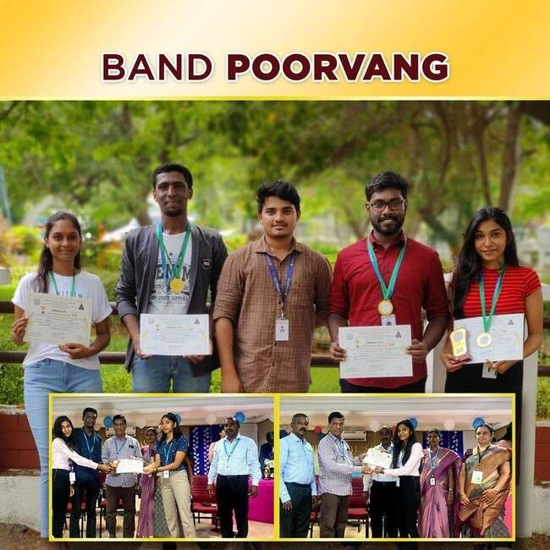

#### YARONA’22 | Event Date: Tuesday, 5th, April 2022 -Wednesday, 6th,

**April 2022**

“YARONA 2022”, an Inter-department Cultural Fest was hosted by Office of Student Affairs on 5& 6 April 2022. Packed with a whole bunch of entertaining and explorative events, YARONA has forever been the most magnificent event, happening every year, to promote healthy competition in orderto bring out the best in young sprouts of exceptional talents, wonderfully topped with departmental championship and exciting prizes for winners of individual competitions.This amazing platform is definitely a spirit-lifter for the vibrant youth to enhance their potential even amidst the global pandemic conditions. The pre- registration process, both manually and online, started three weeks prior to the fest by Student Council Members.The Organizing Committee comprised of Head-Student Affairs;Mrs. Beena James, Asst. Head- Student Affairs; Mr. B. Royson, Officer Student Affairs & Cultural Coordinator; Mr. C Santhosh, Music Instructor; Ms. Priyadharshini, Cultural Sec., and Mr.J. Prabhu Dhanasekar, Cultural Advisor&Event Manager.

The inaugural function was brightened up by the very enthusiastic hosts, Ms. Srinidhi Suresh, IV Year, B.Tech. Aerospace Engg. and Mr. Rakesh, I Year, B.Tech. Aeronautical Engg. The felicitations for the ceremony was delivered by Dr. S. N. Sridhara, Vice Chancellor; Dr. Pon. Ramalingam, Registrar;and Head of Student Affairs, who filled the air with their enthusiastic and encouraging words about YARONA’22. The stage was then elated by an elegant Classical dance performance by Ms. Sathiga, I Year, B.Sc. Fashion Tech., Ms. Pooja

R. Balaji, I Year, B.Des., and Ms.Tarunika J., I Year,B. Tech. Biotechnology followed by a duet singing performance by Ms. Nila Ellaya Lama, I Year, BA English and Ms. Varsha Nair, II Year, BA English. These performances were just a trailer of the galaxy of talents yet to be showcased as they set the stage up on fire which kick started the event to the next level. The inaugural ceremony came to an end with an official Flag off for YARONA’22, followed by the National Anthem.

Subsequentto the formal programme, a host of 40+ cultural events such as Groove (Indian & Western group dance), Solo Singing, Fashion Ramp, Solo/Duet Dance, Master of Mic, Power Chords Western Music Group, Rap & Beat Boxing, Classical Dance Solo, Classical Instrumental Solo, Classical Vocal Solo, Adzap, Mime, Mimicry, Stand-Up Comedy, Face Painting, Junk Art, Puddle Jumper, Stack Attack, Eat the Cookies, Best Beard Watermelon Mania, Cinematic Events: Lights Camera Action; Groove on Beats; Diehard Fan; Cine Quiz, Woofer ON With Dance, Rain Dance, Treasure Hunt, Tug-of-War, Light Music Group, DJ War, Group Dance, Gaming, Mono Acting, Theatre, Cooking Without Fire, Full of Hot Air, This Blows, Don’t Blow The Kings, etc., held concurrently at 7 different venues such as: OAT, MGR Auditorium, Parabola, Freedom Zone, Tennis Court, Parkour Training Centre and Main Ground. Around 150 student volunteers were actively involved in successfully organizing the YARONA’22 with 60+ faculties guiding them. The celebration sawa huge contingentof

cultural troupes numbering about 4500+ registrations with 720 teams for 49 events. The veteran experts in their respective fields and senior level Professors adjudged events and tremendously contributed towards the smooth run of YARONA’22.

DJ Night Featuring DJ Sam (Indian Music), and DJ Priyanka (International Music) on 5 April elevated the evening’s energy enabling the crowd put on their dancing shoes to a 3-hour non-stop DJmusic. Thelive Music Concertofthe NonViolinist Projectcomprisingthe Airtel Super Singer famed Anand Aravindakshan, Rakshita Suresh, Diwakar, SrinishaJayaseelan on the evening of 6 Aprilfilled the music on air with vibrant notes letting the crowd gently groove.

The valedictory function held at the Main Stage on 6 April 2022 evening commenced with the welcome address by Head-Student Affairs. Declaration of Winners were made followed by theprize distribution ceremony. Dr. S. N. Sridhara felicitated andconferred the Overall championship (rolling trophy) to the School of Aeronautical Sciences;and the Runner Up to the School of Liberal Arts and Applied Sciences. YARONA’22 winded up in an extremely enthusiastic note, making it both a memorable and a great learning experience for the entire crew. It was a delight for the hearts, minds and soul for all those who were present at the occasion, particularly the students.

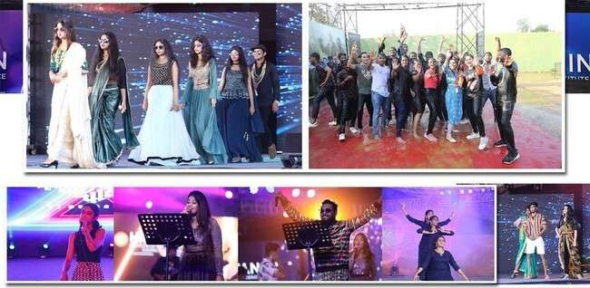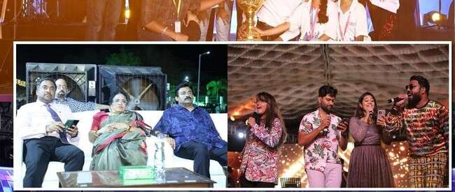

#### BAND-EX WINS HANDS DOWN | Event Date: Saturday, 2nd, April 2022

SAMGATHA'22, a nationwide cultural festival was conducted by IITDM College Chennai, on

2 April 2022. BAND-EX of Hindustan Institute of Technology and Science bagged THIRD placehands down in Light Music event with a dynamic performance of the mashup of famous Tamil number "Sorgam Madhuvilae". The all-boys Band-EX walked away with a good amount of Rs. 10,000 as cash prize.

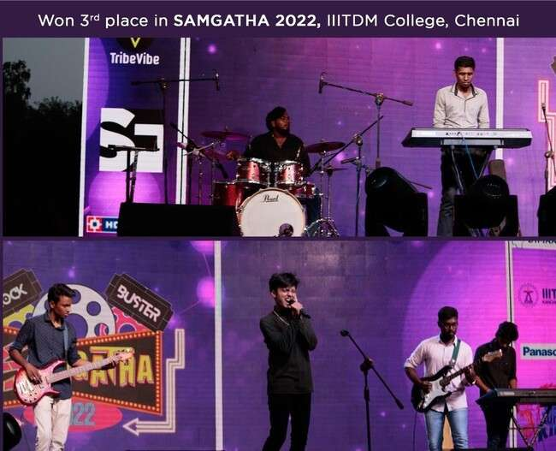

###### BAND-EX

* Lead Vocalist - Mr. Chandhan Paridha, II Year, BCA General.
* Keyboardist - Mr. Jerin Paul, III Year, CSE.
* Keyboardist - Mr. Simeon Rohith Adams, II Year, IT General.
* Electric Guitarist - Mr. Alwin,III Year, BBA Aviation.
* Guitarist - Mr. Shakthivael B. II Year, B.Tech. Aerospace Engg.
* Drummer - Mr. Sailesh, I Year, BBA Aviation.

#### UGADI CELEBRATION | Event Date: Saturday, 2nd, April 2022

Ugadi- the New Year Day for thepeopleof Andhra Pradesh, Telangana, and Karnataka states was celebrated with devotion on 2 April 2022. The Office of Student Affairs brought together faculty and students to celebrate the occasion filled with music and dance. Traditionally decorated arches welcomed the guests. Vice Chancellor, Dr. S. N. Sridhara was greeted by students in their traditional style. In his message, Dr. S. N. Sridhara said, "Ugadi is an occasion where people begin their new year with hope and confidence. Their livesareexpected to change for thebetter from thisday”. He addedthat for faculty and students, this is also a time to understand the cultures of the Ugadi celebrating states. Head-Student Affairs in his message said, "Ugadi is not just a celebration of the beginning of a new year; but energises young and old for better days ahead". Luhitha, Coordinator of Ugadi'22 proposed the vote of thanks. With a scrumptious Ugadi meal served, the celebration brought in exchange of greetings, comradeship, and joy.

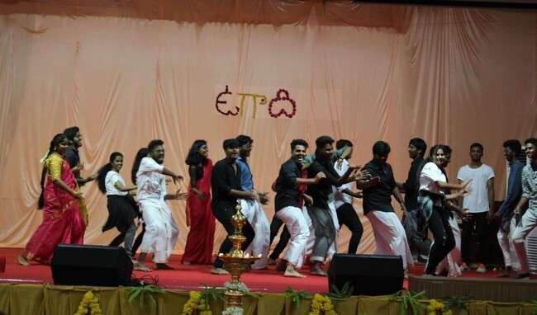

#### UNIVERSITY DAY'22 | Event Date: Friday, 29th, April 2022

The University Day of Hindustan Institute of Technology and Science celebrating the key achievements of the academic year 2021-22 was observed on 29 April 2022. Dr. G.A. Ramadass, Director, National Institute of Ocean Technology, Government of India, was the Chief Guest. The Pro Vice Chancellor, Dr. R. W. Alexander Jesudasan welcomed the gathering. The Vice Chancellor, Dr. S. N. Sridhara presented the Annual Report briefing various achievements of HITS including, Launchingof M.Tech. Defence Technology, CODE (Centre for Open & Digital Education), KCG Verghese Sat, Collaboration with Royal Enfield Training Centre and King Sejong Institute, Scholarships for students, Funding for ATAL Tunnel Visit, Sports, NSS, NCC, Culturals etc.As many as 372 studentsand 68 staff members were honoured by the Chief Guest for the remarkable achievements in academics, research, co-curricular,extracurricular, and administration activities.

Dr. G. A. Ramadass in his University Day address remarked,“Opportunities for today's youth are as openandwide as the ocean. Studentscan choose from a wide variety ofoptions and move ahead in life. The only requirement is vibrancy among the youth community.**”Campus Talk,** HITS' Newsletter, providing a quick, comprehensive look at Hindustan's recent achievements, key events, culturals, sports, and celebrationswas released by Dr. G. A. Ramadass during the event. The Director-Projects, Dr. N. Manoharan; the Registrar, Dr. Pon. Ramalingam felicitated. The Head-Student Affairs, Dr.A. Prabaharan proposedthevoteofthankswhichwas followedbystudents’ culturalperformances.

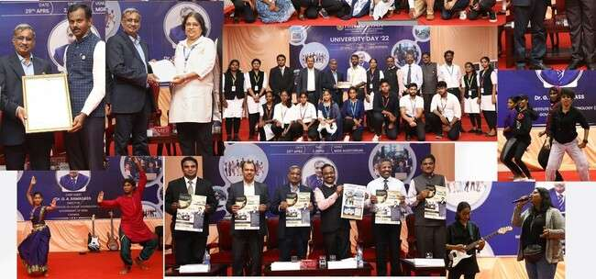

#### IFTAR'22 | Event Date: Wednesday, 27th, April 2022

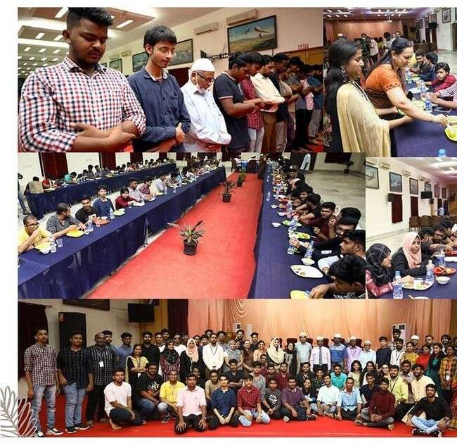

Ramadan is the holy month in which the sacred Quran was revealed to Prophet Mohammed. During this month, Muslims all over the world fast and pray.The Office of Student Affairs organised an Iftar (fast breaking ceremony) on 27 April 2022 at the MGR Auditorium. This created religious harmony and better understanding among the HITS community. The Vice Chancellor, Dr. S. N. Sridhara;the Registrar, Dr. Pon. Ramalingam;the Head-Student Affairs, the Student Chaplain, Rev. Justin Jose; the IQAC Coordinator, Dr. T. Sudalai Muthu;the Deputy Registrar, Mr. A. Ghouse Pasha, the HoDs, faculty members, staff and over 200 students participated inthe Iftar and exchanged greetings.

#### YOUTH TALKS WITH Ms. KANIMOZHI KARUNANIDHI, MP. | Event Date:

**Monday, 25th, April 2022**

Imagination, ideals and energy of young people are vital for the continuing development of the societies in which they live. Provided with the knowledge and opportunities, youth can be a driving force for a nation’s development. Keeping this in view, HITS has taken an initiative**—“Youth Talks”**, an encouraging platform for youngsters to address on pressing and trending topics.

Under “Youth Talks”, the Member of Parliament and Poet, Ms. Kanimozhi Karunanidhi engrossed a-500 strong audience for over two hours on several pressing socio-political issuesatAndromedaLecture Theatreon25April2022.Ms.Kanimozhiopinedthattheyouth are nerve centre of the society; and unless and until they come forward and take charge, nothing will move ahead. She patiently listened and firmly answered to more than two dozenofquestionssome ofwhichinclude: 1. Why Tamil Nadu alone opposes NEET whenall other states including progressive Kerala supports? 2. Why Tamil Nadu gives free sops? 3. Will DMK align with BJP in 2024? 4. How are you going to fight the attack on federal rights?

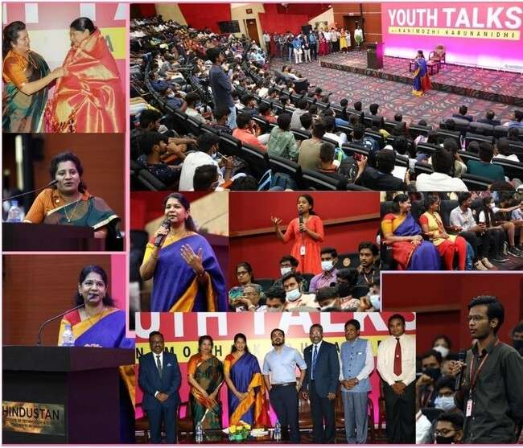5. Why youth is given a very low representation in politics & parliament? etc. Earlier that day, the Pro Vice Chancellor Dr. R.W. Alexander Jesudasan welcomed the gathering, the Vice Chancellor, Dr. S. N. Sridhara, and the Director of Hindustan College of Arts & Science, Dr. Susan Marthandan felicitated. The Deputy Director Mr. Enid Verghese Jacob; the Registrar, Dr. Pon Ramalingam; Deans, HoDs and Faculty members attended the session along with students. The Head-Student Affairs, proposed the vote of thanks.

#### BEATITUDO'22 | Event Date: Friday, 6th, May 2022

More than 600 residents of Jupiter, Galaxy, Bethany and Susan hostels of HITS celebrated their year-long happiness at Beatitudo'22 (Hostel Day) on 6 May 2022. This year's hostel day was special for many reasons. After two years of Covid'19, the hostel day celebrations had restarted.

Ms. Gauri, Senior Scientist of Indira Gandhi Atomic Research Centre (IGCAR), Kalpakkam and an alumunaof ECEdepartmentof HITS (Batch 1993) was the chiefguest. Chief Warden & Head - Student Affairs Dr. A. Prabaharan welcomed the gathering. Director (Research), Dr. K. Nandakumar offered felicitations. Warden Dr.Geethadevi C.E.; Assistant Warden Dr.RhytheemaDuloo; Hostel Manager, Mr. Anantharaman, staff andresidentsparticipated in the celebrations.

In her hostel day address, Ms. Gauri said, "I see a lot of positive changes in the HITS. Residents should utilize this wonderful infrastructure and go up in life. Research is the lifeline of world development. Students should use the library, lab and other facilities to develop their personalities".

The Chief Guest laterpresentedprizes and certificates tothewinnersofseveralsportsand cultural events organised on the occasion of Beatitudo'22. A colourful cultural presentation was the highlight of the event.

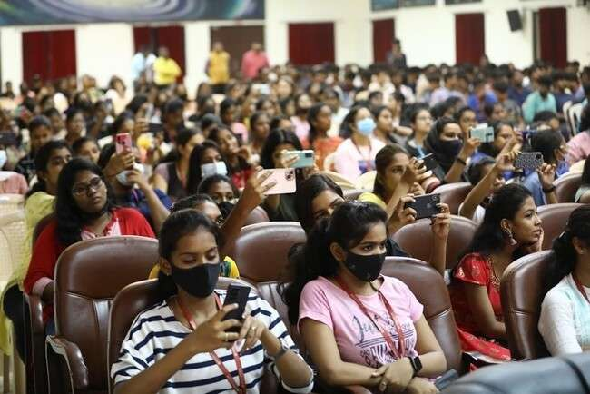Mr. Calvin Edgar, a resident of Jupiter hostel proposed a vote of thanks.Ms. Prathyuksha Nair, a resident of Bethany hostel compeered the event.

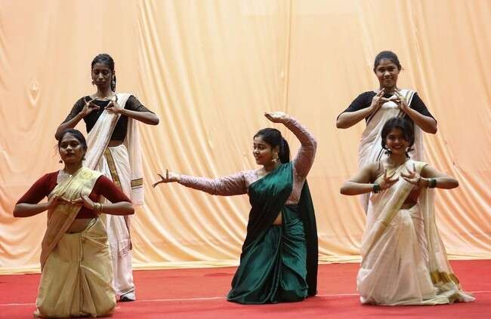

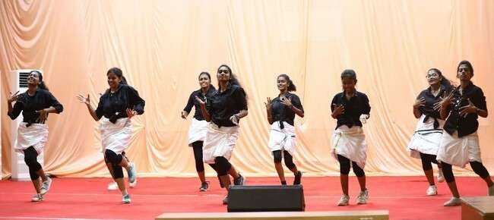

#### ETHOZ 2022 CULTURAL FESTIVAL | Event Date: Friday, 12th, August 2022

We create winners! The Hindustan Dance team participated and bagged the First Place under the Group Dance category at the Cultural Festival, ETHOZ 2022. The event was organized by Sri Ramachandra Medical College, Chennai on 12 August 2022. Out of 18 teams, the dance team from HITS were announced as winners for their complete and dynamic performance.

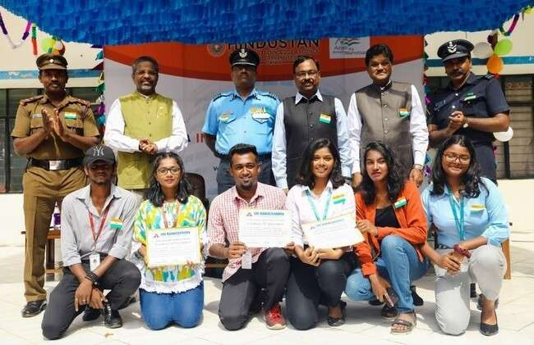The team was felicitated with certificates by Gp. Capt. M. Murugan, Commanding Officer, WTI, Air Force Station, Tambaram, during the 75th Independence Day Celebration at HITS on 15 August2022.

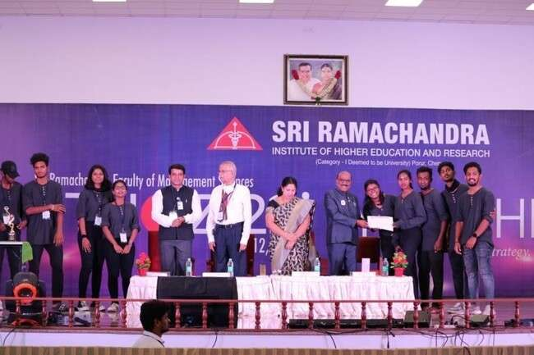

#### BAND-EX WINS HANDS DOWN | Event Date: Saturday, 28th, April 2022

Kalopsia '22, a nationwide cultural festival was conducted by SDNB Vaishnav College, on 28 April 2022. BAND-EX of Hindustan Institute of Technology and Science bagged Runner- up placehands down in Light Music event with a dynamic performance of the mashup of famous Tamil number "Sorgam Madhuvilae".

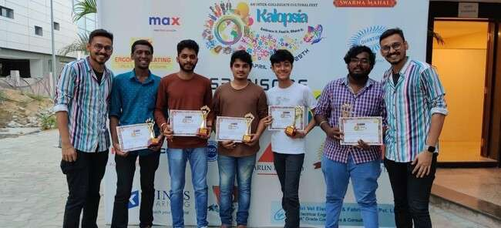

###### BAND-EX

* Lead Vocalist - Mr. Chandhan Paridha, II Year, BCA General.
* Keyboardist - Mr. Jerin Paul, III Year, CSE.
* Keyboardist - Mr. Simeon Rohith Adams, II Year, IT General.
* Drummer - Mr. Sailesh, I Year, BBA Aviation.

#### BAND-EX WINS HANDS DOWN | Event Date: Saturday, 26th, March 2022

SAMYOGA'22, anationwidecultural festival wasconductedby JGIJaincollege, Bangalore on 26 March 2022. BAND-EX of Hindustan Institute of Technology and Science bagged Runner-up place hands down in Light Music event.

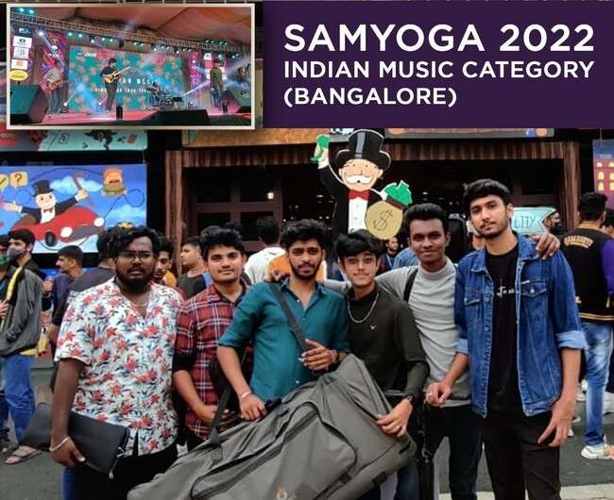

###### BAND-EX

* Lead Vocalist - Mr. Chandhan Paridha, II Year, BCA General.
* Lead Vocalist – Neeraj, III Year, Aerospace
* Keyboardist - Mr. Simeon Rohith Adams, II Year, IT General.
* Electric Guitarist - Mr. Alwin,III Year, BBA Aviation.
* Guitarist - Mr. Shakthivael B. II Year, B.Tech. Aerospace Engg.
* Drummer - Mr. Sailesh, I Year, BBA Aviation.

#### DITANS -VIT University ,Chennai. | Event Date: 22nd, April 2022

The dance team of HITS participated & won Runner-up at DITANS cultrural fest in the Group Dance event held at VIT , Chennai.

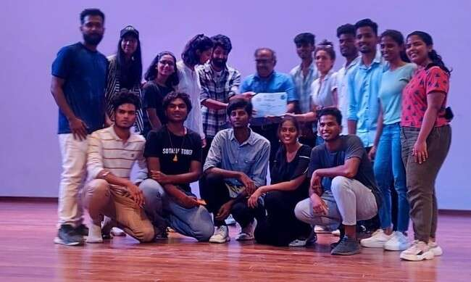

#### MITAFEST | Event Date: 30th, April 2022

The dance team of HITS participated & won Runner-up at MITAFEST Cultural Fest 2022", competition organized by MIT College ,Chennai.

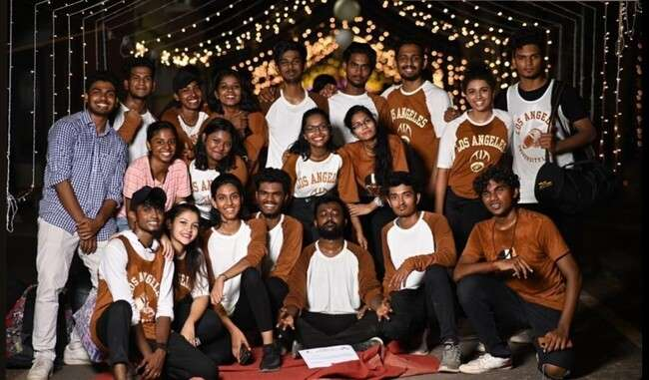

#### UTSAV | Event Date: 7th, May 2022

The dance team of HITS participated & won Runner-up " UTSAV Cultural Fest 2022", competition organized by MCC College ,Chennai.

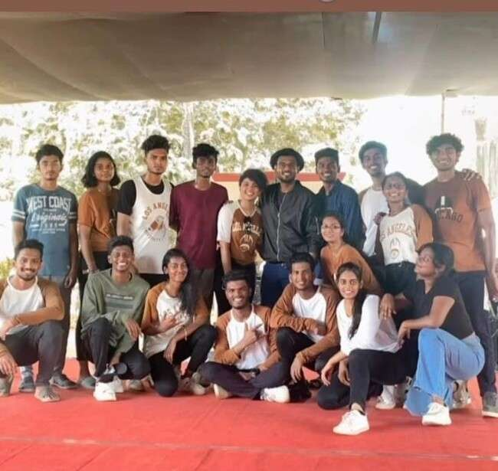

#### EVENING GIGS I 11 & 12 August 2022(Independence Day Special)

A vibrant and humongous Cultural performance towards **75th Independence Day** was organized and planned by Cultural club of HITS during **“EVENING GIGS”** held on 11th and 12th August 2022 at the Open-Air Theatre. The event was filled with a whole bunch of entertaining and explorative events, like

* + **Classical dance (Bharathanatiyam & Oddissi)**
  + **Group dance**
  + **Instrumental Music**
  + **Group & Solo Music**
  + **Thematic Fashion Show**
  + **Silambattam**
  + **Karate**
  + **Poetry**
  + **Speech**

Around 70+ cultural club students participated in the 2-day event which is definitely a spirit-lifter for the vibrant youth to enhance their potential and also marked their salute to the great leaders of India. As a tribute to **75th Independence Day** the students of HITS performed for 75minutes(2days) as a whole to mark their patriotism towards the Nation as well.

**Mrs. Beena James Asst. Head- Student Affairs, Mr. B. Royson, Officer Student Affairs & Cultural Coordinator, Mr. C Santhosh Music Instructor** were key individuals in organizing this 2-day programme.

## The **“EVENING GIGS”** winded up in a highly enthusiastic note, making it both a memorable and a great learning experience for the entire crew. It was a delight for the hearts, minds and soul for all those who were present at the occasion, particularly the Students & Staff members of HITS.

**Classical dance (Bharathanatiyam & Oddissi)**

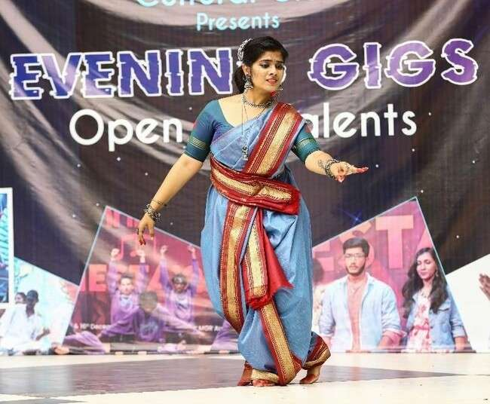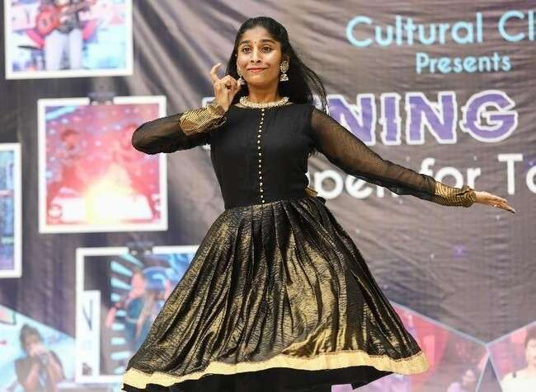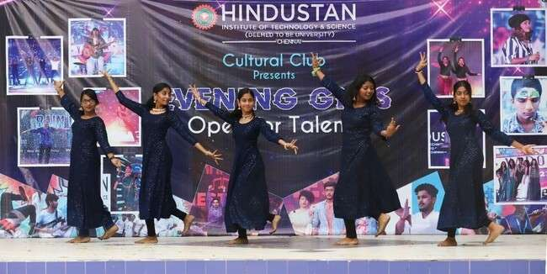

**Group dance**

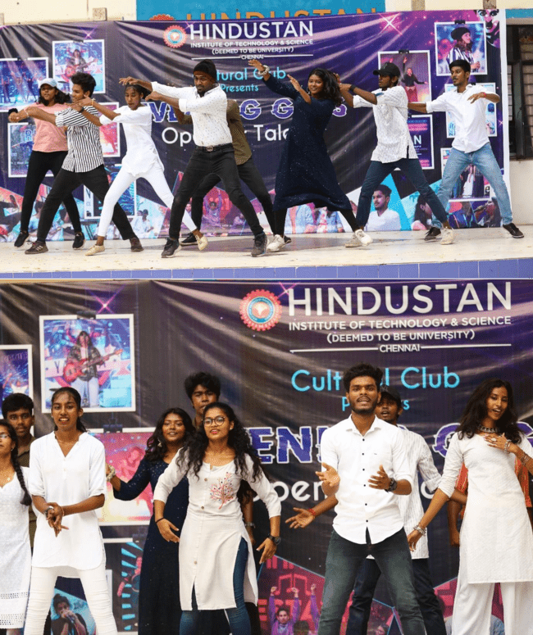

**Instrumental, Group & Solo Music**

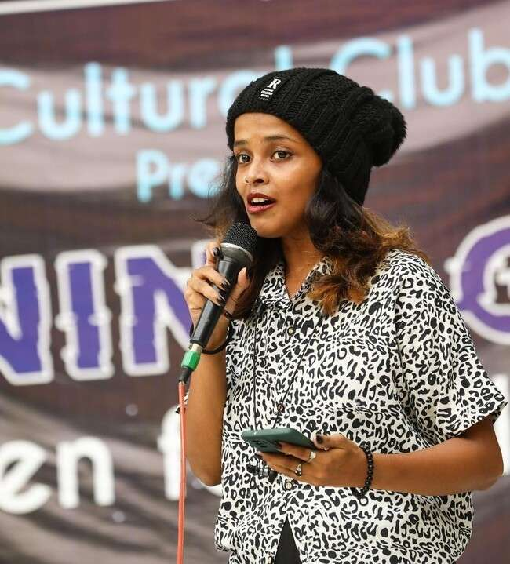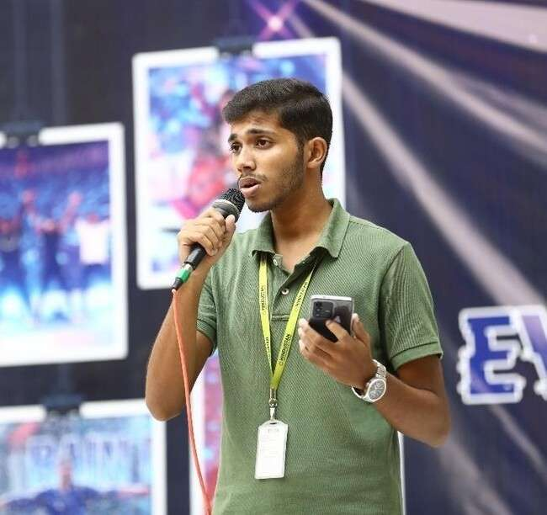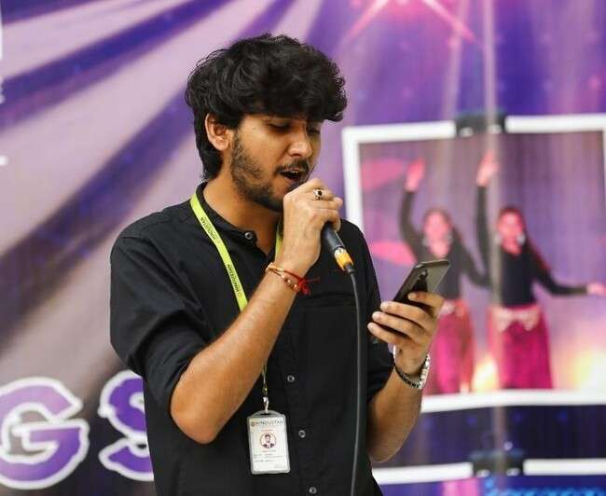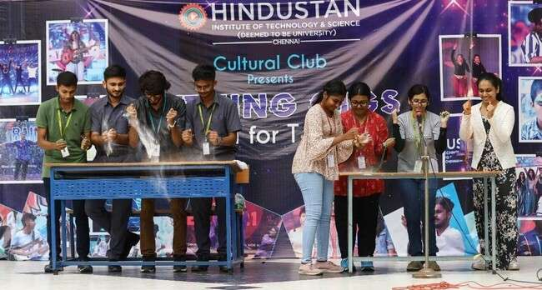

**Thematic Fashion Show**

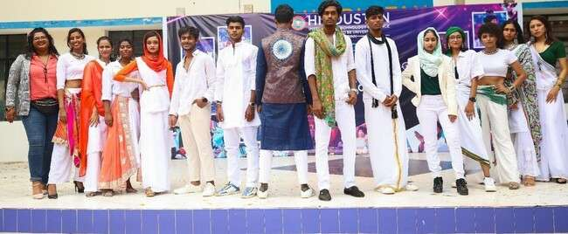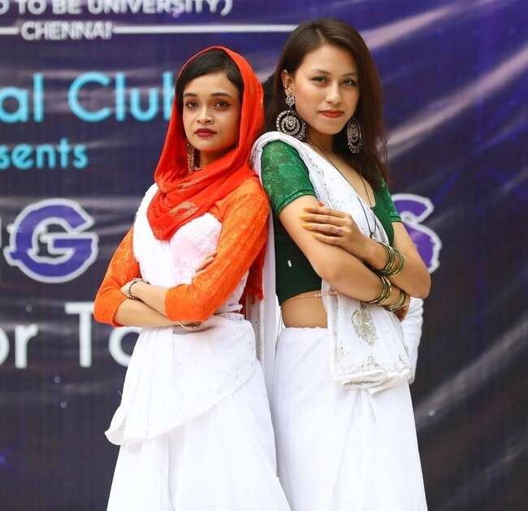

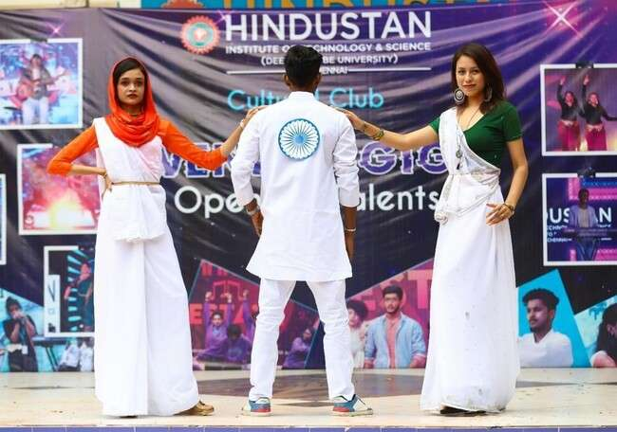

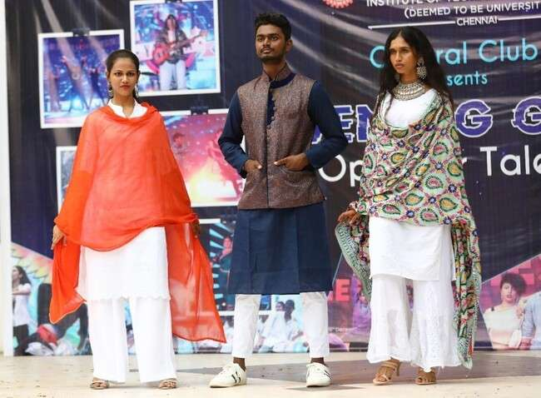

**Silambattam & Karate**

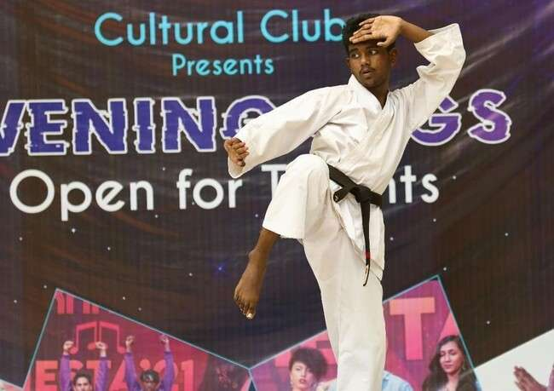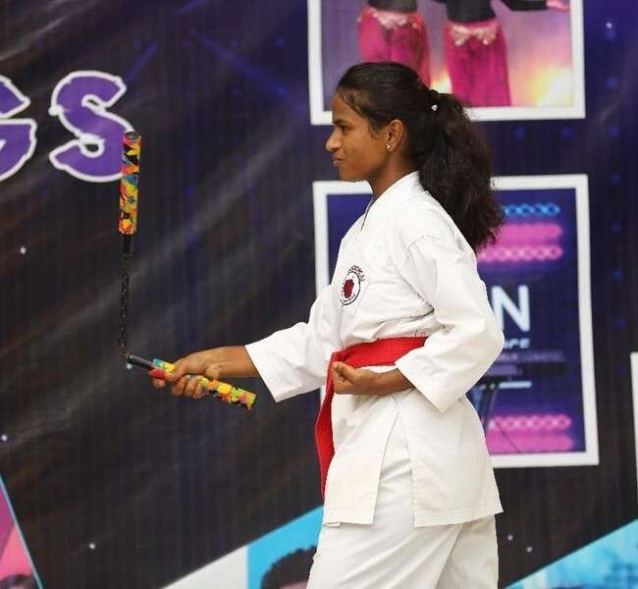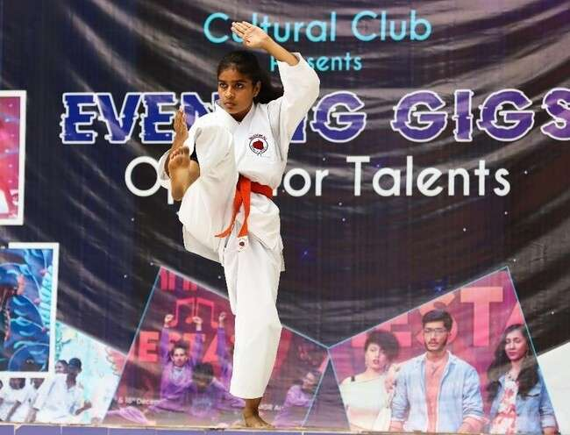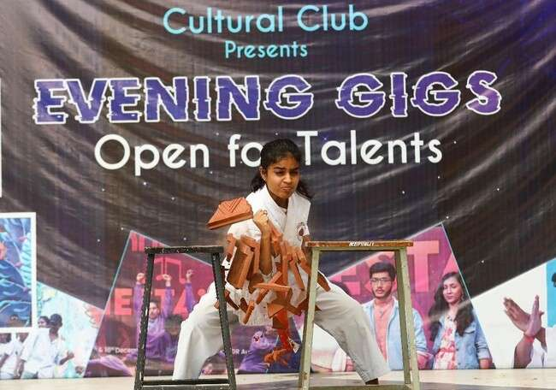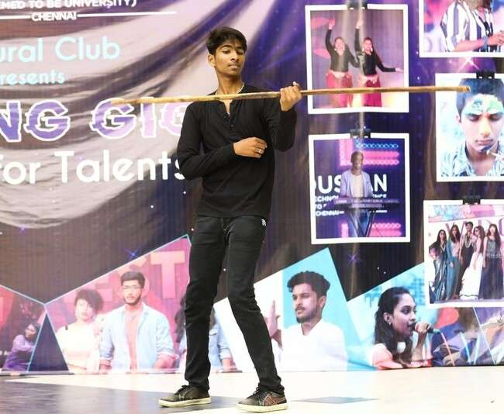

#### EVENING GIGS

Evening Gigs is a Open talent Show for the students of HITS, which will be held on every Friday’s. The dance, Music, Fashion,Literary & Fineart club students showcase their hidden talents in the evening Gala.

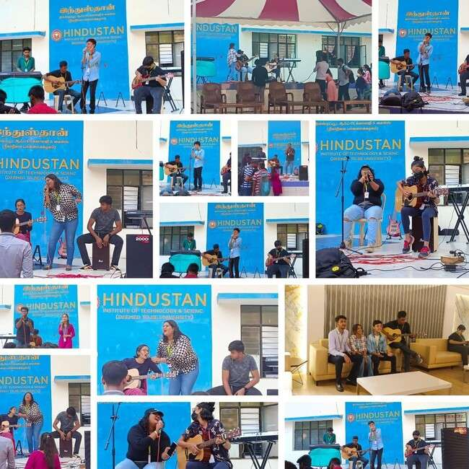

#### HINDUSTAN’S GOT TALENT 23rd S36eptember 2022(Chancellor’s Day Celebration)

A vibrant and humongous Talent festival named “HINDUSTAN’S GOT

TALENT” was organized by Office of Student Affairs & Cultural Club towards Chancellor’s Day Celebrations held on 23rd September 2022 at the Open-Air Theatre. The event was filled with a whole bunch of entertaining and explorative events, like

# Solo dance

* + - **Group dance**
    - **Solo singing**
    - **Instrumental Music**
    - **Group & Solo Music**
    - **Solo & Group Fashion Ramp Walk**
    - **Sketching/Painting**
    - **Poster Making**
    - **Poetry**

Based on 200+ registrations online entries prelims were conducted for the events like Dance, Music & Fashion Walk at Parabola from 9am to 1pm. Around 121 students attended the prelims. The top 15 students from all the categories were shortlisted based on their performance, standards and presentation. Totally 50+ students were geared up to perform for the finale which kick started from 3pm onwards. The dignitaries Dr. S.N. Sridhara-Vice-Chancellor, Dr. R. W. Alexander Jesudasan- Pro Vice-Chancellor, Dr. Pon. Ramalingam, Registrar & Mrs. Beena James Head- Student Affairs I/c were present for the program to witness the talents of students. The celebration saw a huge contingent of audience numbering about 600+. The Emcee Ms. Preethi from CSE department welcome the gathering and gave an introductory note about Chancellor and the event “HINDUSTAN’S GOT TALENT”.

Mr. B. Royson, Officer Student Affairs & Cultural Coordinator, Mr. C Santhosh Music Instructor were key individuals in organizing this programme.

The “HINDUSTAN’S GOT TALENT” winded up in a highly enthusiastic note, making it both a memorable and a great opportunity for the students of HITS to be a part of Chancellor’s Day Celebrations 2022. It was a delight for the hearts, minds and soul for all those who were present at the occasion, particularly the Students & Staff members of HITS.

##### 37

Glimpse of “HINDUSTAN’S GOT TALENT”

38

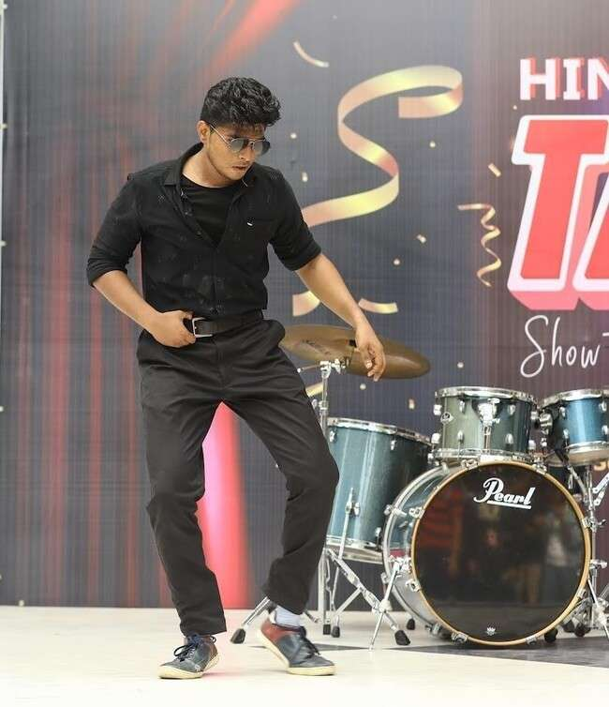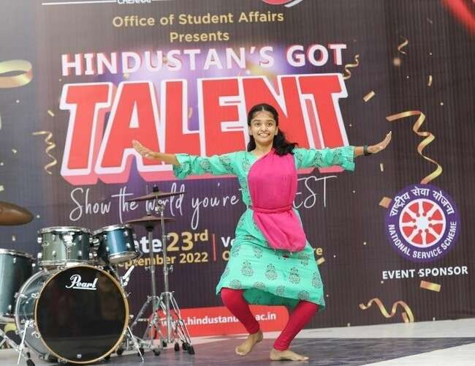

Solo & Group Dance

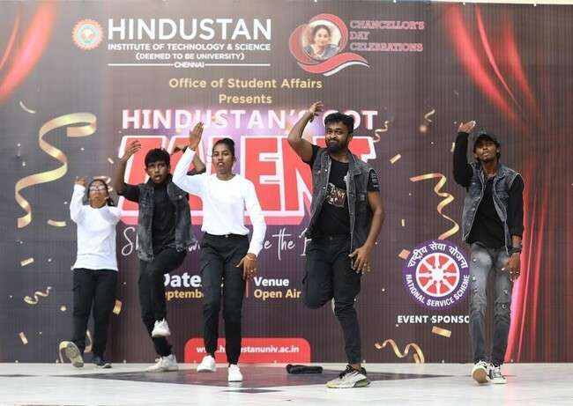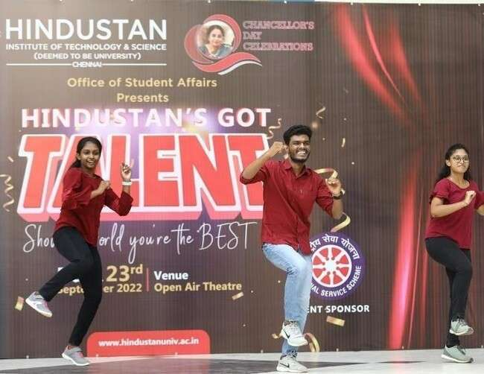

##### 39

Instrumental, Group & Solo Music

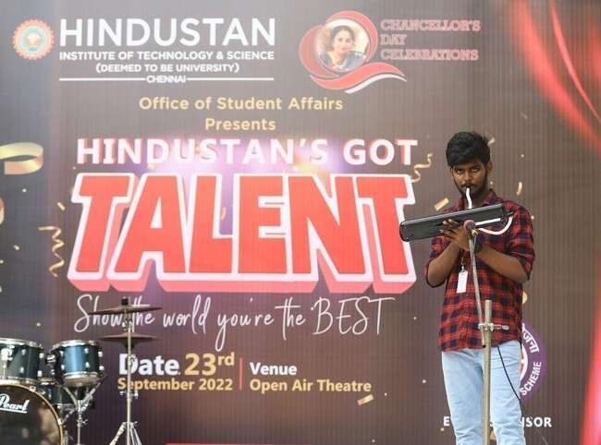

40

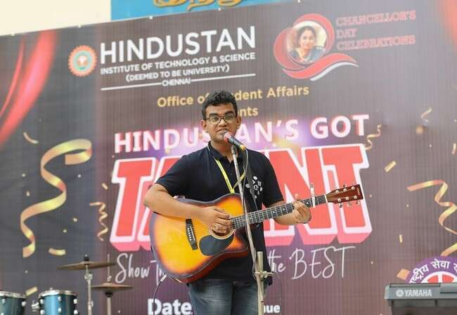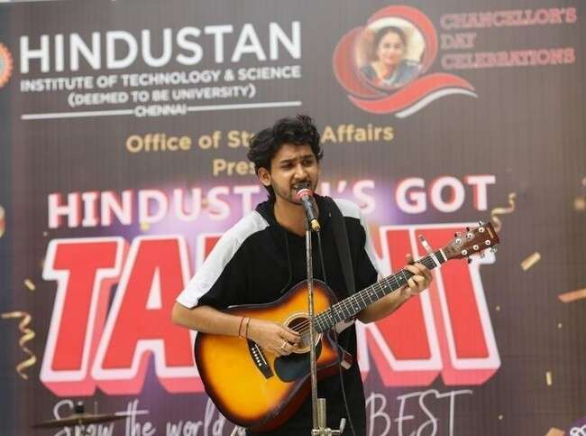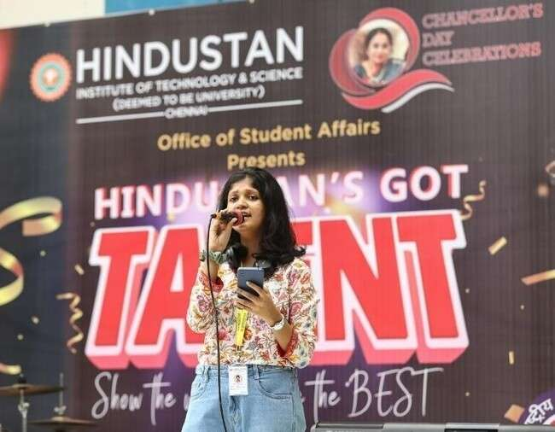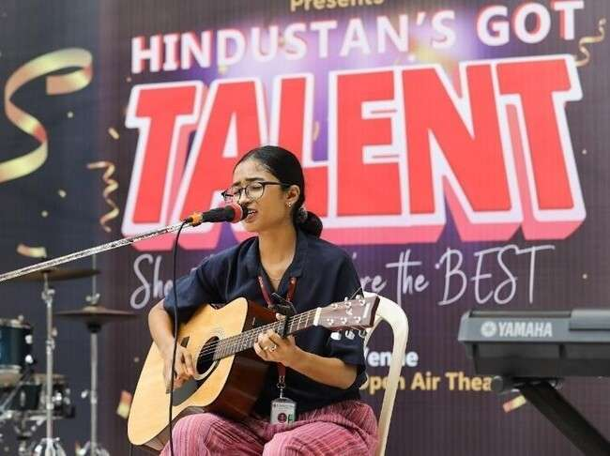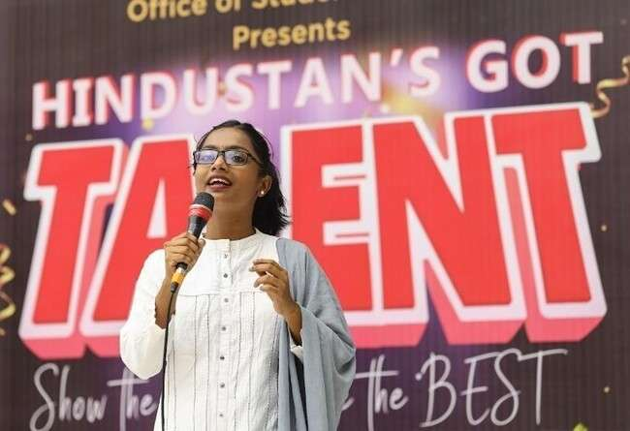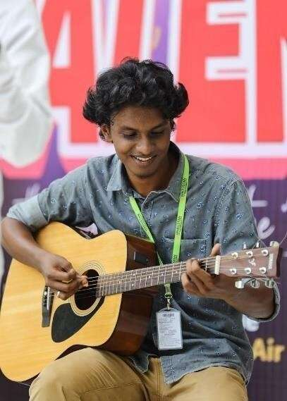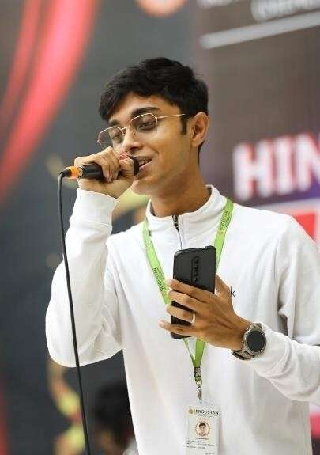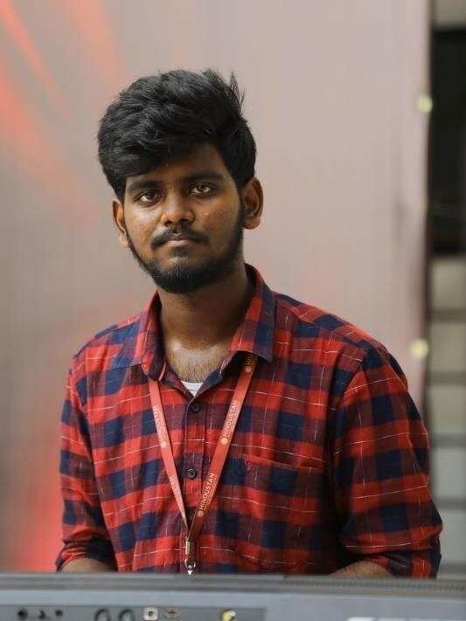

41

Fashion Show

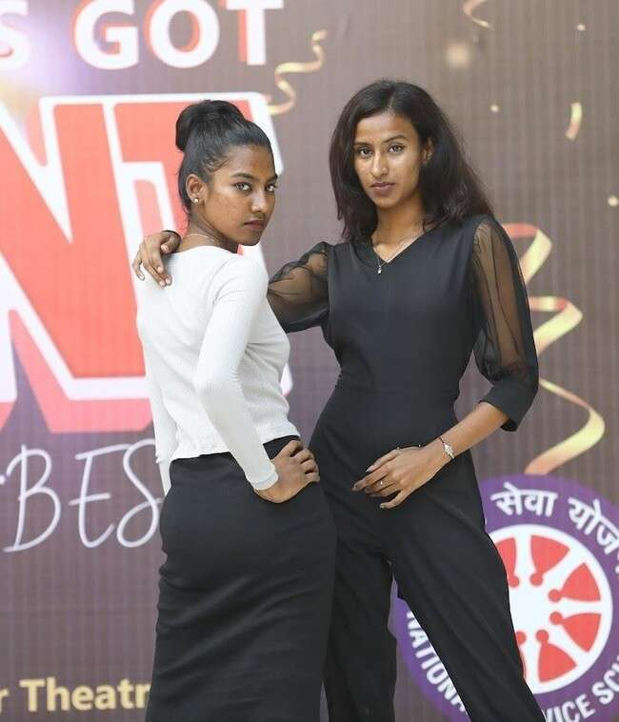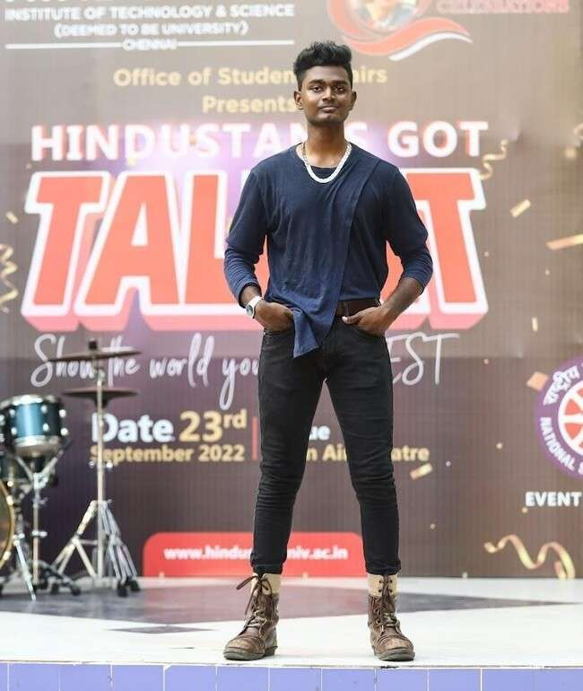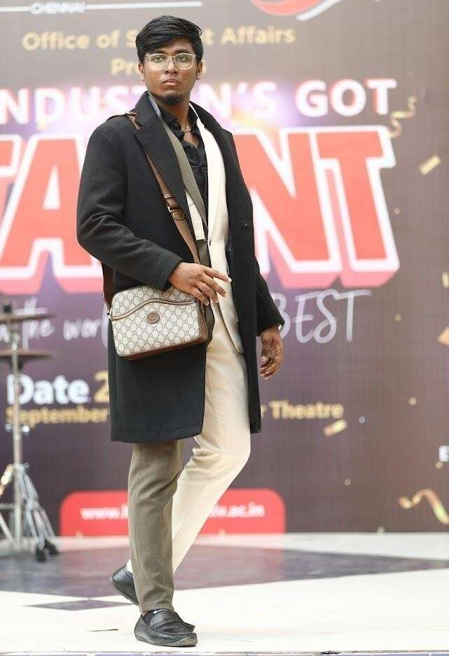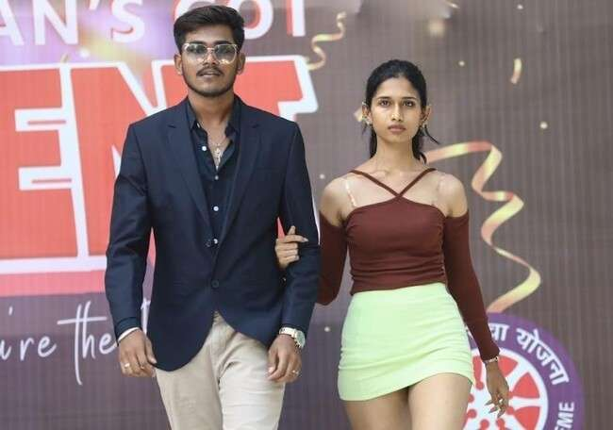

*POLLUTION FREE DIWALI CELEBRATION 2022 | Event Date: Friday, 21st,*

*October 2022*

The Office of Student Affairs, HITS celebrated Pollution Free Diwali 2022 on 21 October 2022 at OAT. Competitions such rangoli, Jewellery making and cooking without fire were conducted. The staff andstudents participated enthusiastically.The celebration commenced with the lighting of lamps and diyas by Dr. S. N. Sridhara, Vice Chancellor; Dr. R. W. Alexander JesudasanPro Vice Chancellor;Dr. Pon Ramalingam, Registrar; Gp. Captain. Shibu Babu, Head Admin;andMs. Beena James, Head of Student Affairs.The cultural team entertained the audience with music and dance. The celebration concluded with prize distribution to the winners competitions.

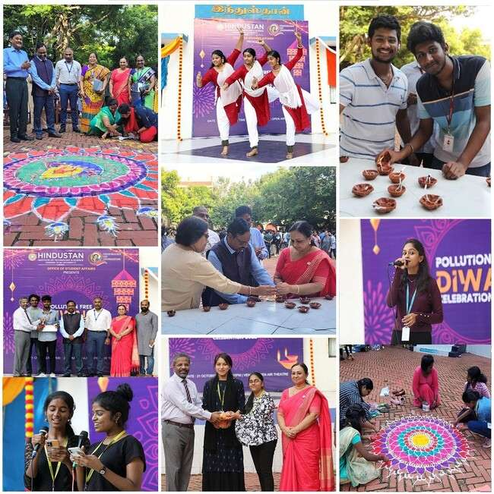

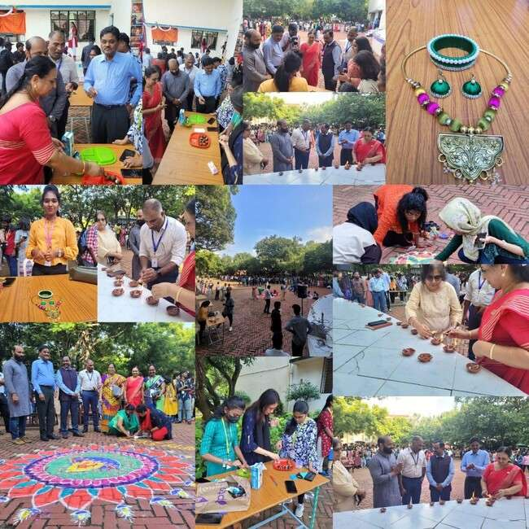

*GERMAN UNITY DAY CELEBRATION | Event Date: Monday, 10th, October 2022*

The German Unity Day celebration was held on October 10 2022 at Hyatt Regency Chennai. The highlight of the celebration was students of HITS performed an Indian Classical Dance and 2 German Dance wearing German Costume in the presence of Consul General Mrs. Michaela Küchler, Thiru Thangam Thennarasu, Industry Minister of Tamil Nadu, Mr. Palanivel Thiagarajan, Finance Minister of Tamil Nadu and dignitaries of diplomatic and industrial circles. The performance of the students of HITS was well appreciated by all. German Unity Day is celebrated to commemorate the nation’s reunification in the year 1990. Consul General Mrs. Michaela Küchler, pointed out that It is overwhelming to celebrate the German Unity Day in India. She also added that the Indian-German relationship has developed wonderfully over the years. One very important factor that makes the partnership strong is the connection between the Indians and Germans in all strata of life.

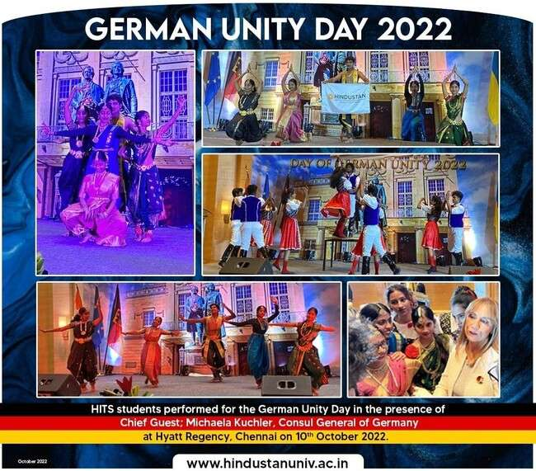

### CHAIRPERSON’S DAY THANKSGIVING CELEBRATIONS | Event Date: Monday,

*10th, October 2022*

The Chancellor's Day was celebrated on 10 October 2022 to commemorate the birthday of Madam Chairperson Dr. (Mrs). Elizabeth Verghese. The celebration started with the opening prayer by Rev. Justin Jose, Student Chaplain, HGI followed by an Opening Hymn by the HITS Choir.

Dr.Samuel Sampathkumar, Vice Principal HCAS proposed the vote of thanks and the **event concluded with a series of cultural events by HITS Music Band** and a High Tea.

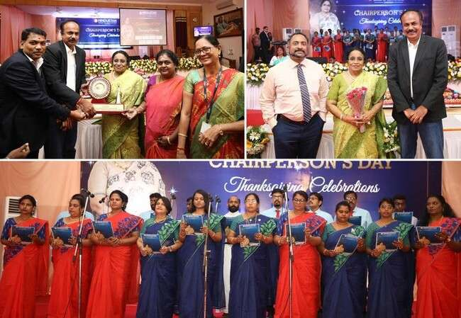

### LETTER OF INTENT | Event Date: Tuesday, 20th, September 2022

HITS hosted the Letter of Intent (LOI) between District Rural Development Agency, Government of Tamil Nadu and the City of Trier, Germany with the coordination and support from Trier University of Applied Sciences, Germany HITS. This collaboration looks forward to exchange best practices in sustainable development. The Letter of Intent was signed by Prof. Dr. Peter Koenig, Project Lead-DAAD & IURC Projects, Dr. Karl Hofmann Van-Kap-Herr, Co-Lead DAAD Project, Dr. Panagiotis Karamanos, Urban Development Expert IURC, Tmt. R.V. Shajeevana I.A.S, Sub-Collector, Chengalpattu District, Mr. Ashok Verghese, Director, HITS and Mrs. Elise Limbacher, Coordinator International Relations and Sustainability, Trier.

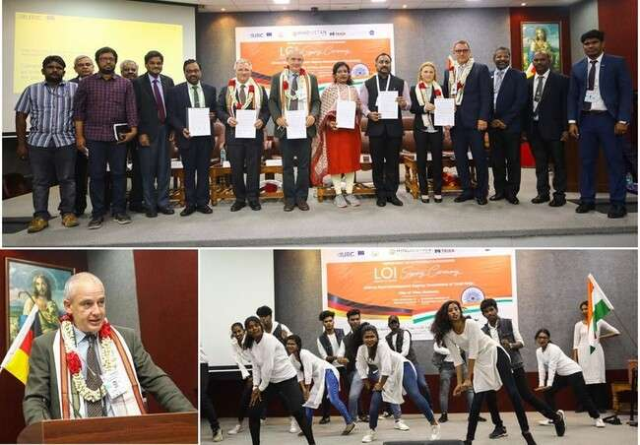

### ONAM CELEBRATION AT HITS | Event Date: Saturday, 17th, September 2022

The Ponnonam '22 was graced by presence of Dr. Elizabeth Verghese, Chancellor, HITS and Ms. Parvati Nair, Indian Actress as chief guests. With the lighting of ceremonial lamp and key address marked the message of joy and celebrations for the festivities.

The event was lit with various forms of decor ranging from Athapookalam competition to cultural programme garnering the participation of students and staffs alike. Stellar performances of Mohiniyattam, Thiruvathira, Melam, Group Singing, Fusion Dance, Singari Melam and many more created a wave of joy and vibrancy at HITS! The event concluded on a delicious note with traditional Onam Sadhya served with 21 different delicacies adding all the flavours to the celebration.

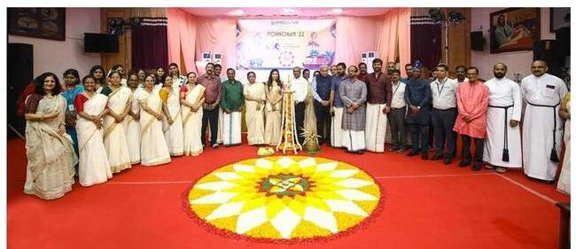

### TEACHER'S DAY CELEBRATION 2022 | Event Date: Monday, 5th, September 2022

The office of student affairs , HITS organized Teacher’s day celebration on 5th September 2022. The event started with prayer by Rev.Justin Jose, Student Chaplain, HITS.

Dr. R.W. Alexander Jesudasan, Pro Vice Chancellor delivered the welcome address where he gave an emphasison the role of a teacher in the society and the importance he/she has in framing the future of a nation. Dr. S N Sridhara, Vice chancellor delivered the Presidential address.

Dr.H Devaraj, Former Vice Chairman UGC addressed the gathering by sharing his experiences as a teacher and cherished few moments of his tenure at UGC. He pointed that the respect he got from The Central Education Minister was not because for his position at UGC but due to his profession as a Teacher.

The chief guest was honoured by the Vice chancellor with a memento and a portrait which was done by Dilshad Basheer K from SPADE. Chief Guest was overwhelmed by the portrait and he congratulated the student on stage.

Dr.Sonu Joseph, Asst prof of Dept of Languages announced the Awards for internal and external staffs and prizes were distributed by the Chief Guest. CODE also sponsored cash awards for the staffs.

Arshiya Fathima of 2nd yr mechatronics dept raised a toast for teachers- Head of Ogma Note, Wing of Athena Literary club. After the warm toast, the music team took over ,to make everyone move and groove. LekhaShree Suresh of 2nd year B.Des fashion and NilaEllyaLama of 2nd year BALiterature, gave an amazing performance by singing a duet followed by Calvin Edgar and team with their amazing band performance.

The grand celebration came to an end with the vote of thanksby Nithin Thomas, Vice President of students council . The celebration was hosted by PrathyukshaNair cultural secretary of the student council.After the vote of thanks the event ended with the national anthem.

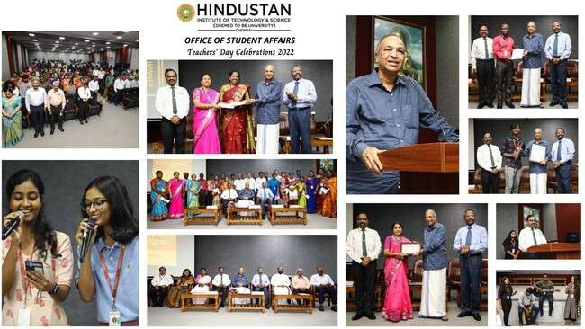

### CAMPUS LEAGUE 2022 | Event Date: Saturday, 27th, August 2022

Let’s tap out feet to the rhythm of music! The Hindustan Dance team bagged the runner up trophy at the Campus League 2022 Talent Hunt organized by the Viral Fashion Company. The event was held at Anna Nagar - ARJ Hall, Chennai on 27 August 2022.

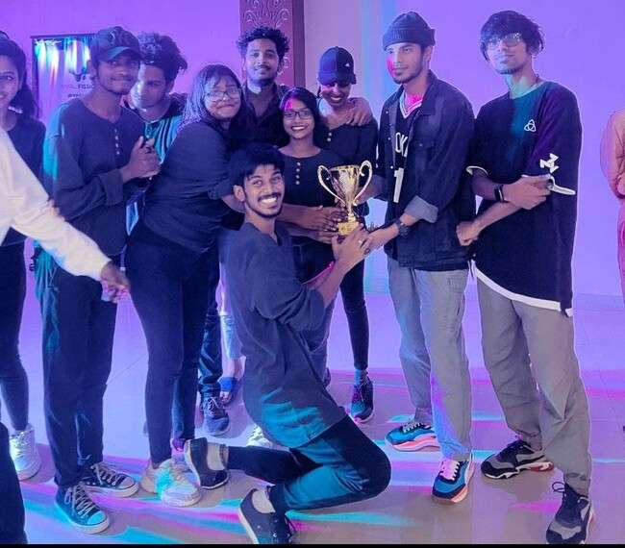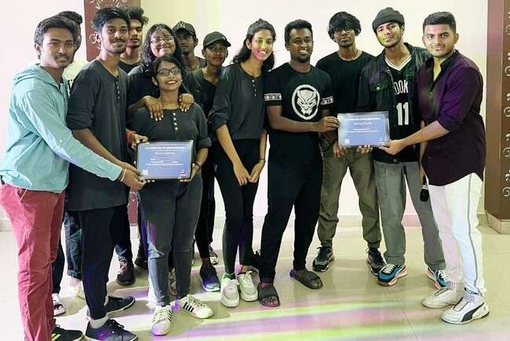

### TREASURE HUNT | Event Date: Friday, 26th, August 2022

A Treasure Hunt event was conducted by the Centre for Open and Digital Education (CODE) in association with the Department of Student Affairs, HITS on 26 August 2022. A total of 100 students participated in the event in groups of five. The participating teams were accompanied by 20 NCC Cadet Volunteers to ensure the discipline and decorum. The clues were placed in 10 different locations across the campus between garage café and the Building Sciences Block. The event started at OAT where the first clue was handed over to the participants and it ended at the Redbox. The team named “Spade 24” arrived first at the Redbox with all the 10 clues in hand. They also received Redbox vouchers worth Rs.500 as prize. The prizes were handed over to them by Ms. Ami Agarwal, Head, CODE. The event coordinators were Ms. Ami Agarwal, Head, CODE, Ms. Shabana K. M, Assistant Professor, CODE, Ms.

1. Bhavani, Assistant Professor, Department of Languages and Department of Student Affairs.

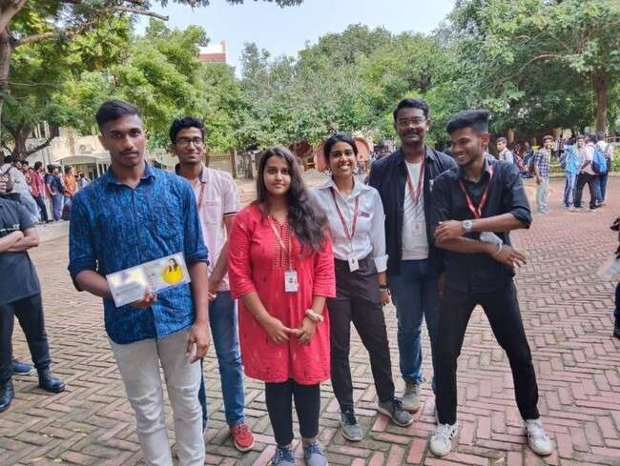

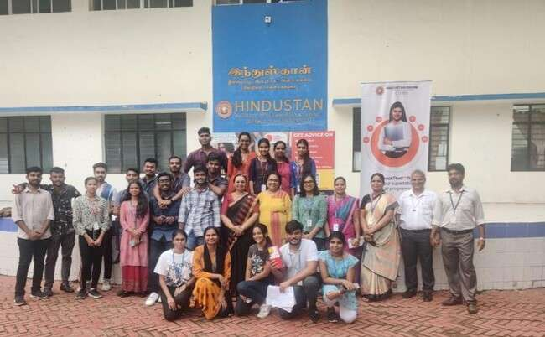

### COUNCIL OF EU CHAMBERS OF COMMERCE IN INDIA | Event Date:

*Wednesday, 24th, August 2022*

The students of Hindustan Institute of Technology and Science gave a stunning classical dance performance for the dignitaries at the Council of EU Chambers of Commerce in India held at Taj Coromandel, Chennai on 24 August 2022. The performances commenced with solo classical dance and ended up with a dual and trio performances with the display of the HITS flag.

The following students were the performers:

* + Ms. Tarunika - II B. Tech Biotechnology
  + Mr. Dhanush - IV B. Tech. Aerospace
  + Ms. Padmaja - III B. Tech. Biotechnology

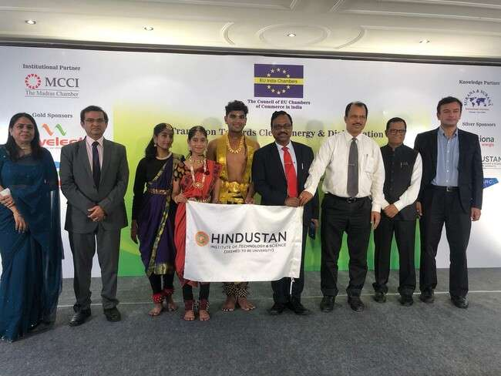

### NSS CAMP | Event Date: Monday, 18th, July 2022 -Sunday, 24th, July 2022

The Special NSS, HITS camp was held between 18 and 24 July, 2022 at Sirudavoor Village, Thiruporur. Dr.S.N.Sridhara, Vice Chancellor, HITS inaugurated the camp along with Head (Student Affairs). A total of 35 students along with 4 faculty members attended the camp and gave a cultural performance for the village residence.

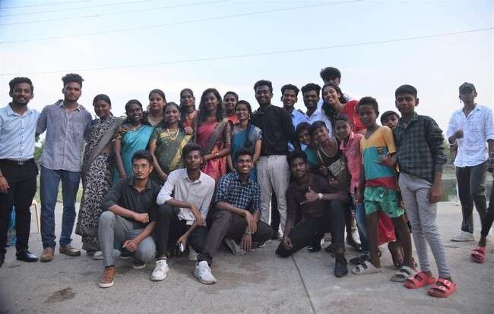

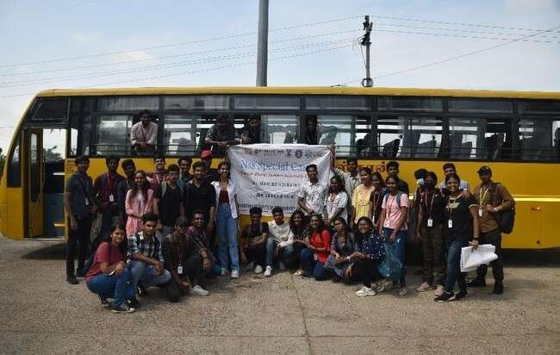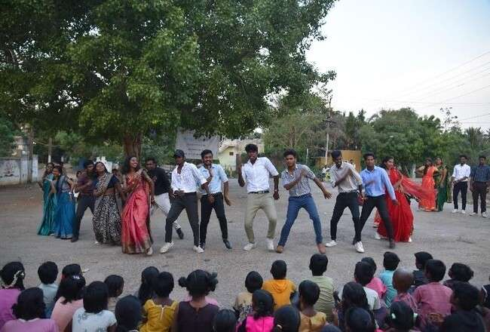

### SPORT-X AN EXCLUSIVE BADMINTON TOURNAMENT FOR ALUMNI | Event

*Date: Saturday, 9th, July 2022*

Evening Session:

Finals for all the matches of Singles Men’s, Singles women, Doubles Men’s, & Mixed Doubles were

conducted at 4PM

Dr. T. Maran, Indian Badminton Coach, was the Chief Guest. Mr. Adhithya Elango, Former International Badminton Player, MD, Tejesh Sports Academy was the Guest of Honour, Other Guests were Mr. Prabhu Dhanasekar(‘2000), MD, Spring Boots Academy of Dance, Mr. Ganesh Prabhu (2012, 2014) Technical Manager, Chennaiyin FC & MD, Terrawatt, MR. Prabu P. R. (2005), MD, MoMo Sa-Khang and Mr. Abraham, Sports Advisor of HITS.

The audience was entertained by the electrifying performance of HITS cultural team. BandEXas the Music band and Team-99 as the Dance team of HITS coordinated by Mr. Santhosh, Music Coordinator and Mr. Royson, Cultural Coordinator enhanced the beauty of the event.

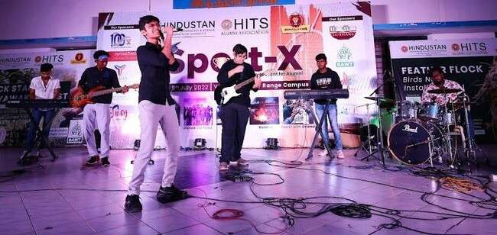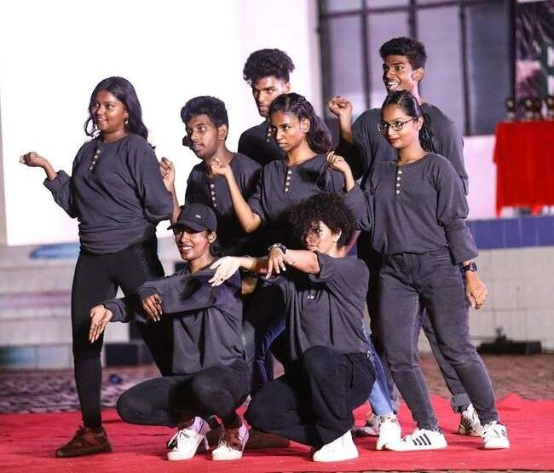

### Vijay Takkar – College Da Shoot | Event Date: 11th, October 2022

The Vijay Tv;s sub channel Vijay Takkar conducted “College Da” shoot exclusively for the youth was organized on 11th October, 2022 at HITS Campus. The students from various departments like Aero, Auto, Fashion, SOL, CSE, IT, SPADE, NCC, Culturals,Sports etc. participated in the shoot. “College Da” episode was telecasted in Vijay Takkar and official Youtube pages of Vijay Television.

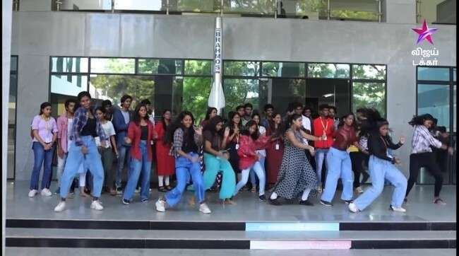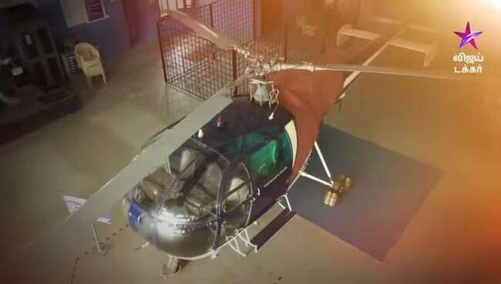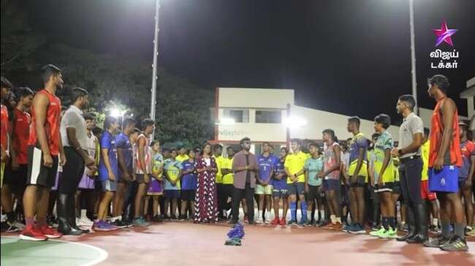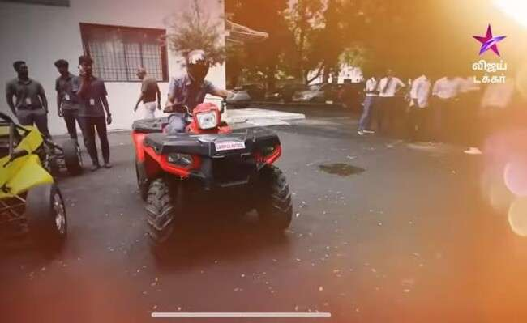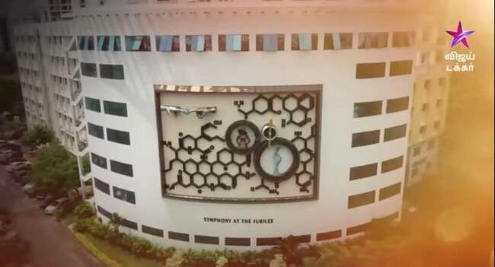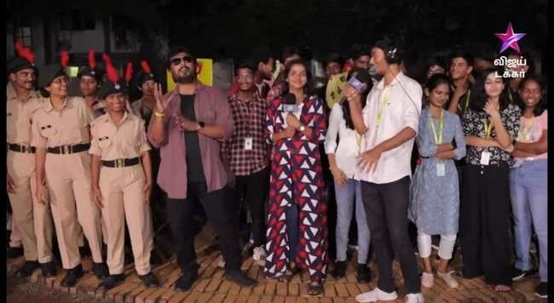

**Times Fresh Face | Event Date: 2nd, November 2022**

A wave of talent and enthusiasm took over as students of HITS displayed their passion through music, dance and various art form at Times Fresh Face 2022 organised by Times Of India at the HITS Campus. Witnessing genres of all kinds under one roof, 12 participants qualified for the semifinals scheduled for December 2023.

We congratulate all the semifinalists and wish them the best for the upcoming events.

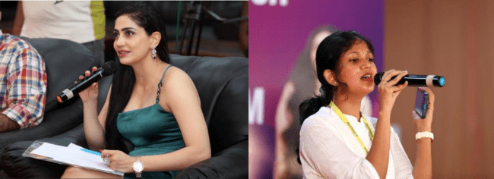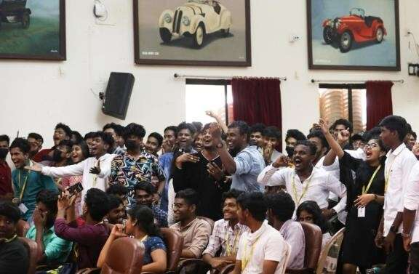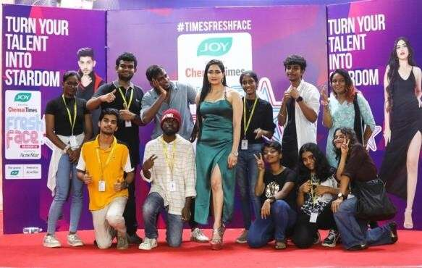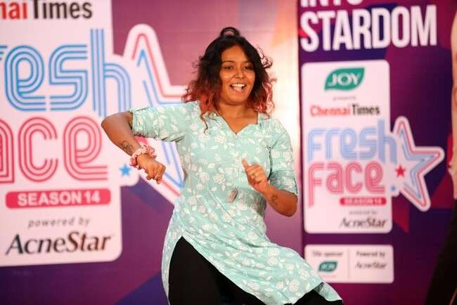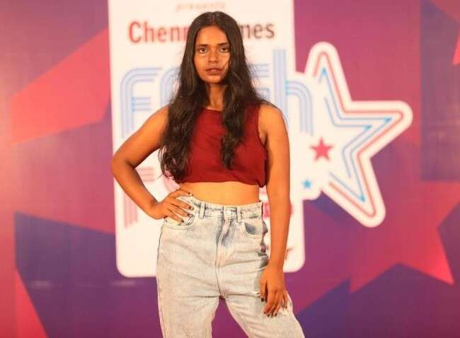

**BAND-EX WINS HANDS DOWN | Event Date: 1st, October 2022** XANTHRONS'22, anationwidecultural festival wasconductedby SRM Instuitute Chennai on 1st October 2022. BAND-EX of Hindustan Institute of Technology and Science bagged 1st place hands down in Light Music event among 18teams who participated.

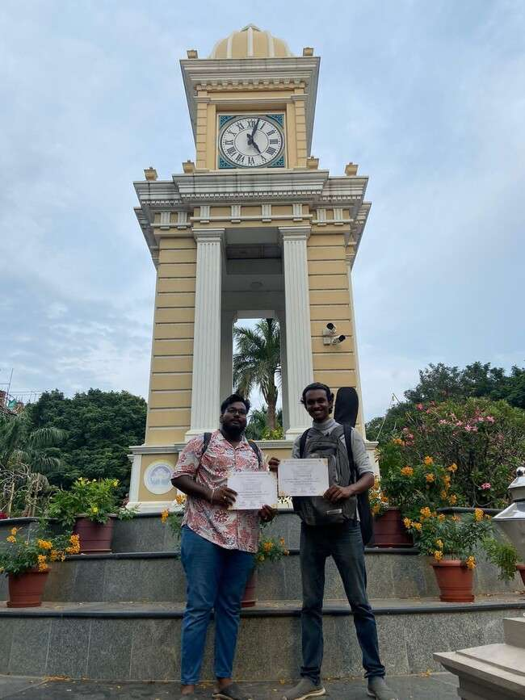

59

**Hindustan Springboots Dance Team | Event Date: 22nd, October 2022**

UTSAV '22, cultural festival was conducted by MCC on 22nd October 2022. Dance team from Hindustan Institute of Technology and Science bagged 2nd runner- up in Group Dance event.

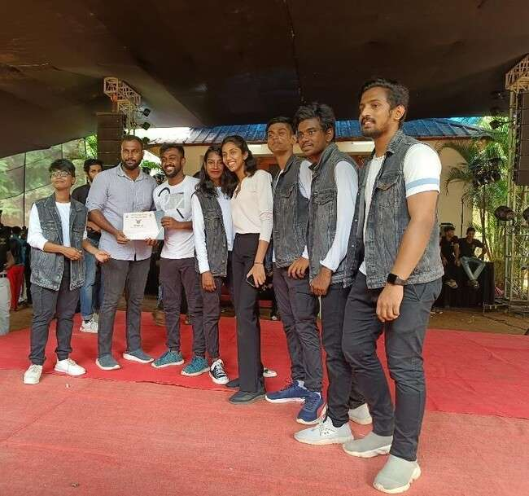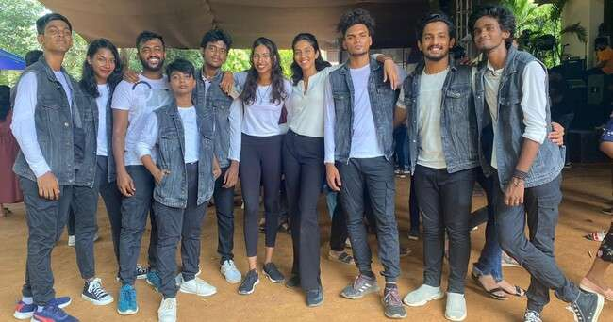

**BAND-EX WINS SOLO & GROUP MUSIC | Event Date: 25th, November 2022**

CRESCENTIA '22, cultural festival was conducted by Crescent Engineering College, Chennai on 25th November 2022. BAND-EX of Hindustan Institute of Technology and Science bagged 1st place in Solo singing & 2nd runner-up in Light Music event.

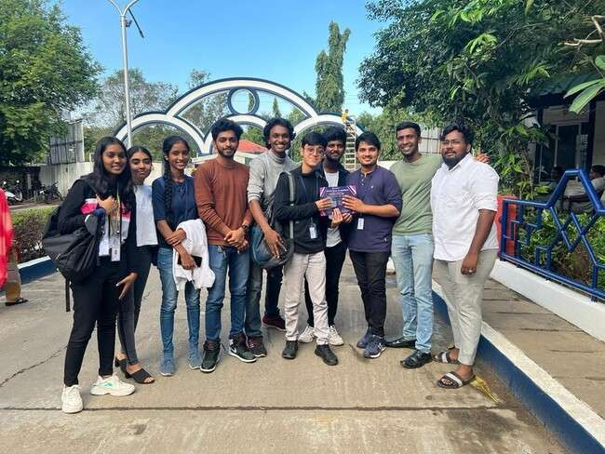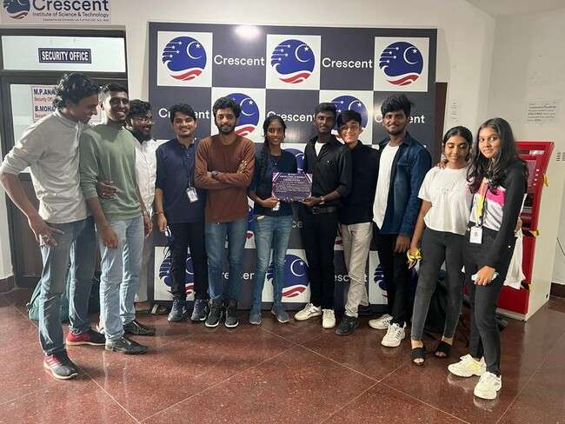

### FIESTA'22 | Event Date: Saturday, 26th, November 2022

The Office of Student Affairs of HITS organised a Freshers Welcome Meet named Fiesta'21 for the first-year students of E&T & SPADE held on 26 November 2022. Rev. Justin Jose & Dean E&T blessed the occasion with their prayers and welcomed the gathering. Dr. S.N. Sridhara, Vice Chancellor and Mr. Ashok Verghese,Director gave felicitation address for the gathering.

Director (AV) gave an inspiring speech for the fresher’s by sharing all the facilities offered, achievements, staff coordination & health tips provided at the campus. The VC & Director felicitated the chief Nawabzada Mohammed Asif Ali – Dewan to Prince of Arcot with a bouquet and memento. The chief guest address was indeed an out of box session when compared to a usual speech. General quiz was conducted for the audience and totally 15+ students answered correctly which was a memorable session for the students and staff.

More than 1.5 hours of gala cultural events from classical dance to rock/light music to karate demonstration, drama and fusion dance which enchanted the audience.

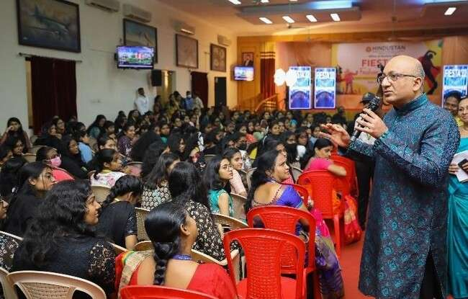 . 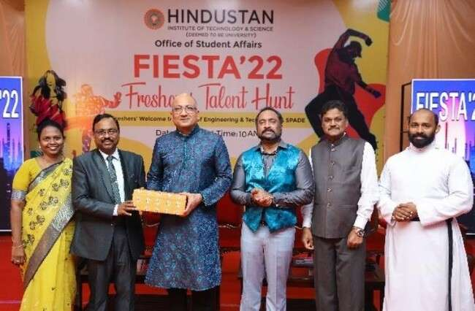

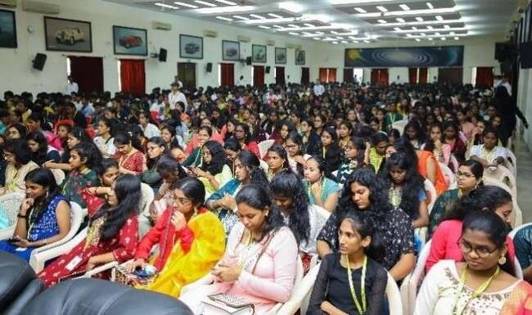

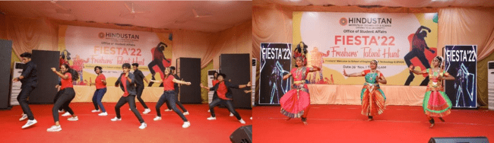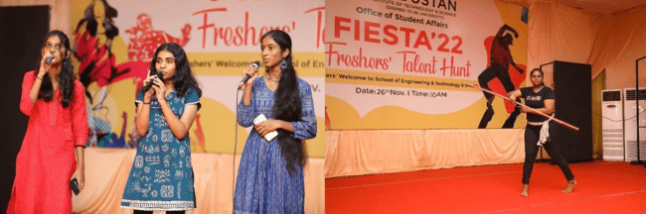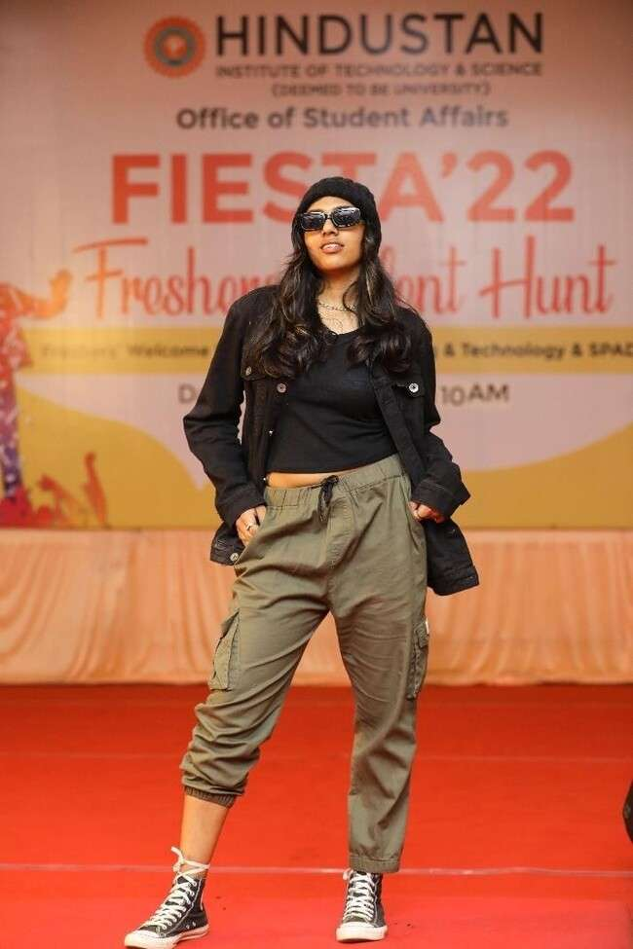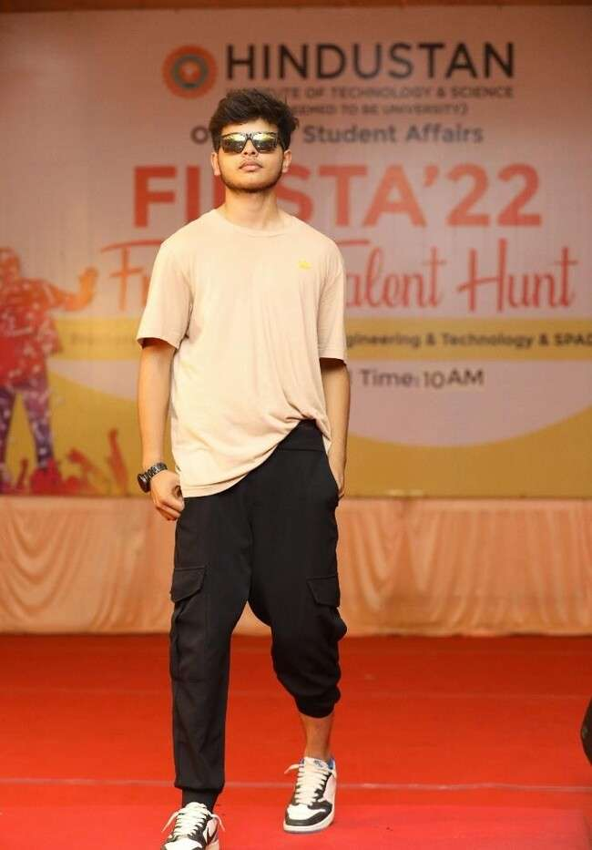

#### RAZZLE DAZZLE 8.0 | Event Date: Friday, 2nd, December 2022

###### RAZZLE DAZZLE 8.0 – Graduation Fashion Show 2022

Razzle Dazzle 8.0 - the Graduation Fashion Show 2022 was held on 2 December 2022. The event was witnessed by more than 900 fashion enthusiasts. The Chief guest for the evening was His Excellency Mr. Juan Angulo, Ambassador of Chile in India and the Guest of Honor and Show Stopper was Ms. Sakshi Agarwal, Actor and Model. Both the guests addressed an enthralled gathering and appreciated the Institution for conducting such events to encourage the budding designers. The event marked the continuation of the Chancellor’s Day Celebration of Dr. Elizabeth Verghese, who graced the event with her presence along with distinguished members of the management – Dr. Anand Jacob Verghese, Pro-Chancellor; Mr. Ashok Verghese, Director; Dr Annie Jacob, Director, KCG College of Technology; Mr. Enid Verghese Jacob, Deputy Director; Dr. S.N Sridhara, Vice Chancellor; Dr. R.W. Alexander Jesudasan, Pro Vice Chancellor, Dr. Pon Ramalingam, Registrar; Deans, Heads of the Departments, staff and students.

Mr. Sudhakar, Head, Department of Design welcomed the distinguished guests. The event was jointly hosted by Dr. Sonu Joseph, Assistant Professor (S.G) and Ms. Vyshali. The show was curated and choreographed by Ms. Prajanya Anand, Choreographer and Stylist. A team of 10 female and 5 male professional models showcased the collections of the first batch of B. Design Fashion and Apparel Design and eighth batch of B. Sc. Fashion Design students. The designs ranged from elaborate evening gowns, party wear to conceptual, inspirational themes like nostalgia and sensitive topics like gender identity.

Ms. Fouzul Inaya, received the Best Designer Award and Ms. Maria Jenita was awarded the Second Best Designer for the B. Design (Fashion and apparel Design) programme. Under the B.Sc. (Fashion Design) Programme, Mr. Mahendra Sai and Ms. Varsha M received the Best Designer and the Second Best Designer awards respectively. The event ended with a vote of thanks proposed by Dr. Afrose Farid, Professor and Head, Department of Fashion Design and Arts.

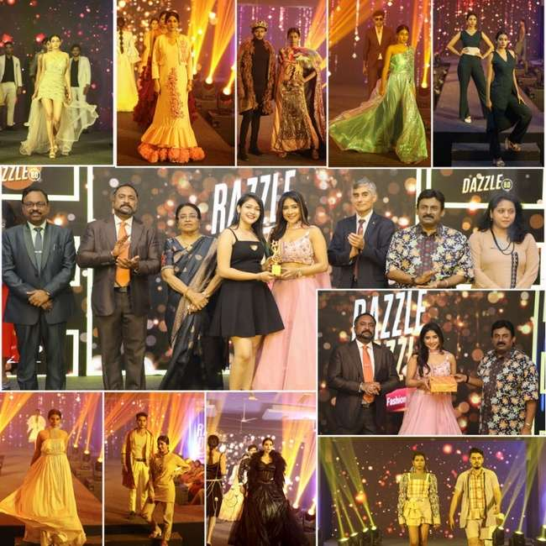

#### INAUGURATION OF ROYAL ENFIELD EXPERIENTIAL TRAINING HUB | Event Date: Wednesday, 30th, November 2022

The National Training Centre of Royal Enfield was inaugurated at Hindustan Institute of Technology and Science on 30 November 2022. Earlier, a Blessing Ceremony was held at the facility. The service was conducted by Rev. Justin Jose, Student Chaplain, HITS in the presence of Dr. Anand Jacob Verghese, Pro Chancellor; Directors - Mr. Ashok Verghese and Dr. Aby Sam; Dr. S. N. Sridhara, Vice Chancellor; Dr. Pon Ramalingam, Registrar; Deans, Heads of the Departments, staff and students.

Mr. B. Govindarajan, CEO, Royal Enfield was the Chief Guest and Mr. Rajeev Sharma, CHRO, Royal Enfield was the Guest of Honour for the inauguration. The event commenced with the opening of the hub by Dr. Anand Jacob Verghese, Pro Chancellor and Mr. B. Govindarajan, CEO, Royal Enfield and unveiling of the plague as a signet for the inauguration.

At the inaugural ceremony, Mr. B. Govindarajan, CEO, Royal Enfield said that he was elated to be at HITS on this auspicious occasion. He also informed that the training hub at HITS is the 15th centre in India and also is a milestone for RE because it is the first of its kind to be established inside an academic institution. Mr. Govindarajan assured that the trainee-students from HITS can undergo internship at RE and also stand an opportunity for a job placement in the company. He concluded his speech by wishing the students and trainers a successful learning experience.

In his presidential address, Dr. Anand Jacob Verghese welcomed the dignitaries and the audience for the inaugural ceremony. He narrated the history of Hindustan Engineering Training Centre established in 1966 by Dr. K.C. G. Verghese, the Founder Chairman, whose vision was to provide a non-formal technical education. He pointed out that HITS has achieved many laurels in aviation, management, law, fashion and the other branches also. He said that it is a special occasion because HITS has brought a prominent motorcycle industry, the Royal Enfield, to the campus. He said that the iconic brand’s experiential training hub will provide students opportunities to be placed in a core industry. He urged the students to utilize the hub for their academic and professional betterment.

The welcome address was delivered by Dr. S. N. Sridhara, Vice Chancellor, HITS. He said that it is another day of achievement for HITS as the vision of the Founder Chairman is being realised. The training hub is built on an area of 10,000 sq. ft. based on the MoU signed between HITS and Royal Enfield. He said that the centre will throw open training facilities to both the employees of RE and the staff and students of HITS. The Vice Chancellor also briefed the audience about HITS and the accolades achieved by the Institution. The event also witnessed the release of the Brochure of the Royal Enfield Experiential Training Hub. The first copy was released by Mr. B. Govindarajan, CEO, RE and the same was received by the Dr. Anand Jacob Verghese, Pro Chancellor, HITS. In order to celebrate the advent season, the dignitaries joined together for the cake mixing and tree plantation event. The inaugural ceremony concluded with the vote of thanks proposed by Dr. P. Vijayabalan, Head, Department of Mechanical Science.

The special occasion also witnessed the Royal Enfield bike rally. The Safety Gear Awareness Rally was flagged off by Dr. Anand Jacob Verghese, Pro Chancellor, Mr. Ashok Verghese, Director and Mr. B. Govindarajan, CEO, RE. It started from HITS to Mahabalipuram and then returned to the Bay Range Campus. Around 50 riders comprising of staff and students of HITS with their Royal Enfield bikes participated in the rally.

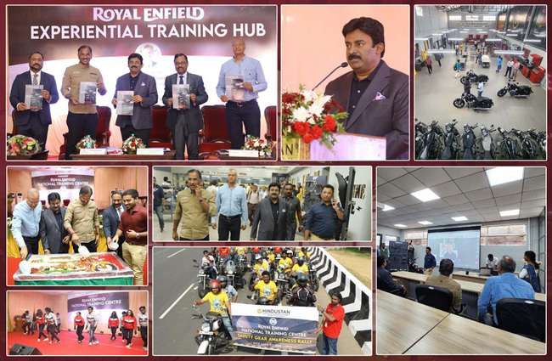

#### VIBRANCE ’22 | Event Date: Saturday, 3rd, December 2022

VIBRANCE 2022 - The Fresher's Talent Hunt for the first year students of the School of Liberal Arts and Applied Science, School of Management, School of Law and School of Allied Health Sciences was celebrated on 3 December 2022. The Chief Guest for the celebration was Mr. Karthik Thirunarayanan, Director-Hybrid Cloud Systems, Oracle. In his address, Mr. Karthik beautifully weaved the connection between technology and liberal arts. He traced from ancient Indian history the accuracy and precision of the Indian knowledge systems. He appreciated HITS and its students for actively filing more than 100 patents. Also, as India is a land of start-ups, Mr. Karthik urged the freshmen to be innovative and entrepreneurial. He said that the college campus is the best place to explore their potentiality for innovation and entrepreneurship. He also pointed out that India being a land of youngsters, the world is looking up to young Indians to contribute globally. He concluded his speech saying that as the competition is very high, it is important for the students to be courageous and committed. The Chief Guest held an interactive session with the students and answered their questions on building a successful career.

The welcome address was delivered by Dr. Pon Ramalingam, Registrar. Dr. R. W. Alexander Jesudason, Pro Vice Chancellor, delivered the Presidential address in which he encouraged the students to utilise their energy for their own development and thereby bring out the best in themselves. The vote of thanks was proposed by Dr. M. K. Badrinarayanan, Head, School of Management. Students showcased their talents by performing under different cultural genres. The event was attended by the Deans, Heads of Departments, staff and students of the School of Liberal Arts and Applied Sciences, School of Management, School of Law and School of Allied Health Sciences.

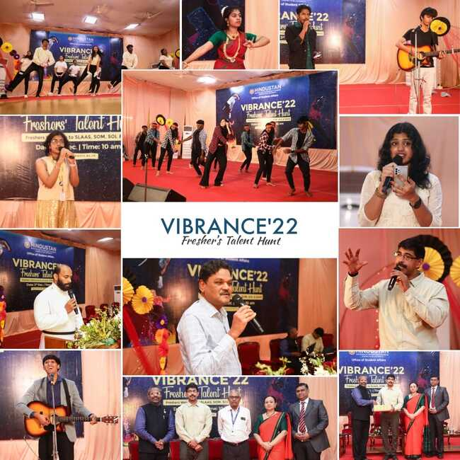

#### ANNUAL ALUMNI MEET 2022 | Event Date: Saturday, 7th, January 2023

The Annual Alumni Meet 2022 was held on 7 January 2023. Around 250 alumni visited the meeting.

The welcome address was delivered by Dr.PonRamalingam, Registrar. Dr. R. W. Alexander Jesudasan, Pro Vice Chancellorin his addressappreciated the alumni of HITS for their successful career in various fields such as research, government sectors, corporate industries, sports and fine arts across the globe. He also urged the alumni to contribute generously to alma mater in all means. The Pro Vice Chancellor concluded his speech by congratulating the awardees who were honoured for their remarkable contribution toward the development of the institution.

Dr. S.N. Sridhara, Vice Chancellor of HITS released the Alumni Connect – a Digital Alumni News Letter, January 2023 edition. He briefed the audience about the latest rankings achieved by HITS.He also stated that alumni interaction and alumni involvement with the alma mater would not only upgrade the institution’s accreditation grades, but alsocompliment the growth of the alumni in theirpersonal and professional life. He also announced the launch of “Hindustan Talks” programme.

Mr. Kamal B. N., President of HITSAA presented the activities of HITSAA. He also urged the Alumni Chapters across the globe be active.Cash awardsworthRs. 100,000were presented to alumni, students and faculty. The cash prize was sponsored by the Mr. Ashok Verghese, Pro Chancellor and the alumni of batch 1992. The awardees were meticulously chosen by the Office of Dean (E&T) and the respective heads of the departments based on various criteria.The event concluded with cultural performance by the students and vote of thanksproposed by Mr. S. S. Murthi, Assistant Vice President, HITSAA. The event was organised and coordinated by Ms. Pragatha, Deputy Registrarand Coordinator, HITSAA, Ms. Kanpur Rani AP(SG) -EEE and Alumni Relations Officer and Mr. C. Santhosh, Alumni Coordinator.

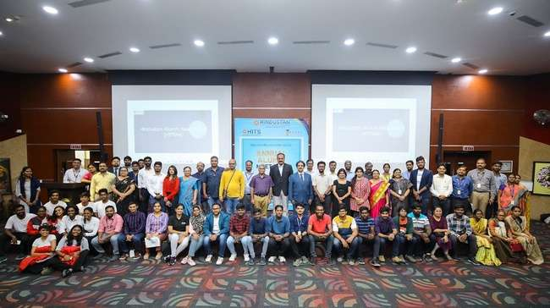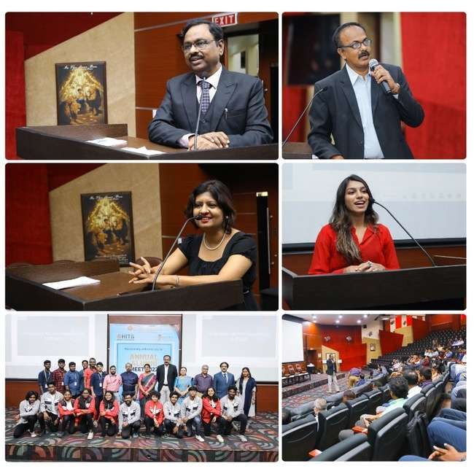

#### YUVOTSAV 2023" – HINDUSTAN DANCE TEAM WINS THE CONTEST | Event Date: Sunday, 22nd, January 2023

The Yuva Kerala Arts and Sports Club, Chennai organised the "YUVOTSAV 2023" Season 8 on 22 January 2023 at Dr. Ambedkar Arangam, ICF. The Hindustan Dance team competed with 12 other dance teams and won First Prize in the Fusion Group Dance category for their power packed performance. The Dance Team is appreciated for their accomplishment.

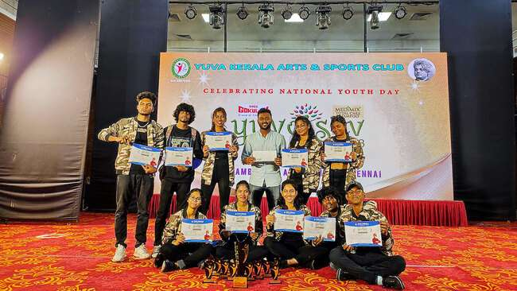

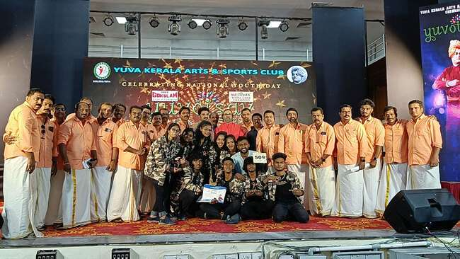

#### PONGAL CELEBRATION | Event Date: Saturday, 14th, January 2023

Pongal, the festival of harvest was celebrated on 14 January 2023. The Chief Guest for the celebration was Thiru. S. S Balaji, MLA of the Thiruporur Constituency and the Guest of Honour was Dr.Sharmila Balaji, General Physician, Actress and Social Activist.

Thiru. S. S Balaji emphasised the importance of agriculture and the efforts by the Government to enhance it. He appreciated HITS for celebrating the thanksgiving festival of farmers. He urged the students to consider farming as a profession. The Guest of Honour, Dr.Sharmila, briefed the efforts and hardwork of farmers in bringing food to the dining table and said that they should not be neglected.

Dr.Pon Ramalingam, Registrar delivered the welcome address and Dr.S.N Sridhara, Vice Chancellor, presided over the function. The other dignitaries to grace the occasion were Dr.Angelina Geetha, Dean (E&T) and Ms.Beena James, Head of Student Affairs. The staff and students participated in the celebration fervently. The vote of thanks was proposed by Mr. Hari Krishnan P M, NSS Secretary, Hindustan Student Council.

The celebration commenced with the cooking of pongal dish and followed by the construction of a special makeshift hut and creation of rangoli designs. Traditional folk dances such as, Thappattam, Karakattam, Oyilattam and Maadattam were performed by Damuru, the Band. Sweet pongal and sugarcanes were distributed to staff and students who also enjoyed the traditionally decorated bullock cart ride inside the campus. Traditional games like Uriyadi, tug of war, musical chair, filling the bottle with water, target throw, slow cycle race and many more which brought alive the spirit of Pongal.

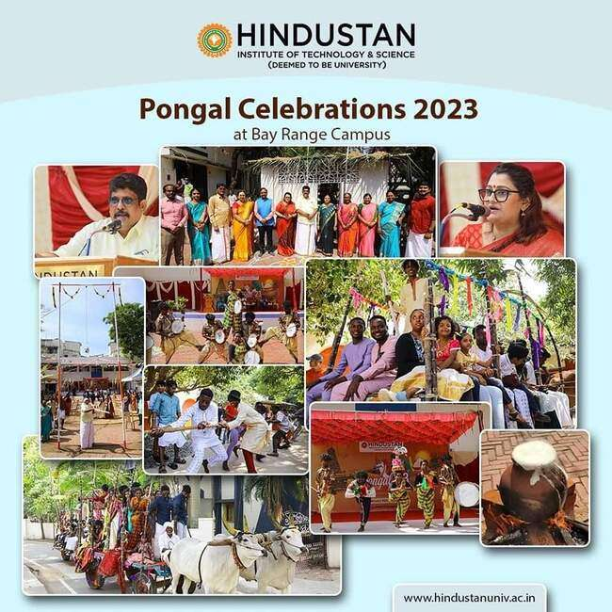

#### ILLUSION AND REALITY | Event Date: Monday, 9th, January 2023

Illusion and Reality, Magic with Science was performed by a five-member team from the United States America on 9 January 2023. The team included of Magic Bob and Suzie (Michigan, USA), Andrew and Zandra Anderson (Illinois, USA), and Illusionist Michael Bruce (Florida, USA). Their tricks were a splendid combination of magic and science which included intellectual tricks based on science, engineering skills, art, and chalk show. The show aimed to inculcate social values in today’s youth. The show was attended by the staff and students of HITS and HCAS.

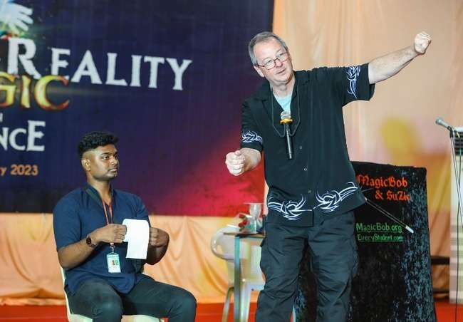

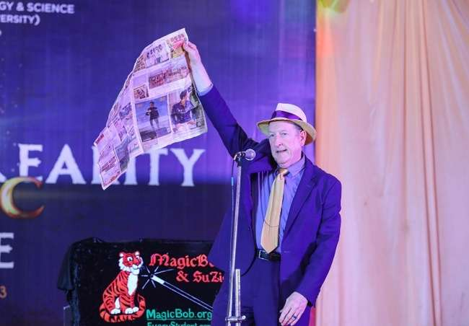

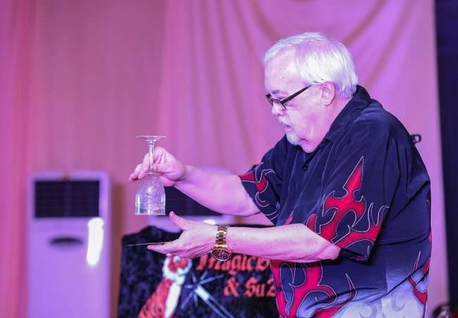

#### HINDUSTAN DANCE TEAM – WINNERS AT "VASUDHAIVA KUTUMBAKAM 2023" | Event Date: Saturday, 11th, February 2023

The Hindustan Dance Team won the First and Second place for boys and girls respectively at "VASUDHAIVA KUTUMBAKAM 2023" an Inter Collegiate Fest. The event was held on 11 February 2023 and was organised by Stella Maris College, Chennai. The dancers showcased a stunning performance with their elegant and graceful dance movements. The HITS fraternity appreciates their yet another accomplishment.

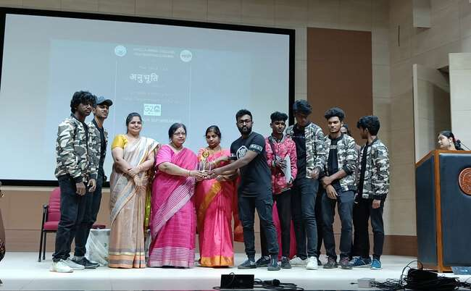

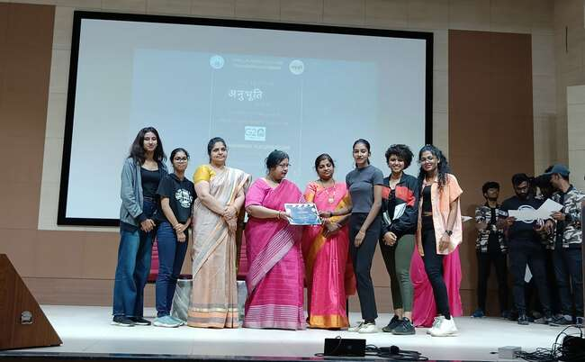

#### CULTURAL VISIT TO AMIR MAHAL | Event Date: Saturday, 25th, February 2023

A contingent of 30 students and 4 staff members were invited by Nawabzada Mohammed Asif Ali, Dewan to Prince of Arcot to Amir Mahal at Royapettah, Chennai on 25 February 2023. The visit aimed to educate the students on the rich heritage and culture of India. The team comprised of students from the Engineering, Arts, Business Studies, and Sports stream. The foreign students were also a part of the troupe. The Dewan accompanied the students on a tour of the palace. He encouraged them to showcase their music talents inside the music recording room in the palace. The visit concluded with luncheon with the Dewan and his wife. The students and staff overwhelmingly inspired by the cordiality, hospitality, and humility expressed the Dewan and his family.

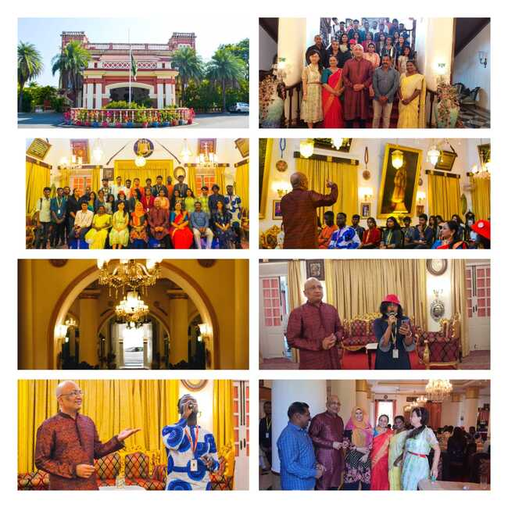

#### HOLI CELEBRATION ’23 | Event Date: Wednesday, 8th, March 2023

Holi, the festival of colours was celebrated at Bay Range Campus, Padur on 8 March 2023. The celebration was organised by the Office of Student Affairs in order to promote cultural awareness and celebrate diversity.

The event provided an opportunity for the campus community to come together and celebrate festival of Holi, to learn the cultural significance of the festival, and to encourage intercultural understanding and harmony.

The celebration started with the Presidential Address by Dr. S. N Sridhara, Vice Chancellor who briefed the audience on the significance of Holi . Students and faculty members then participated in colour throwing, which was the main highlight of the event. Around 1000 students and staff members attended the event.

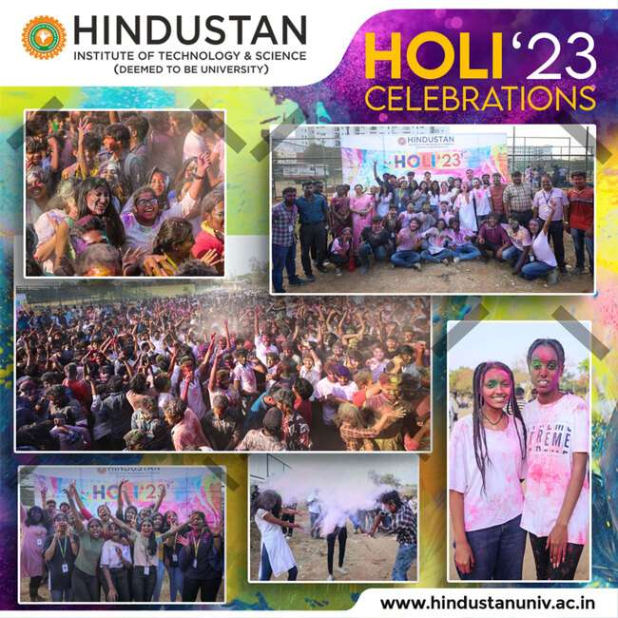

#### YARONA 2023 | Event Date: Saturday, 1st, April 2023

A vibrant and humongous Inter-Departmental Cultural Fest “Yarona 2023” was held on 1April 2023 at the Bay Range Campus. The event was jointly organised by Dr. K S Shaji, Dean, Student Affairs, Mrs. Beena James Head - Student Affairs, Mr. Adarsh V Pillai, Officer Student Affairs, Mr. Royson, Cultural Co-Ordinator & Officer Student Affairs, Mr. C Santhosh, Music instructor, Mr. Calvin Joseph, Event manager, Ms. Shirley Armstrong, President HSC and Mr. Nithin Thomas, Vice President HSC.

The felicitation address was delivered by Dr. S. N. Sridhara, Vice Chancellor, Dr. Pon. Ramalingam, Registrar and Dr. K S Shaji, Head of Student Affairs.The stage was then lighted up by an elegant performance by team Band EX followed by an elegant dance performance by the Hindustan Dance Team. Subsequently, a prayer song was rendered by the choir team and followedby opening prayer by Rev.Fr. Justin Jose, Student Chaplin. The formal inauguration function started with the lighting of kuthuvilakku by the dignitaries and Hindustan Student Council representatives and the inaugural function concluded with the revealing of the Yarona rolling trophies for both the winners and runners.

Following the formal inauguration, a line of cultural events such as Groove (Indian & Western group dance), solo singing, Fashion Ramp, Solo/Duet Dance, Master the Mic, Rap & Beat boxing, Classical Dance Solo, Classical Instrumental Solo, Classical Vocal Solo, Adzap, Mime, Mimicry, Stand-Up Comedy, Face Painting, Junk Art, Puddle Jumper, Stack Attack, Eat The Cookies, Watermelon Mania, Cinematic Events: Lights Camera Action; Groove on Beats; Diehard Fan; Cine Quiz, Treasure Hunt, Tug-Of-War, Light Music Group, DJ War, Group Dance, Gaming, Mono Acting, Theatre,Cooking Without Fire, Full Of Hot Air, This Blows, Don’t Blow The Kings, were held concurrently at 6 different venues such as: MGR Auditorium, Parabola, Freedom Zone, K S Moorthy hall, Good Shepard Hall and Main Ground.

Around 100 student volunteers actively involved in successfully organizing the event with 30+ faculties guiding them. The celebration saw a huge contingent of cultural troupes numbering about 1500+ registrations with 30 events evaluated by 20+ judges. This year’s fest witnessed an increased number of participants from various departments. The veteran experts in their respective fields and senior level professors contributed hugely towards the smooth running of Yarona’23.

Dr. S. N. Sridhara Vice Chancellor, HITS initiated the valedictory function held at the Main Stage in the evening. The eventcommenced with the Presidential Address by Mr. Ashok Verghese, Pro Chancellor who also announced the winners and the runners-up of Yarona ’23 along with the chief guest, Ms Samyuktha Shan, Film Actress. The Vice Chancellor, conferred the overall championship (rolling trophy) to the Aeronautical Department and the runner up were awarded to the Department of SLAAS.

The evening events included light music show by the band “Get Nithyafied” whose lead vocalist is Ms. Nithyashree, Playback Singer. The other singers of the band included: Ms. Srisha, Mr. Raja Ganapathy and Mr. Syed Subahan. The DJ Night was hosted by DJ Navas and DJ Deepika, the first DJ couple in Chennai.

The YARONA’23 winded up in a highly enthusiastic note, making it both a memorable and a great learning experience for the entire crew. It was a delight for the hearts, minds, and soul for all those who were present at the occasion, particularly the Students of HITS.

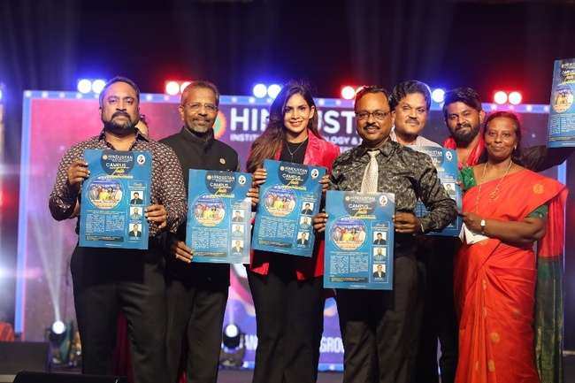

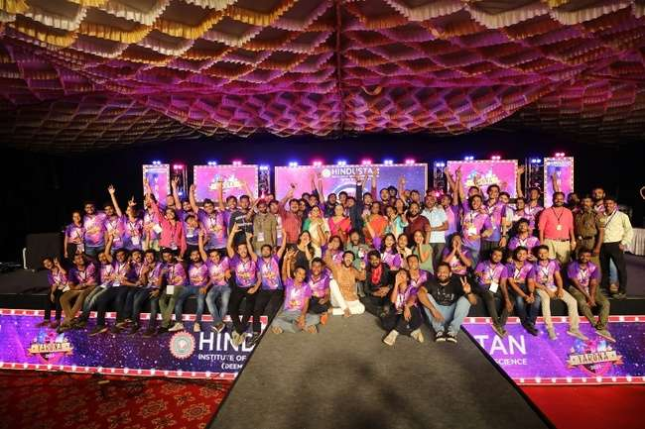

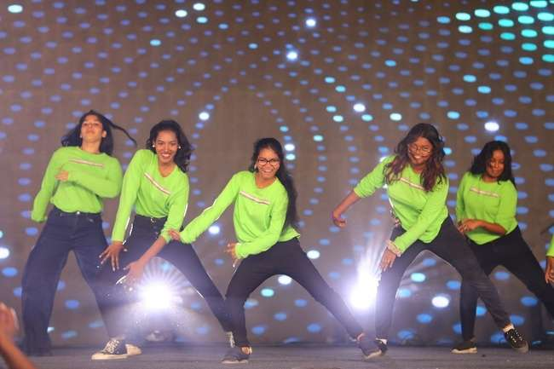

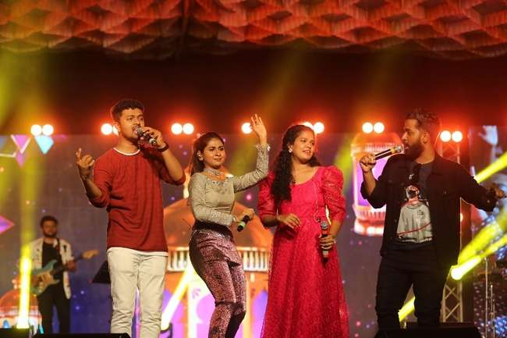

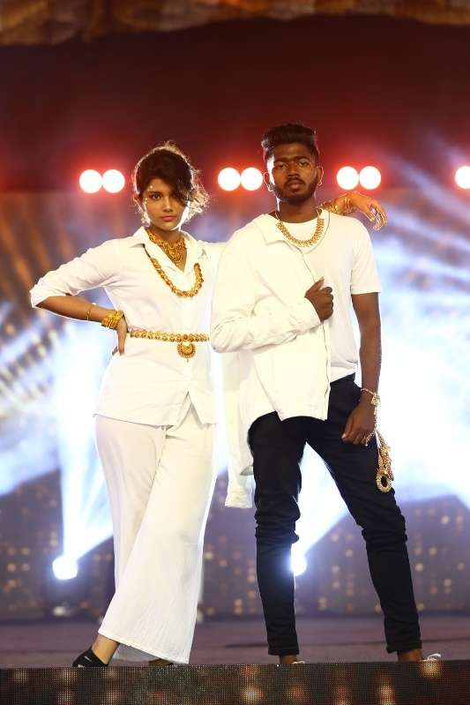

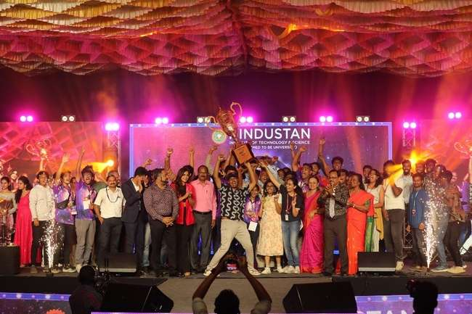

#### AUTO CARNIVAL ’23 ONLINE AUTOMOTIVE FIESTA | Event Date: Thursday, 30th, March 2023

The Department of Automobile Engineering organized the AUTO CARNIVAL '23 - a Global Online Automotive Event and Offline Award Ceremony on 30 March 2023. The Auto Carnival was the first non-technical online event in South India to be sponsored by Ringfeder Power Transmission Pvt. Ltd. The event commenced with the inauguration of Auto Carnival ’23 and Vahanaa ‘23. The guests for the event were Mr. Zubin Songadwala, Area Manager South ITC Hotels and General Manager ITC Grand Chola and Mr. Thirunavukkarasu K, General Manager (Eng.), Ringfeder Power Transmission. The inauguration was also graced by Mr. Sandeep Kumar, International Racing Driver, Indian Racing Champion and Ms. Rehana Reya, Motorcycle Racer and National Champion 2019-21 grace the occasion.

Dr. Pon Ramalingam Registrar delivered the welcome address. Dr. M. Jaikumar, Head, Department of Automobile Engineering delivered the felicitation address and briefed about Auto Carnival ‘23. The annual magazine, Spark ’23 was released by the dignitaries. Mr Zubin Songadwala delivered the inaugural speech followed by the presidential address by Mr. Ashok Verghese, Pro Chancellor. The keynote speeches were delivered by Mr. Sandeep Kumar, Indian Racing League Champion, and Mr. Thirunavukkarasu K. Finally, Dr. T. Shanmuganathan, Convenor proposed the vote of thanks.

Post the inauguration, the Auto Expo, organized as the part of Auto Carnival ’23 and Vahanaa ’23, was unveiled by Mr. Ashok Verghese, Pro Chancellor, and other dignitaries. A trip through the Auto Expo provided the spectators an opportunity to interact with the exhibitors. The Expo displayed premium cars, super cars, vintage cars, modified cars, super bikes, and in-house vehicles designed by the students of Motor Sports.

During the afternoon session, the special guests Mr. R. Ramesh Shankar, Principal Photographer (Times of India, Chennai), Mr. R. Satish Babu, Chief Photographer (The New Indian Express, TN) and S. Sathiyaseelan, News Photographer (Dinamalar) presented the awards to the winners of the “Photography Contest.” Mr. Pradeep E Raghav, Film Editor and Mr. T. Sivanandeeswaran, Film Editor distributed the Awards to the winners of “Montage Contest.”

The Auto Carnival ’23 created an opportunity for the budding automobile enthusiasts to show case their talents. Both the technical and non-technical events witnessed a participation of around 400 entries from 25 colleges. As Auto Carnival ’23 was an open event for all, there were more than 150 participants from all over the globe participated.

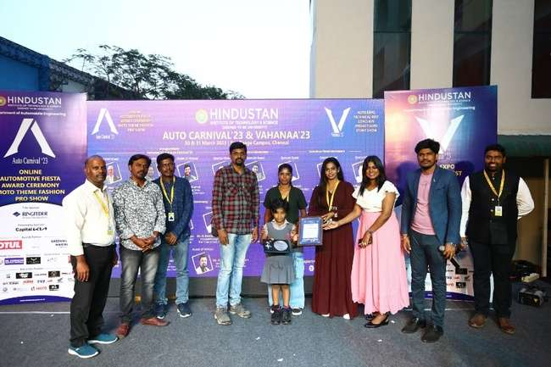

#### CELEBRATION OF UGADI 2023 | Event Date: Wednesday, 22nd, March 2023

The Office of Student Affairs organized UGADI ’23 to celebrate Telugu New Year on 22 March 2023 with great enthusiasm and fervour. The event was marked by the presence of Dr. S. N. Sridhara, Vice-Chancellor; Dr. Pon. Ramalingam, Registrar; Dr. K. S. Shaaji, Dean, Student Affairs; Ms. Beena James, Head i/c, Student Affairs, staff, and students. The event was celebrated with cultural programme and a traditional lunch.

The event commenced with a welcome address by the Vice-Chancellor, who warmly greeted all the guests and participants. He highlighted the importance of Ugadi in Telugu culture and the significance of the festival in heralding a new beginning. While addressing the gathering, the Registrar emphasized the need to preserve and promote cultural heritage in academic institutions.

The cultural program included traditional Telugu dances, songs, and music. The performances by the students were well-received, and the audience enjoyed the vibrant display of Telugu culture. The event also featured trivial questions on Telugu culture and history asked by the Vice-Chancellor, which saw active participation of the students.

After the cultural programme, a traditional Telugu feast was served. The feast included a variety of dishes, such as pulihora (tamarind rice), poornalu (sweet), Ugadi pachadi, and traditional Telugu meals. The food was served on banana leaves, which is a traditional way of serving food in South India.

The event provided an opportunity for the Telugu community of our university to greet each other and celebrate their culture and traditions. It also helped to promote Telugu culture and traditions to non-Telugu people who attended the event. The cultural performances, traditional food, and cultural activities were appreciated by all, making it a memorable event.

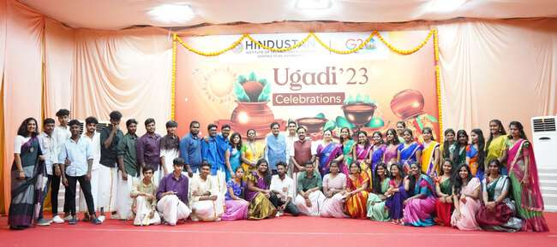

#### WORLD THEATRE DAY 2023 | Event Date: Wednesday, 12th, April 2023

The Department of Languages hosted a stage play on the occasion of the World Theatre Day on 12 April 2023. The audience in the Andromeda Hall of Hindustan Institute of Technology and Science had an electrifying experience as they watched a dramatic Sherlock Holmes mystery brought to life on stage by the Hindustan Masquerade Theatre Club. The play was produced and enacted by a diverse cast of talented individuals from various departments and years of study.

The drama featured numerous well known and loved characters from Arthur Conan Doyle's original works, such as the iconic duo, Sherlock and Watson, as well as Lestrade, Sally and Bunson, and of course, the notorious Moriarty - but in disguise. The show had everything one could hope for and more, from an intriguing plot, haunting music at every moment, intricately timed light-work and even a glorious climactic fight sequence. It was certainly a nail-biting and highly entertaining show that had the audience on the edge of their seats throughout.

Following the play, the introduction of the chief guest was given by Dr. David Easow, Head of School of Liberal Arts and Applied Sciences. Ms. Aysha Rau, founder and managing trustee of The Little Theatre, was the honored chief guest of the evening. She was quite impressed by the performances, stating that she hadnot known what to expect but was pleasantly surprised. Ms. Rau, who had initially inaugurated the club, was quite appreciative of the progress it had made over the years. Certificates were distributed to laud the actors for their hard work and skillful portrayal of their characters.

Mr. Ragesh Shyam, who was the director, script writer, composer, set and costume designer and actor. His diligence, dedication, and ability to deliver under stress was an inspiration to not only the cast and crew, but also to the audience, and received well-deserved appreciation from the crowd.

Dr. Sonu Joseph, faculty coordinator of Athena, proposed the vote of thanks to conclude the event. The show was also live streamed and later posted to YouTube on the official university channel and is available for viewing to the public.

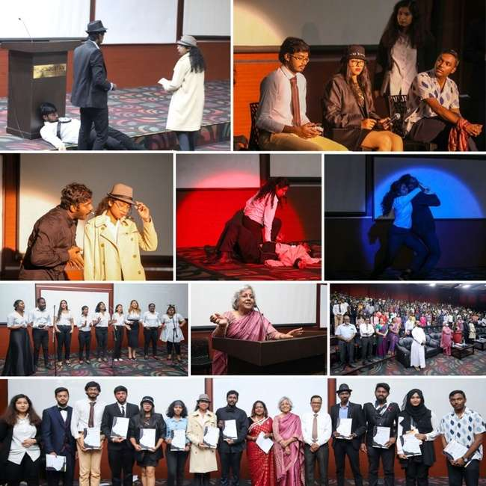

#### UNIVERSITY DAY 2023 | Event Date: Saturday, 29th, April 2023

The University Day 2023 of Hindustan Institute of Technology and Science was held at the Bay Range Campus on 29 April 2023. The Chief Guest and Guest of Honour for the programme were Hon’ble Justice Mr. J. Sathya Narayana Prasad, Judge, Madras High Court, and Mr. M. Sathyanandan, Vice President, Product Development, Ashok Leyland respectively.

At the outset, the Chief Guest, Hon’ble Justice Mr. J. Sathya Narayana Prasad, Judge, Madras High Court thanked the HITS management, University officials, staff and students for inviting him to the University Day Celebration. In his address he said that the students must be proactive in order to successful individuals. He advised the future citizens of the nation to respect their parents for their advises lead towards the betterment of one’s life. Through many real-life case studies, the Judge echoed the importance of following the advice of parents, respecting elders, and showing gratitude to the ones who helped them during the tough times. The Judge concluded his speech by saying that the student community should reciprocate love and affections and help the needy

The Guest of Honour, Mr. M. Sathyanandan, Vice President, Product Development, Ashok Leyland, in his address dwelled on the key influencers of future mobility that starts with climate control and sustainability. He said that fuel, which is important for mobility, is getting depleted and hence an alternative resource is required to meet this loss. He pointed out to an alternate energy called Green Hydrogen which can fuel mobility of vehicles and also be environment friendly. Mr Sathyanandan motivated the students to have the drive and courage to adapt new technologies. He said that students must learn to overcome challenges and face change with grace. He iterated that students should learn from their past experiences, give importance to relationships, both new and old in their life. He concluded his speech by pointing out that each young mind should have the ability to learn which is a skill and also have the willingness to learn which is a choice.

Mr. Ashok Verghese, Pro Chancellor, welcomed the chief guest and guest of honour for the University Day Celebration and congratulated the staff and students for their achievements. In his presidential address, the Pro Chancellor, recollected the evolution of mankind which has brought the species to the current developed and supreme status. He said that success comes when one realises the purpose of one’s birth in this world. He said that the three pillars of HITS are the staff, students and the alumni. He informed the audience that the alumni of the Institution have grown in leaps and bounds and have contributed in realizing the vision of the Late. Founder Chairman, Dr. K. C. G. Verghese. “To Make Everyman a Success and No Man a Failure”. He urged the students to always ponder on contributing their best to the upliftment of their alma mater. He concluded his speech by saying that at times asking a question may not get the answer but dwelling on the question will surely fetch the answer.

Dr. Sivathanu Pillai, Father of BrahMos and Professor, Emeritus in his felicitation address appreciated the achievers. He informed that HITS is progressing remarkably and this progress will place the Institution at top of the world in the next five to ten years. He also pointed out that Space Research at HITS has reached the next level as the KCG Verghese Satellite will be launched in June 2023. The Scientist said that there are 16 lakh job opportunities available for the youth in India for which they must be equipped with the right skill. Dr. Sivanthanu, at this juncture also requested Mr. M. Sathyanandan, Vice President, Product Development, Ashok Leyland, and the Guest of Honour to collaborate with Hindustan in order to propagate Green Hydrogen fuel in the academic environment.

The event commenced with Thamizh Thai Vazhthu rendered by the University Choir. The welcome address was delivered by Dr. R. W. Alexander Jesudasan, Pro Vice Chancellor. Dr. S. N. Sridhara, Vice Chancellor presented the Annual Report of 2022-23. The report heralded the milestones achieved by the HITS fraternity during the academic year. The report informed the academic and industry collaborations of the University. It also showcased the various events held on campus and the research developments on campus. The vote of thanks was proposed by Dr. Pon. Ramalingam, Registrar. The investiture of the Student Council for the academic year was also held during the event. The staff and students were honoured with awards and certificates for the exemplary performance and outstanding contribution towards the betterment of the Institution. The dignitaries also released Digitalk April 2023 issue. The University Dance Team and Music Band entertained the audience with their exuberant performances. The programme concluded with the National Anthem sung by the University Choir.

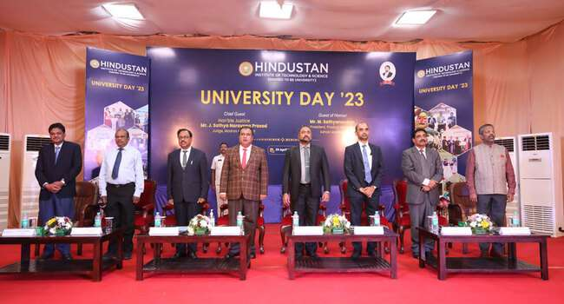

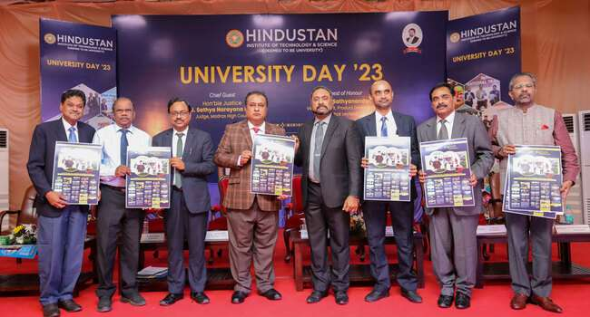

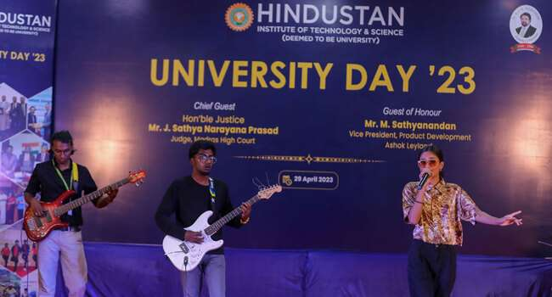

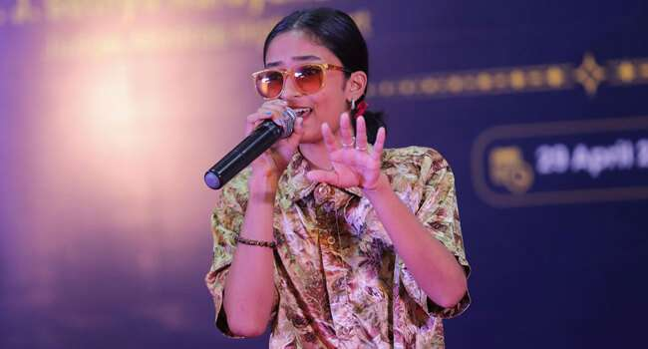

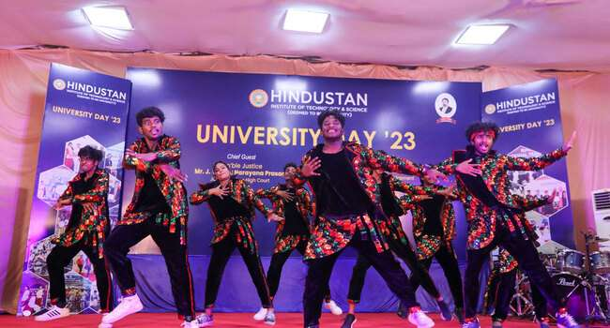

|  |  |  |
| --- | --- | --- |
| 1 | 17.02.2023 | NIFT Bangalore 2nd place in Group Singing |
| 2 | 02.03.2023 | Hindotsav 2nd place in Light Music |
| 3 | 02.03.2023 | NIFT Chennai 1st place in Solo Singing |
| 4 | 05.03.2023 | SRM MILAN '23 2nd place in Light music |
| 5 | 24.03.2023 | Rajalakshmi Engineering College 2nd Place in Light music |
| 6 | 25.03.2023 | Don Bosco College 1st place in Light music |
| 7 | 02.05.2023 | Rajalakshmi Institute of Technology 1st Place in Light music |
| 8 | 08.05.2023 | Sona College 1st Place group |
| 9 | 08.05.2023 | Sona College Instrumental |
| 10 | 11.05.2023 | SVCE 2nd Place |

**Music Team Achievements**



