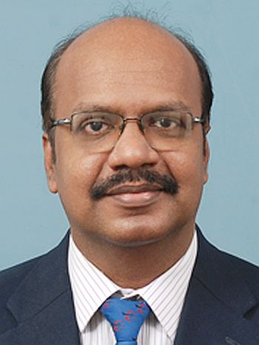 | Dr. P. Chandrasekar  Professor  Department of Civil Engineering  Hindustan Institute of Technology and Science  Email: pchandra@hindustanuniv.ac.in  Phone: +91-44-27474262  Qualification:  B. E. (Civil Engineering, Madras University, 1990)  M. E. (Urban Engineering, Anna University, 1996)  Ph. D. (Transportation Engineering, National University of Singapore, 2001)  Experience: 21 years  Research area: Transportation Engineering, Intelligent Transport Systems, Simulation Modelling, Public Transport.
Key Publications:

- Chandrasekar, P. (2015). Big Data and Transport Modelling: Opportunities and Challenges. International Journal of Applied Engineering Research. Research India Publications, New Delhi. 10 (17), pp. 38038-44.

- Lee, D. H., Jeng, S. T. and Chandrasekar, P. (2004). Applying data-mining techniques for Traffic Incident Analysis. Journal of the Institution of Engineers, Singapore. Institution of Engineers, Singapore. 44(2), 90-102.

- Lee, D. H. and Chandrasekar, P. (2002). A Framework for Parallel Traffic Simulation Using Multiple Instancing of a Simulation Program. Journal of Intelligent Transportation Systems: Technology, Planning, and Operations. Taylor & Francis, UK. 7 (3-4), pp. 279-294.

- Chandrasekar, P., Cheu, R. L. and Chin, H. C. (2002). Simulation evaluation of route-based control of bus operations, Journal of Transportation Engineering, ASCE, USA. 128 (6), pp. 519-527.

- Lee, D. H., Yang, X. and Chandrasekar, P. (2001). Parameter calibration for Paramics using genetic algorithm. In Proceedings of the 80th Annual Meeting of TRB, Washington, D. C., USA. [146 citations]

Google Scholar:
https://scholar.google.co.in/citations?hl=en&user=izLvXcYAAAAJ&view_op=list_works

Research Gate:
https://www.researchgate.net/profile/Chandrasekar_Parsuvanathan

LinkedIn:
https://www.linkedin.com/in/chandrasekar-parsuvanathan-b2780aa6/

