DEPARTMENT OF ELECTRICAL AND ELECTRONICS ENGINEERING
SN | NAME | PHOTO | DESIGNATION | GEN DER | QUALIFICATION | PREV. RESEARC H / TEAC EXP. | INDUS EXP. | HITS EXP. | TOTAL EXP. | D.O.J | SPECIALISATION
1 | DR. N. MAHIBAN LINDSAY |  | ASSOCIATE PROFESSOR & HOD | M | B.E (EEE) – Apr. 2007  M.E (Power System Engineering) - Apr 2011  Ph.D (Power System Reliability) -2020 | 4 | 0 | 12.3 | 16.3 | 13-Jun-11 | POWER SYSTEMS
2 | DR. A.K. PARVATHY | 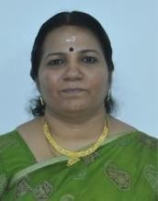 | PROFESSOR | F | B.Tech. (EEE) - Sep 1993  M.Tech. (Power System) - Feb 1998 Ph.D (Electrical Engineering)- Jan - 2013 | 6.8 | 2 | 18.8 | 27.4 | 15-Nov-04 | POWER SYSTEMS
3 | DR. C.E. GEETHA DEVI |  | ASSOCIATE PROFESSOR | F | B.Tech (EEE) - Apr 1988  M.E. (Applied Electronics) - Dec 1999 Ph.D (Power System Control) - 2021 | 4 | 1.5 | 29.2 | 34.7 | 11-Jul-94 | POWER SYSTEM CONTROL
4 | DR. N. KARTHIK | 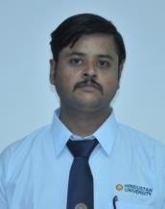 | ASSISTANT PROFESSOR (SELECTION GRADE) | M | B.E (EEE) - Apr 2000  M.E (Power Electronics & Drives) - Jun 2005  Ph.D (Power Systems) - 2021 | 3.5 | 2.2 | 12.3 | 17.10 | 13-Jun-11 | POWER SYSTEMS
5 | DR. P. GETZIAL ANBU MANI | 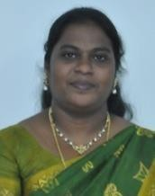 | ASSISTANT PROFESSOR (SELECTION GRADE) | F | B.E. (EEE) - Apr 2003  M.E. (Power Electronics and Drives) - 2006  Ph.D - Sep 2023 | 0 | 0 | 17.1 | 17.1 | 23-Aug-06 | POWER ELECTRONICS & DRIVES
6 | DR. V. KANPUR RANI | 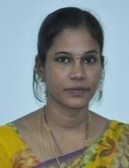 | ASSISTANT PROFESSOR (SELECTION GRADE) | F | B.E. (EIE) - Apr 2004  M.E. (Control & Instrumentation Engg.- Nov 2008  Ph.D - Smart Sensor - Sep 2023 | 2 | 0 | 14.2 | 16.2 | 22-Jun-09 | SMART SENSOR
7 | DR. NAGESWARARAO KUDITHI | 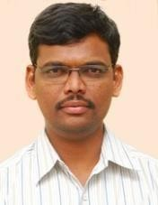 | ASSISTANT PROFESSOR (SENIOR SCALE)  & OFFICER -  INTERNATIONAL  AFFAIRS | M | B.E (EIE) - Apr 2007  M.Tech (Electronic & Instrumentation) - Apr 2009  Ph.D (Renewable Energy) - 2019 | 1.4 | 0 | 13.2 | 14.6 | 21-Jun-10 | RENEWABLE ENERGY
8 | MR. VENKATARAMANA RAO | 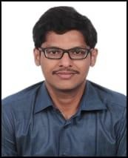 | ASSISTANT PROFESSOR | M | B E - EEE  ME - Power Elelctronics - 2015 | 1 | 0.8 | 12.4 | 14 | 30-May-11 | POWER ELECTRONICS

SN | NAME | PHOTO | DESIGNATION | GEN DER | QUALIFICATION | PREV. RESEARC H / TEAC EXP. | INDUS EXP. | HITS EXP. | TOTAL EXP. | D.O.J | SPECIALISATION
9 | MS. S. PRIYADARSHINI |  | ASSISTANT PROFESSOR  & ACOE | F | B.E (EEE)- Apr 2014  M.E (Power Electronics & Drives)- Jun 2016 | 0.8 | 0 | 6.2 | 6.10 | 3-Jul-17 | POWER ELECTRONICS AND DRIVES
10 | DR. RAGHUNANTHAN R |  | ADJUNCT FACULTY | M | Ph.D | 0 | 17.8 | 3.4 | 21 | 18-May-20
11 | DR. KK SASI | 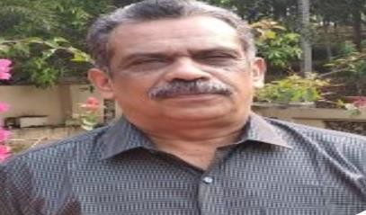 | ADJUNCT FACULTY | M | B.Sc (Engg.) - 1980  M.Sc (Engg.) - 1984  Ph.D (Wind Electricity) - 2000 | 0 | 12 | 3.4 | 15.4 | 18-May-20 | WIND ELECTRICITY

