Inaugural and Seminar Report
On behalf of Civil Engineering Department, Hindustan Institute of Technology and Science, we have inaugurated a research laboratory ‘Honda Fujishima Renewable Energy Laboratory’ on 4th august 2016.
In the presents of Chief guest Dr.Ligy Philip, guest of Honour Prof. R.Nagendran, Registrar, Director Research and HOD Civil, we have inaugurated the research laboratory and in addition to that our chief guests delivered a seminar on ‘centralized wastewater treatment work carried out at IIT Madras’ and guest of honour Professor R.Nagendran has spoken about ‘role of judiciary on waste management’.
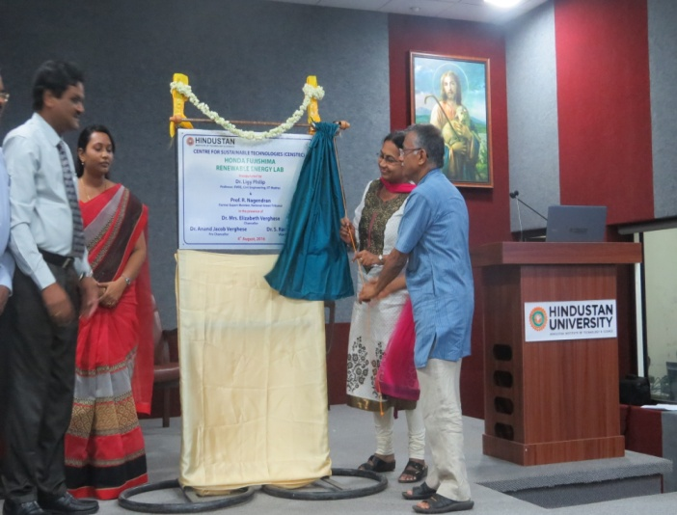 | 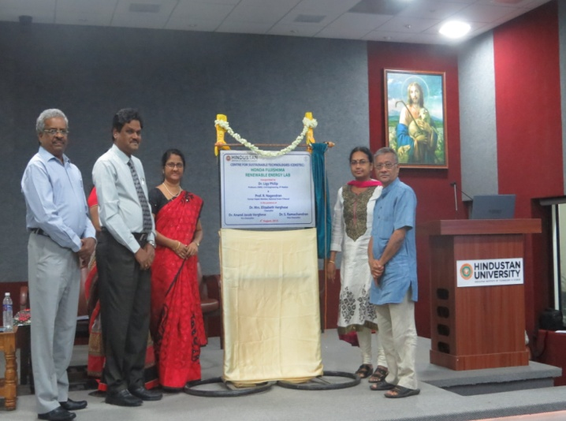

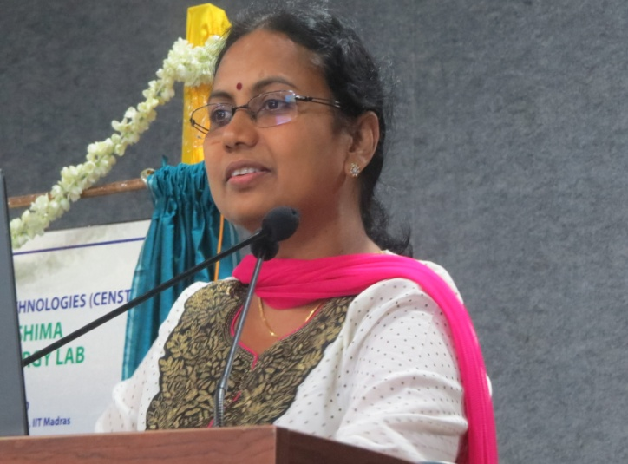 | 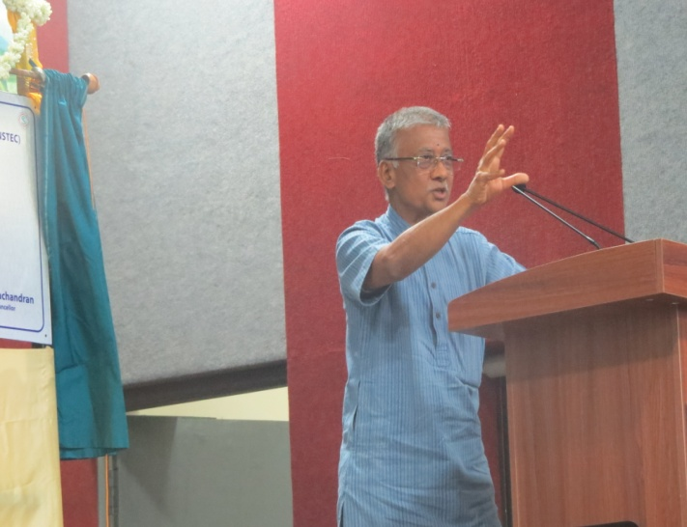

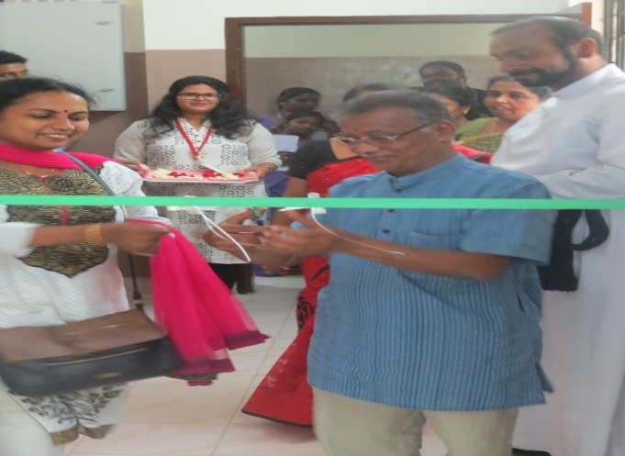 | 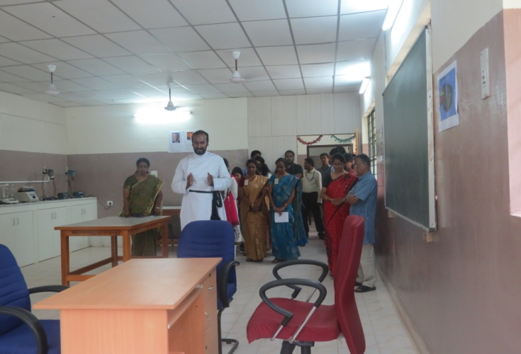
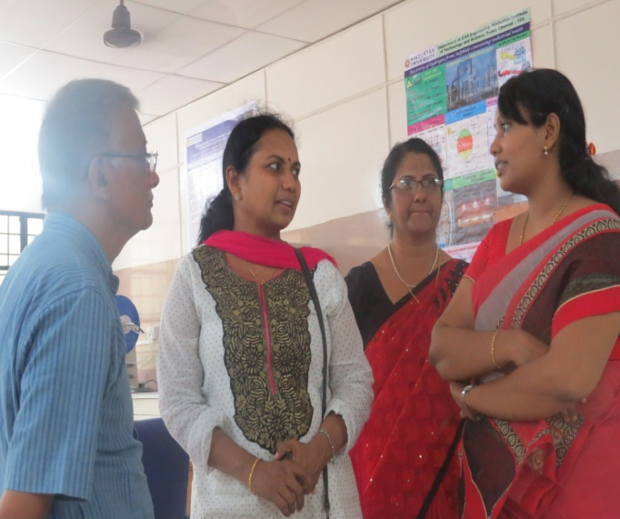 | 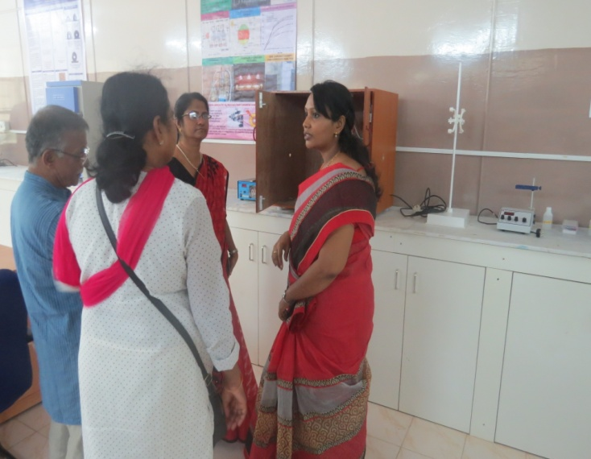
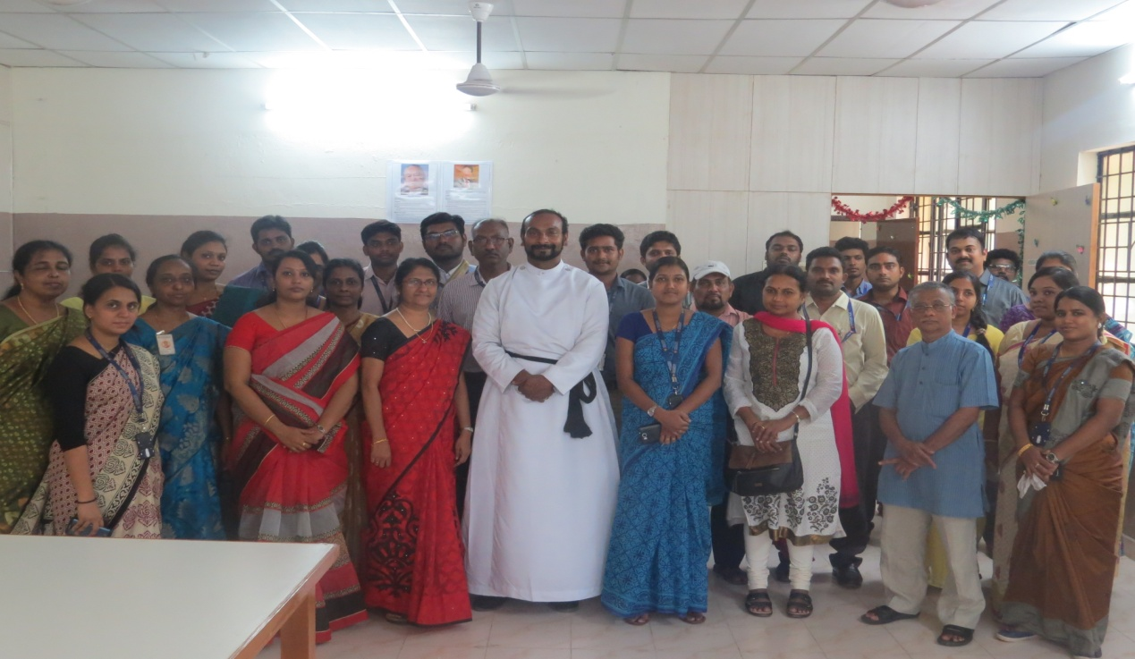
After the seminar the chief guests, HOD Civil, Reverend and all the staff members of civil department went to the renewable energy laboratory and inaugurated with a prayer.

