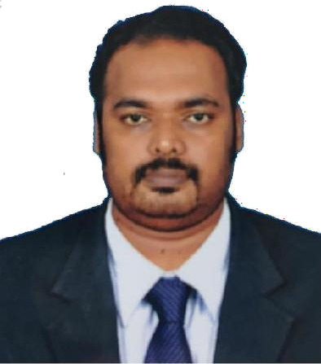
Mr. J. Karthick
Assistant Professor (SG),
Hindustan Institute of Technology and Science karthikj@hindustanuniv.ac.in

Total experience (in years): 12

Research area: Environmental impact assessment, Environmental quality monitoring, Environmental modeling, Air modeling

Recent Publications:
- J. Karthick, R.Samuel Devadoss, S.Sharmila, and S.Karthikeyan,(2020) Assessment `of Meteorological Parameters For Flat Terrain Condition By Using AERMET a `Pre-Processor Dispersion Model, Research Journal of Chemistry and Environment., `24(8), 96-107.

- Karthick.J, Samuel Devadoss.R, Sharmila.S and Natesan.R. (2020). investigational assessment on gaseous stack Emissions from liquid form of fuels under various Loading conditions’. Poll Res.39, pp S113 – S119.

- Karthick.J and Samuel Devadoss.R. (2019). ‘Comparative study on air ontaminants discharged from several industrial stacks operated from various forms of fuels’. Disaster Advances. 12 (11), pp 7 – 14.
- Karthick.J, Natesan.R, Samuel Devadoss. R and Shanaz Fathima A. (2019). Limited environmental impact (Air Pollution) evaluation for a Tamilnadu Port, India’ Eco. Env. & Cons.25(1),pp347-351.

- J. Karthick and R. Samuel Devadoss ""Behaviour and the influence of Meteorological parameters towards air pollutant dispersion modelling studies, Manali Industrial area, Chennai, India", Journal of Ecology, Environment and Conservation, 24 (4) : 2018; pp. (1822-1828)

